Current Event # ____
x
Name:

(put the current event assignment number [example: Current Event #1])

I need a copy of the article
- you can cut it out and staple it
- copy and paste from a computer
- or email me a link. (pbinder@pps.net)

- Copy word-for-word a significant comment, statistic, well-written sentence, or quote from the article.
- Punctuate properly with quotation marks and end marks—include any other marks of punctuation used in the news item as well.
  - Put quotation marks (“) in front of the first word copied and after the last word copied
  - The last end mark of punctuation goes after the parenthetical citation.
  - Copying a quote requires special punctuation.
    - When directly copying a quote, use a single quotation mark in addition to the two quotation marks to indicate the parts of the quote in the news item that you are copying.
    - Place double quotation marks first, then the single quotation mark before the copied quote (“’)
    - Put the single quotation mark after the copied quote (‘), and the double quotation marks after the tag line (used to identify who said the words).
- Cite your source—give credit to the author (last name or names only) and source from which you copied your quotation.
  - Place the parenthetical citation after the copied words and place the end mark of punctuation after the parentheses.
  - In the parentheses, list the last name (or names) of the authors, the source (basic periodical or website name, and page number (if it is a printed news item) or date you accessed the online article (day, month, and year—without punctuation).

online example with author:
“A launch failure is a dramatic, expensive, visceral event” (Spotts, csmonitor.com, 29 October 2014).

internet example without author:
“A launch failure is a dramatic, expensive, visceral event” (csmonitor.com, 29 October 2014).

newspaper articles with author:
“A launch failure is a dramatic, expensive, visceral event” (Spotts, Oregonian, page A7).

newspaper articles without author:
“A launch failure is a dramatic, expensive, visceral event” (Oregonian, page A7).

copying a quote example with author:
“’A launch failure is a dramatic, expensive, visceral event’ acknowledged Clarissa Christensen”
(Spotts, csmonitor.com, 29 October 2014).

Quote: ____________________________________________________
____________________________________________________
____________________________________________________
____________________________________________________
____________________________________________________
____________________________________________________
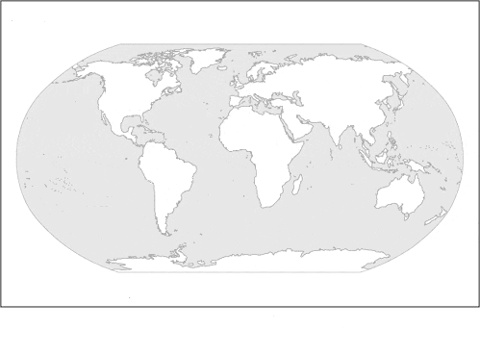
Type:

- Local/Regional
- National
- International
- Sports
- Health
- Business
- Economy
- Politics
- Science
- Technology

Source: ________________
(newspaper name, basic web site name, etc.)

Locate and label on map

Who: ____________________________________________________
____________________________________________________
____________________________________________________
____________________________________________________

Where: ____________________________________________________
____________________________________________________

When: ____________________________________________________
____________________________________________________

What: ____________________________________________________
____________________________________________________
In your own words… paraphrase

*should be 4 sentences minimum & cover the entire article

____________________________________________________
____________________________________________________
____________________________________________________
____________________________________________________
____________________________________________________
____________________________________________________
____________________________________________________
____________________________________________________
____________________________________________________
____________________________________________________
____________________________________________________
____________________________________________________
____________________________________________________

Presentation:

- Eye Contact

- Volume

- Body Language

- Pacing/Clarity

- Content

