**Binder Core: 9/30/2013**

**Absences**

[repeat]

Absences create a few issues, but nothing that cannot be managed. There are a myriad of reasons to miss school, but all students are expected to be responsible for the information and assignments that they missed. An absence is not a free pass, but prolonged absences can (and often do) result in abbreviated work. Please communicate with the office and all teachers regarding all absences: from a momentary absence due to an appointment to a prolonged absence due to illness.

If a student is truly ill, please keep him/her/them at home and contact the office to keep us apprised of the absence. It will only create a small pandemic to send a “borderline” ill child to school. Please do not help spread the germs. Various plagues, that could be avoided if we work together to not spread the germs, devastate classes each year.

If the illness is only a day or two…let the child rest and recuperate. Do not tax his/her body more by trying to keep up with homework and lessons. It only exhausts the body and mind more. If the illness lasts for more than several days, please communicate with the office and teachers. Check in with us to see if there are things that could be done to keep from falling too far behind, or if some things can be shortened or eliminated.

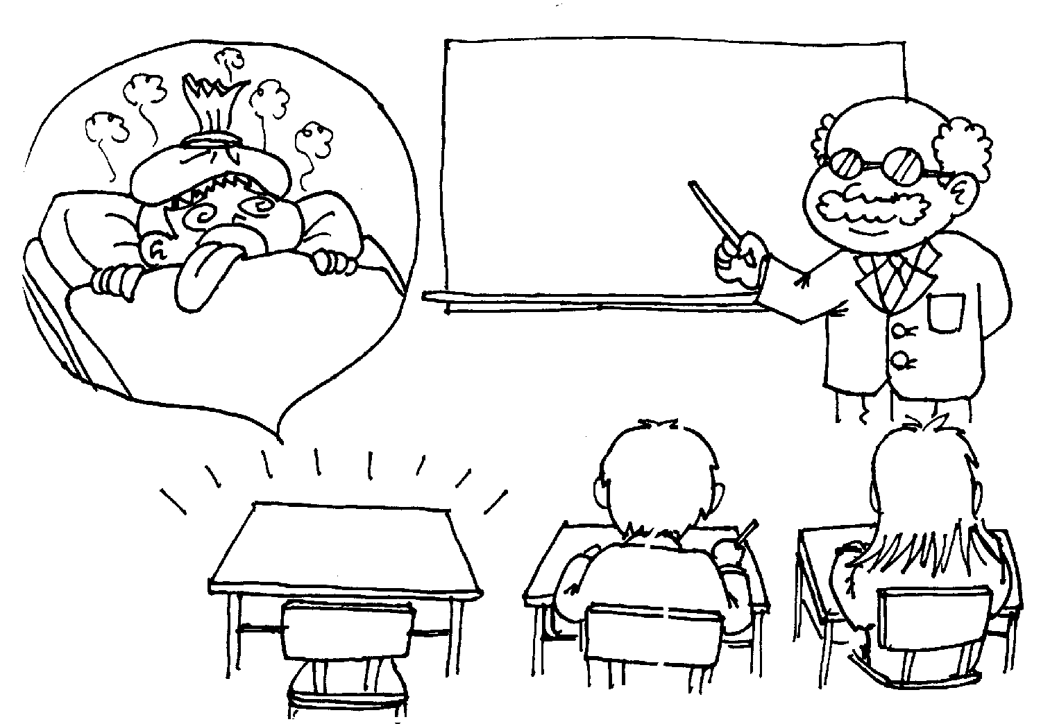If the absence is because of a family function (80th birthday for a grandparent, family reunion, family vacation, etc.) please notify the office and all teachers several weeks **prior** to the absence if possible. I am very supportive of family time. It is the strength from which an individual grows. Please keep in mind that the sooner we know of upcoming absences the easier it is on all of us. I often create alternatives or schedule work to be done ahead of time and create a plan for catching up upon one’s return.

If a student is simply tired from a late night activity (attending a Dandy Warhol concert, midnight screening of the Ender’s Game movie, or texting friends until dawn), please send them to school. Life is full of lessons and the natural consequences. It is okay to be a bit tired and worn-out in class.

In the case of an absence, do not panic. Do not break nearby glass in search of a “quick-and-easy” solution. Instead, try the following:

1. Consult the most recent **newsletter**. It may be in your email, posted to the [Binder Core website](http://733257565503770808.weebly.com/newsletters.html), or printed (if you print it yourself).
2. Peruse the **planner**. We copy the next week’s lessons into the planner at the end of every week. Each student should, at minimum, have the basics of what we will be working on and what is due.
3. Check the [Binder Core Google **calendar**](https://www.google.com/calendar/embed?src=dt13r1m86md7hjv4comn7mgnmk%40group.calendar.google.com&ctz=America/Los_Angeles).
4. Call a **classmate**. While this is similar to “Phone a Friend”, it will not result in winning millions of dollars. It will, however, result in discovering information.
5. **Email** or **phone** [Binder](mailto:pbinder@pps.net?subject=question%20regarding%20absence) and any other teachers for help and guidance.
6. **Relax**. Students generally are allowed two days to make up work for each one missed school day. One should, however, check with each teacher to verify expectations.

Please communicate any issues prior to an absence or as soon thereafter as possible. I will do my best to respond in a prompt manner.



**Synergy Updates**

[repeat]

**From the distrct…**

**ParentVUE & StudentVUE:**  Parents and students will be receiving their login information the last week of September/ first week of October.  Parents who have an email address on file will be first asked to validate their emails and then will be sent their login information electronically. Remaining parents will be mailed home their login information. Please visit the [Spotlight Family](https://by2prd0611.outlook.com/owa/redir.aspx?C=wPTJqyjmFkqFr9K8LTbUr8kaEvIIgtAI3D4j8wIOlqRXrgb868C4MEbFKomjbtvzZTZ24-zd2XQ.&URL=http%3a%2f%2fwww.pps.k12.or.us%2fdepartments%2finformation-technology%2f8258.htm" \t "_blank) page for more information.



♠

**Reading**

**Book Drive**

[repeat]

We are having a contest between the AM and PM Cores to see who can bring in the most books. Our classroom library has grown by leaps and bounds throughout the years, but new materials are always needed. Please donate any age appropriate novels that you do not need or gift certificates to a local bookstore.

I routinely pick up a novel while in an airport and then donate the lightly used book to the classroom. I always think that a true gem or a good “once read” deserves another set of eyes. Please help stir the literary passion of our students by donating what you can. Thank you in advance for whatever you can do.

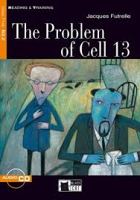**Short Stories**

This week we will be reading “The Problem of Cell 13” by Jacques Futrelle. The story is posted to the “READING” page on my web site.

" **The Problem of Cell 13**" is a short story by Jacques Futrelle, first published in 1905 and later collected in *The Thinking Machine* (1907), which was featured in crime writer H. R. F. Keating's list of the 100 best crime and mystery books ever published. Science fiction author Harlan Ellison selected the story for Lawrence Block's *Best Mysteries of the Century*.

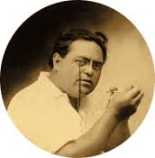Like Futrelle's other short stories, "The Problem of Cell 13" features Augustus S. F. X. Van Dusen as the main character, although most of the story is seen through the perspective of a prison warden. While in a scientific debate with two men, Dr. Charles Ransome and Alfred Fielding, Augustus, "The Thinking Machine", insists that nothing is impossible when the human mind is properly applied. To prove this, he agrees that he will take part in an experiment in which he will be incarcerated in a prison for one week and given the challenge of escaping. Along the way, he tosses out "impossible" fillips and red herrings, such as writing notes with no pen and making change from a five-dollar bill.

It is another “locked room” mystery, but without the resulting boy-and-his-puppy sadness.

Students will eventually be asked to answer a question or questions about the readings in both a written and artistic format. Written answers should be focused (not rambling) and clearly explained. The written answers should not be first drafts. Students should revise, edit, process, and proofread their answers. Artistic responses should demonstrate effort but not hours of work. The artistic side should employ a draft and a finalized product of the student’s “best” skills. Overall, each side should take at least 30 minutes of time and effort. Please refer to upcoming newsletters for due dates of reading journals and for authors we will be reading.

♠

**Writing**

**Vocabulary #2**

All vocabulary students should be reviewing their lists for five minutes a day. Repeated exposure to the words or stems will help in the long-term retention of the meaning and lead to greater success on the quizzes. Students who cram the night before or day of generally do not score as well, nor do they remember the meanings down the road. On Thursday (10/3), the W3 and the regular vocabulary students will take a quiz.

**Detective Story**

We are beginning the process of writing our first significant piece, a detective story. We will be working on the first two, of thirteen steps over the next couple of weeks. It provides students time and space to mentally edit, revise, and evaluate their initial story ideas.

We will be working on the following:

1. Choose a time period for your detective story. It can be any time, any place, from Ancient Egypt to the future or it could go to any kind of imaginary planet in a new galaxy.
   1. Do some research about what happened in any country; any kind of murder, any kind of strange case known. If the case never close, you could make the end anyway you please.
2. Develop the personality of your detective; he could be tough, comprehensive, patient or he could be even the murder of your story. Answering all of the following questions may be unnecessary. However, being thorough in this step can help you write a believable story based on a complete and rounded main character.
   1. Think of the basics. Boy or girl? What is their name? How old are they? What do they look like (hair color, eye color, and skin tone)? Where are they from? Where are they living when your story starts? How did they become part of the story? are they victims? Are they the cause of the problems in your story?
   2. Develop a family for your character. Parents? Siblings? Significant Other? Children? Other relations? Sociably problematic groups? A character which may know everything but has disappear...Make it as normal or as interesting as you want!
   3. What kind of life do they live? Are they famous, or are they just starting out? Are they unexpectedly smart? What kind of mysteries do they solve? (murder, theft, a combination, other kinds?)
   4. Develop their tastes. Favorite sentence to say? What is their favorite color? Place to be? Soft drink? Book? TV show? Movie? Music? Meal? What are they afraid of? How practical are they? Do they wear a scent, and if so, what scent? Strong, soft, nice or not pleasant?
   5. Come up with their religion. Do they have a religion? If so, what? Did they invent one or combine some to suit themselves? How does this influence their actions? Are they superstitious?
   6. Develop their relationships. Do they have a lot of friends? A best friend? Are they romantic? What first impression do they make? Do they like children? DO they like smokers? Do they like reading?
   7. How do they dress? Do they use makeup or hair dye? How about piercings or tattoos? How attractive are they, and how attractive do they think they are? Is there something they wish they could change, or something they are particularly happy with? How much time do they spend thinking about physical appearance?
   8. Though this may seem like a lot to worry about for a short story, having your characters developed to the fullest is an essential part of writing a good story.

♠

History

**Current Event #2**

All missing or make-up presentations will take place Monday (9/30). News items may come from any reliable and non-comedic source (sadly…the “Onion” and the “Daily Show” are satirical and not valid sources of articles). I have a list of useful sources posted on my “CURRENT EVENTS” web page.

Students need to remember to prepare a current event the day before it is due. If a current event is not ready when it arrives in class then it will be presented the next day. Presentations are 30-45 second summaries of the news item.

An unfortunate new twist to the current events assignment is that newspapers **may not** be available in the Binder Core classroom this year.

“Oregonian Media Group will introduce new and improved digital products, including enhancements to Oregon's largest news website, OregonLive.com. The company will provide up-to-the-minute news and information, when and where readers want it -- on their desktops, laptops, smartphones and tablets. At the same time, it will continue to publish Oregon's oldest, largest and leading newspaper.

The Oregonian will continue to be published daily and sold at outlets in the Portland metropolitan area and elsewhere in the state and southwestern Washington. Home delivery will be Wednesday, Friday, and Sunday. Additionally, a bonus edition will be delivered Saturday. (<http://www.oregonlive.com/news/index.ssf/2013/06/about-oregonian-media-group.html>)

Thus, students will be working mostly from **electronic** **sources** of news. There will be “current events” passes available for students in the day(s) prior to the due date of their current event assignment. I provide a daily visual and auditory reminder to students regarding upcoming current events. It is up to the students to request a pass to use one of the three library computers to search for and print an article.

Sorry for any inconvenience and communicate any issues.



**Geography of the AMericas**

Students will take a test Tuesday (101). The test will have a map assessment of the physical and political features of North and South America, questions from chapter 1, as well as an evaluation of latitude and longitude. We will review on Monday (9/30).

We will be venturing forth into our next unit of study, “Explorers of the Americas” beginning Wednesday (10/2).

♠

**Classroom Items Needed**

**MOST IN NEED OF:**

* Anti-bacterial countertop wipes (*Lysol* brand)
* Colored pencils - IN DESPERATE NEED OF THESE
* Colored printer paper *(regular stock and card stock)*
* Markers - THIN & THICK - DESPERATE NEED
* Rubber cement *(lots of art projects each year)*
* 10-15 Small dry erase boards *(for in class quizzes and activities)*
* Dry erase markers *(multiple colors - NO fine point, please)*
* Composition notebooks (college ruled)
* Black Fine or Pinpoint felt markers *(for making good black lines on drawings, Papermate is best)*
* GRAPHIC DESIGN/PHOTO/IMAGE CATALOGUES OR BOOKS *(kids use these frequently in our class - if you are or know a graphic designer or anyone in the ad agency world, ask them if they have old books they'd like to donate)*
* *Kleenex* tissue

**OTHER ITEMS WE USE & NEED** (not in any particular order):

* Metal hand held pencil sharpeners
* AA & AAA batteries
* College ruled loose leaf paper
* Card stock weight paper (various colors)
* Multi-colored pocket folders
* Calligraphy pens/makers (with felt tips, especially during storyline units)
* Stencils (almost any kind)
* Stickers (any kind)
* Word games (*Scrabble* isn't the only one out there. How about: FUNGLISH, PICTUREKA, BUZZ WORD, IN A PICKLE, LAST WORD, IMAGINE IF, MAD GAB, TABOO)
* Playground equipment: basketball, football, rubber 4-Square balls, hoola-hoops, soccer ball, sidewalk chalk, foxtails, large size kickball, beach balls
* Brita water filters—including the replacement filters
* Any technology
* Other?

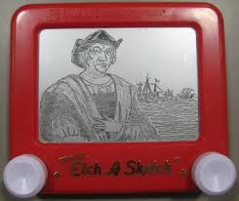

**Locker Painting Volunteers Needed:**

* lend your expertise to the creative process
* monitor students
* assist in clean up
* 10/9 from 1:15-2:45
* 10/10 from 8:15-9:15
* either or both days

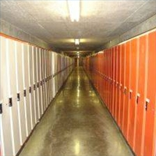

Planner **September 30- October 6**

|  |  |  |  |  |  |  |
| --- | --- | --- | --- | --- | --- | --- |
|  | **Monday 9/30** | **Tuesday 10/1** | **Wednesday 10/2** | **Thursday 10/3** | **Friday**  **10/4** | **Weekend 10/5-6** |
| **Writing**  (Language Arts) | **Detective Story**  -creating the main character: physical & personality aspects  -written and dimensional form of character | **Vocabulary #2**  -review?  **Detective Story**  -creating the main character: physical & personality aspects  -written and dimensional form of character | **Vocab #2 Quiz [10/3]**  -regular = fill-in-the-blank sentences  -W3 = stems & mystery questions  **“Detective” Character Biography**  -written: physical, personality, & other aspects  -dimensional representation: doll, puppet, caricature, etc. | | **Detective Story**  -creating the antagonist character: physical & personality aspects  -written and dimensional form of character | **Vocabulary #3**  -words & work 10/7-10  \*assignment due 10/10  -quiz 10/17  **Detective Story**  -work time to create the character biography for antagonist  \*antagonist biography due 10/10…both a written and dimensional form |
| **Reading** | **20’ Reading**  -student book of choice  -student meetings  **“The Problem of Cell 13” by Jacques Futrelle**  -read aloud  -literary devices, elements of detective fiction, plot line, connections, etc. | **20’ Reading**  -student book of choice  -student meetings  **“The Problem of Cell 13” by Jacques Futrelle**  -read aloud  -literary devices, elements of detective fiction, plot line, connections, etc. | **20’ Reading**  -student book of choice  -student meetings  **“The Problem of Cell 13” by Jacques Futrelle**  -read aloud  -literary devices, elements of detective fiction, plot line, connections, etc. | | **20’ Reading**  -student book of choice  -student meetings  **Novel Sharing**  -share a good novel you have, are, or want to read | **“The Hands of Mr. Ottermole” by Thomas Burke**  -read aloud  -class review & discussion  **Reading Log #2**  \*due 10/18 representing 250+ pages of reading |
| **History**  **(Social Studies)** | **Current Event #2**  -make-up & missing presentations  **Geography of the Americas**  -review maps: landforms, bodies of water, political, latitude, & longitude  -review “Native Americans” (chapter 1) | **Geography of the Americas Test**  -due **beginning** of class | **Current Event #2**  -update & review  **Exploration of the Americas**  -read “European Exploration & Settlement” (chapter 2: pages 16-33)  -read and take notes together | | **Current Event #2 Quiz**  -individual quiz  -includes questions on short stories (“Red-Headed League” & “Problem of Cell 13”) | **Current Event #3**  -presentations 10/7-10  -make-up & missing presentations 10/14  -group quiz 10/18  **Exploration of the Americas**  -choose an explorer of the Americas to research  -start research |
| **Other**  Contact Information for Binder  **da Vinci:** 503-916-5356 ext 79140 **Home**: 503-640-5265  voicemail: 503-916-3600 ext 79140  email: [pbinder@pps.net](mailto:pbinder@pps.net)  **WEB PAGE** <http://733257565503770808.weebly.com/> | **Spirit Week:** pajama & stuff animal day | **Spirit Week:** dog vs. cat day | **Spirit Week:** decade day  **Periods: 2, 4, 6, & FLEX** | **Spirit Week:** fandom day  **Periods 1, 3, 5, & 7**  **Zakia Elazami**’s birthday | **Spirit Week:** Portland Day  **Dance Party** 2-3:30  **Olivia Craig**’s birthday | 10/8 **midterm**  10/9-10 locker painting  10/11 inservice—no school  10/20-22 **Outdoor School** for 6th graders |