**Binder Core: 9/16/2013**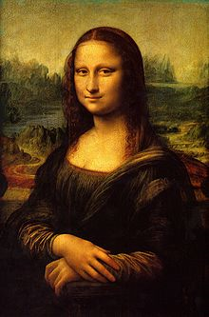

**Introduction**

My goodness…a mad rush has taken place in the first couple of weeks. We have an entirely new program suite for attendance and grades—which you will not have access to until early October, an obtuse web page system, a newer schedule, and new students. The pace and chaos will settle down soon. Please hang in there, communicate any issues/problems, and simply breathe.

♠

**Reading** [some is repeated]

**Daily Reading & Meetings**

During the first twenty minutes of class students have been doing a good job of reading a novel of choice. While students are reading I use the time to meet with students to talk about questions, get to know the newer students, and clarify mistakes on assignments. Students can sign up any time on the “**Binder** **Time**” clipboard to meet with me during Core to answer “me” questions (as opposed to the “we” questions for the whole class). Additionally, I talk with students who have called me and left messages at home or via email that I was unable to respond to the previous night.

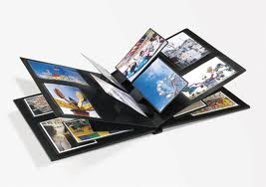Students should also be reading twenty to thirty minutes a night at home. In class and at home reading counts toward their reading log goal of 750 pages a quarter.

**Reading Log/Projects**

The idea of a reading log remains simple…I want students to read. Student comprehension, inference, analysis, and synthesis improve with their reading. Students need only write a summary of the novel when they are done—**not** a daily journal of their reading.

Students do have an alternative. They can complete projects instead of keeping a reading log. The projects are due at the same time as the logs. The log and project instructions are detailed in a “Reading Log” handout I provided the students during the first week of school. The reading logs/projects are due in three separate installments each quarter, beginning Friday, September 27

**Short Stories**

This week we will be reading “The Speckled Band” by Sir Arthur Conan Doyle. The story is posted to the “Reading” page on my web site. It does have a bit of hinted violence, but nothing direct.

"The Adventure of the Speckled Band" is one of the 56 short Sherlock Holmes stories written by Scottish author Sir Arthur Conan Doyle. It is the eighth of the twelve stories collected in *The Adventures of Sherlock Holmes*. It is one of four Sherlock Holmes stories that can be classified as a locked room mystery. The story was first published in *Strand Magazine* in February 1892, with illustrations by Sidney Paget. It was published under the different title "The Spotted Band" in *New York World* in August 1905. Doyle later revealed that he thought this was his best Holmes story.

Students will be asked to answer a question or questions about the readings in both a written and artistic format. Written answers should be focused (not rambling) and clearly explained. The written answers should not be first drafts. Students should revise, edit, process, and proofread their answers. Artistic responses should demonstrate effort but not hours of work. The artistic side should employ a draft and a finalized product of the student’s “best” skills. Overall, each side should take at least 30 minutes of time and effort. Please refer to upcoming newsletters for due dates of reading journals and for authors we will be reading.



♠

**Writing**

**Vocabulary #1**

The W3 and the regular (Binder) vocabulary assignments were due at the beginning of the class last Friday (9/13). I will be checking in with students who did not complete the assignment or who seem confused on the expectations. Copies of the assignment guidelines are posted on my web site.

We will be going over example quizzes and expectations this week in preparation and anticipation of Thursday’s (9/19) vocabulary #1 quiz.

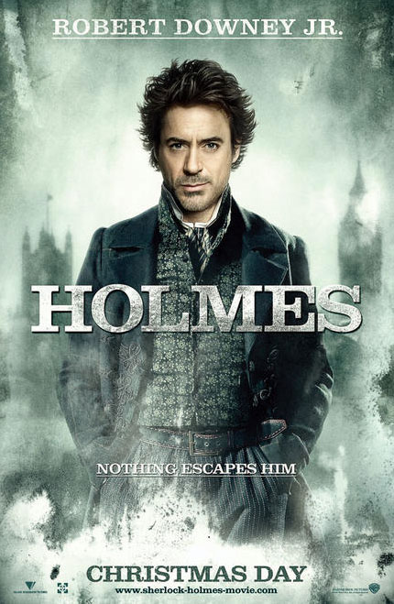Regular vocabulary students will have a quiz with twenty sentence groups. Each numbered sentence group will have a blank in it—a blank in which only one of the vocabulary words fits. Their job is to figure out which word belongs in the blank. 6th graders need to complete any 12 of the 20 blanks, 7th any 14, and 8th any 16.

W3 student have stem definitions and questions to answer. W3 students need to decode (break down and figure out the meaning) of a bold word in the question in order to answer the question and explain their answer.

**Summer Movie Poster**

We have been working on our first project...a summer movie poster. Students are supposed to turn a summer experience(s) into a movie poster with a title, tag line, image, and actors. The poster and a review are due at the beginning of class on Wednesday (9/18).

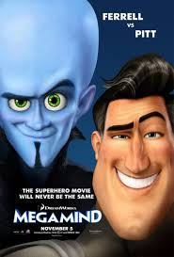Students will submit a finalized—often referred to as a “published” copy—review at the beginning of class on. The published copy needs to be double-spaced. It can be typed or written in blue or black ink and using one’s best writing. The published copy should be free of grammatical mistakes, and presented in a logical order.

We have been and will continue to go over the requirements and expectations of the review. The final version should be at least a page, but not more than three pages. It should be a purposeful review written with one’s best effort.

From Wednesday through Friday (9/18-20) students will be presenting their posters and review to the class. A handout explaining the project, the scoring, and a set of example movie posters that we discussed in class are available via the “WRITING" page of the Binder Core website (<http://733257565503770808.weebly.com/writing.html>).

♠

History

**Current Event #1**

**Classroom Items Needed**

* art supplies
  + colored paper
  + clothe scraps
  + scissors
  + glue
  + pencil sharpeners
  + washable markers
  + colored pencils
  + rulers
  + watercolors
  + paintbrushes
  + other?
* word games—Scrabble isn’t the only one
* playground equipment
  + rubber 4-Square balls
  + soccer ball
  + large size kickball
* Brita water **filters**—not the pitchers, but the replacement filters
* healthy snacks & drinks for classroom
* technology?
* other?

Returning students to Binder Core presented a current event last week (or on Monday 9/16). We will be reviewing and updating the current events and adding new ones throughout the week. On Friday (9/20) students will take a current events quiz over the fifteen (or more) most significant items. The quiz will also include questions from the three short stories we have read

(“Suspicion”, “The Milk Bottles”, and “The Adventure of the Speckled Band”).

**Locker Painting Volunteers Needed:**

* monitor students
* lend your expertise to the creative process
* assist in clean up
* 10/9 @ 1:15-2:45
* 10/10 @8:15-9:15
* either or both days

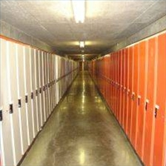

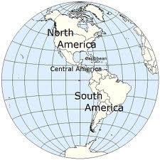Next week all students must present a current event on their assigned day. Directions, expectations, and the current event sheet are available for download via the “Current Event” page of my web site.

**Geography of the Americas**

Students will be working on and submitting the final map assignment for the unit. It involves the nations of the Americas and the states of the United States. The political maps are due at the beginning of class on Tuesday (9/17). Student do have class time to work on the assignment, but if it is not done by the end of class on the 16th, students should take it home to finish it as homework.

We will be reading and reviewing the first chapter in the textbook, “The Native Americans” (chapter 1: pages 1-15). The “guided notes” assignment for chapter 1 is due at the beginning of class next Tuesday (9/24). Throughout the rest of the week, we will be working on latitude and longitude.

♠

Planner **September 16-22**

|  |  |  |  |  |  |  |
| --- | --- | --- | --- | --- | --- | --- |
|  | **Monday 9/16** | **Tuesday 9/17** | **Wednesday 9/18** | **Thursday 9/19** | **Friday**  **9/20** | **Weekend 9/21-22** |
| **Writing**  (Language Arts) | **Summer Movie Poster**  -finalize poster: dominant image, title, tag line, “stars”  -edit/revise review | **Vocabulary #1**  -example quiz & review  **Summer Movie Poster**  -finalize poster: dominant image, title, tag line, “stars”  -edit/revise review | **Vocab #1 Quiz [9/19]**  -regular = fill-in-the-blank sentences  -W3 = stems & mystery questions  **MY SUMMER MOVIE POSTER**  *poster & review due at beginning of class [9/18]  -presentations 9/18-20 | | **Summer Movie Poster**  -presentations  -vote for best movie posters within genres | **Vocabulary #2**  -words & work 9/23-26  *assignment due 9/27  -quiz 10/3  **Detective Story**  -explanation, timeline, and creating a main character |
| **Reading** | **20’ Reading**  -student book of choice  -student meetings  **“The Speckled Band” by Sir Arthur Conan Doyle**  -read aloud  -literary devices, elements of detective fiction, plot line, connections, etc. | **20’ Reading**  -student book of choice  -student meetings  **“The Speckled Band” by Sir Arthur Conan Doyle**  -read aloud  -literary devices, elements of detective fiction, plot line, connections, etc. | **20’ Reading**  -student book of choice  -student meetings  **“The Speckled Band” by Sir Arthur Conan Doyle**  --read aloud  -literary devices, elements of detective fiction, plot line, connections, etc. | | **20’ Reading**  -student book of choice  -student meetings  **“The Speckled Band” by Sir Arthur Conan Doyle**  --read aloud  -literary devices, elements of detective fiction, plot line, connections, etc. | **“The Red-Headed League” by Sir Arthur Conan Doyle**  -read aloud  -class review & discussion  **Reading Log #1**  *due 9/27 representing 250+ pages of reading |
| **History**  **(Social Studies)** | **Current Event #1**  -make-up/missing presentations  **Geography of the Americas**  -Americas political geography map work time | **Current Event #1**  -update, new, & review  **\*Americas political geography map**  -due **beginning** of class | **Geography of the Americas**  -read “The Native Americans” (chapter 1: pages 1-15)  -guided reading notes assignment | | **Current Event #1 Quiz**  -group quiz  -includes questions on short stories (“Suspicion”, “Milk Bottles”, & “Speckled Band”) | **Geography of the Americas**  -read “The Native Americans” (chapter 1: pages 1-15)  *guided reading notes assignment due 9/24  **Current Event #2**  -presentations 9/23-27  -make-up & missing presentations 9/30  -individual quiz 10/4 |
| **Other**  Contact Information for Binder  **da Vinci:** 503-916-5356 ext 79140 **Home**: 503-640-5265  voicemail: 503-916-3600 ext 79140  email: [pbinder@pps.net](mailto:pbinder@pps.net)  **WEB PAGE** <http://733257565503770808.weebly.com/> |  |  | **late opening: 2, 4, & 6 (no flex)** | **Periods 1, 3, 5, & 7**  **Back to School** from 6-8 @ da Vinci | **Picture Day** | 9/30-10/4 spirit week  10/5 dance party 2-3:30  10/9-10 locker painting  10/20-22 **Outdoor School** for 6th graders |