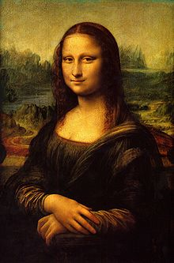**Binder Core: 12/2/2013**

**Conferences & Reflections**

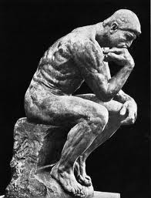I saw or will see 92% of the families that constitute Binder Core.

I will be honest…heading into conferences I was feeling a little defeated. It has been a rougher transition than usual for students—not only from elementary school to middle school, but even within middle school (from 6th to 7th and from 7th to 8th). I have been trying to reflect and ponder how and why the transition was so rough and what can be done to make it smoother for all. I handed reflection sheets to students for conferences and will be sifting through the information during Winter Break.

I put a lot of information out…too much for some and not enough for others. This has been one of the problems. Students, in particular, are not reading the newsletter or directions. I have always said that I hold students accountable for the information. The lack of awareness or follow through is a little concerning.

I try to put information in the newsletter or directions to supplement and supplant the “wisdom” provided orally in class. I want and need students to take ownership of the information. I do not want to waste several hours of class time each week going over details and messages—that feels too much like a staff meeting. It is a skill in life that they need. I have changed the format and method of presentation, but I need some help with the reading part of the information.

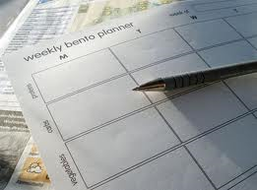The other major concern is planning. There was a good yearlong plan provided at the beginning of the year. I provide detailed weekly plans with each newsletter and a “look what is coming up” weekend section in the planner. I need students and parents to use the planner more effectively to avoid missing significant work and/or to help know what to make up if absent. I fully support and encourage family vacations and trips, but look ahead and plan or notify accordingly so I can help to work things out or rearrange others.

I recommend that students develop a habit of looking at their planner three times. The first is before they leave school to see what they need to take home. The second is right when they get home to see what they need to work on that night. The third and final time is before leaving for school to remind them what they need to take with them. I guarantee that it works if is a habit.

I cannot even begin to tell you how many times a day I hear “We are doing what?” or “I did not know that.” when clearly the student should have known if s/he looked at the daily assignment board, monthly calendar, planner, or listened to the umpteen billion times I talked about it in class. I hope to reduce (eliminate would be too harsh a term) such “ignorance is bliss” situations with your help.

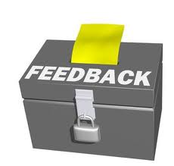Back to the feeling defeated… like you, I suffer when a student struggles. A teacher is a fool if s/he does not care. I care. I want all of my students to achieve the success that they are capable of. Many times it does happen, but many times students, parents, and teacher are left a little discouraged and heartbroken. I have to keep reminding myself that it is a process. I have to keep my eyes looking ahead and focused on where I am trying to guide the students. I have to keep reminding myself that it is a three legged stool and that if one leg is not working then the stool will keep falling over—but it has to get back up and not quit the game otherwise Little Miss Muffett will have nowhere to sit.

I had a lot of good feedback from parents and from returning alumni. Yes…from alumni. I had seven Binder Core survivors return for conferences. They all echoed the same sentiments. Da Vinci taught them well and was probably harder than their freshman year of high school. The benefit is that they were getting mostly “As” and the transition to high school was easy. They watch as fellow freshman struggle with the academic expectations and keeping track of things—and most of the “others” are sinking rather than swimming.

My expectations and demands are lofty, but achievable. I do hold students accountable, but I do support and alter tasks as necessary. The payoff is amazing. I beam each time a former student is in a production—dramatic, musical, dance, or art show. I jump for joy (on the inside…it would just look weird if I did so in real life) when they brag about their grades.

Da Vinci has the best students; both academically and artistically. I believe that to my core. I commute a silly amount of time and distance daily as a testament to my belief. Please continue to communicate successes and struggles so that we can work together to achieve success.

Okay…I think I have stood on my soapbox long enough.

♠

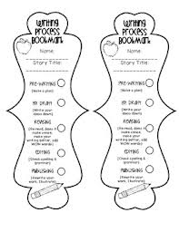**Reading**

**Reading “Logs” 4-6**

Students are still required to read at least ten pages per day (on average), but the “logs” for the second quarter will be bookmarks for their current reading. Students will have to create several bookmarks for each novel. Bookmarks will focus on characters, setting, plot, vocabulary, literary devices, and theme. Each bookmark needs to contain the author, title, and number of pages read in the novel.

I will review and practice the new assignment with the students this week, as well as provide handouts and upload items to the website.

**Short Stories**

We are taking a week off from short stories. We are using the time to focus on the bookmarks, writing, and other aspects and demands of Binder Core and da Vinci.

♠

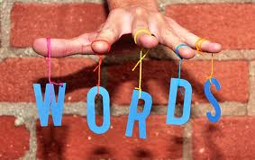

**Writing**

**Vocabulary #6**

The vocabulary #6 quiz will be Thursday (12/5). This might, and often does, pose a problem. The intervening break between the presentation and assignment surrounding vocabulary #6—while good for the mind, body, and spirit—often mean that it is hard to get back into the swing of things.

Regular vocabulary and W3 students on lists #1-20 have the same quiz format as previous quizzes. The regular vocabulary students have to fill in blanks. The W3 students on lists #1-20 have stems and mystery questions.

The W3 students on lists #21+, however, have a slightly new twist to their quizzes. W3 #21+ have stems, words, and definitions on the front side of the quiz, and a “flip side” on the back side of the quiz. The flip side involves using the context (the bold words) in a sentence to determine which word from the current list fits the context. I will review the new format with the students this week. The guidelines are posted on the W3 page of the website.

**

**Detective Story**

We continue the process of writing our first significant piece, a detective story. Students have created the protagonist (detective), antagonist (criminal), crime and setting, plot outline, the solution, clues to embed in the story, the exposition, the initial rising action, and the middle of the rising action. Students will work on the end of their rising action and have an edited and revised copy by Thursday of this week (11/21).

We will be working on:

1. At the end, reveal the motive of the crime. Be sure the ending is clear on who committed the crime and why, and how it was solved. There is nothing worse than leaving a mystery story extremely confused about what was going on!
2. Check the story at least two times and make sure there are no holes. Rewrite things as needed, and reword things to make them more interesting. Cut out as many things as necessary. Be ruthless! You want your story to be the best that it can be.

♠

History

**Current Event #6**

Missing or make-up presentations will take place Monday (12/2) —a bit problematic due to Thanksgiving break and the “out of sight, out of mind” principle of life. The individual current event quiz is Friday (12/6) and it will contain questions about our short stories.

We continue with the same format of presentation throughout the first semester, and then change the type and style of presentation during the second semester. Students still need to prepare a news item (of **at least** ten or more newspaper paragraphs) prior to class. I examine completed summaries at the beginning of class—mainly to provide quick feedback, pronunciation clues, and to partner those who did the same article for a shared presentation. Students then make a thirty to forty-five second presentation to the class and locate the news item on the map.

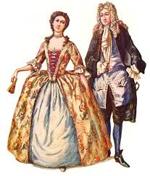The quiz will contain questions about the most significant/interesting news items presented in the last two weeks. The quiz is an individual quiz. Students read the questions and determine the best choice from the list of possibilities. I emphasize the key phrases in the question to help the students (ie: **what country**). Included with the quiz, but scored as a “Reading” grade, will be questions on the short stories we have been reading.

**Colonial AMerica**

We will be finishing chapter 3, “The English Colonies in America”, and starting chapter 4, “Life in the Colonies.” We are working on how to take notes and how to complete guided notes.

There will be a test on the unit, both chapters, next Friday (12/13).

♠

Planner **December 2 – 8**

|  |  |  |  |  |  |  |
| --- | --- | --- | --- | --- | --- | --- |
|  | **Monday 12/2** | **Tuesday 12/3** | **Wednesday 12/4** | **Thursday 12/5** | **Friday**  **12/6** | **Weekend 12/7-8** |
| **Writing**  (Language Arts) | **Detective Story**  -creating the climax, falling action (solution), and resolution  -how did the detective solve the mystery and what was the result?  -work on draft  **Vocabulary #6**  -review vocabulary quiz guidelines & introduce new format for W3 on list #21+ | **Detective Story**  -creating the climax, falling action (solution), and resolution  -how did the detective solve the mystery and what was the result?  -work on draft | **Vocab #6 Quiz [12/5]**  -regular = fill-in-the-blank sentences  -W3 #1-20 = stems & mystery questions  -W3 #21+ = words, definitions, stems & flip side  **Climax through Resolution**  -creating the climax, falling action (solution), and resolution  -how did the detective solve the mystery and what was the result?  -draft shared in small table groups & students edit & revise based on feedback [12/4]  *climax through resolution due **beginning** of class [**12/5**] | | **Detective Story**  -putting it all together  -title, images, spacing, aesthetics, etc. | **Vocabulary #7**  -words and work 12/9-10  *assignment due 12/13  -quiz **12/19**  **Detective Story**  -putting it all together  -title, images, spacing, aesthetics, etc.  *finalized/published detective story due by **12/12** |
| **Reading** | **20’ Reading**  -student book of choice  -student meetings  **Reading Log vs. Project**  -bookmark #1 explanation & example: same face, but different tail  -plot summary | **20’ Reading**  -student book of choice  -student meetings  **Reading Log vs. Project**  -bookmark #2 explanation & example: same face, but different tail  -teaser paragraphs & quotes | **20’ Reading**  -student book of choice  -student meetings  **Reading Log vs. Project**  -bookmark #3-4 explanation & example: same face, but different tail  -character & student choice | | **20’ Reading**  -student book of choice  -student meetings  **Log/Project #4**  -due at **beginning** of class  -representing 250+ pages of reading (1000+ pages total)  -reading log or bookmarks | **“The Giaconda Smile” by Aldous Huxley**  -read aloud  -class review & discussion  **Reading Log/Project #5**  *due 1/7 representing 250+ pages of reading (for a total of 1250+ pages) |
| **History**  **(Social Studies)** | **Current Event #6**  -make-up & missing presentations  **Colonial America**  "The English Colonies in America" (chapter 3: pages 34-47)  -read sections 3:6-8 & take notes as a class | **Current Event #6**  -update & review  **Colonial America**  "The English Colonies in America" (chapter 3: pages 34-47)  -read sections 3:9-11 & take notes as a class | **Colonial America**  "Life in the Colonies" (chapter 4: pages 48-61)  -guided reading notes | | **Current Event #6 Quiz**  -individual quiz  -short story quiz aspects (reading grade)  **Colonial America**  "Life in the Colonies" (chapter 4: pages 48-61)  -guided reading notes | **Current Event #7**  -presentations 12/9-13  -make-up & missing presentations 12/16  -group quiz 12/20  **Colonial America**  "Life in the Colonies" (chapter 4: pages 48-61)  *guided reading notes due 12/11  -test over unit 12/13 |
| **Other**  Contact Information for Binder  **da Vinci:** 503-916-5356 ext 79140 **Home**: 503-640-5265  voicemail: 503-916-3600 ext 79140  email: [pbinder@pps.net](mailto:pbinder@pps.net)  **WEB PAGE** <http://733257565503770808.weebly.com/> |  |  | **Periods: 2, 4, 6, & FLEX**  **Site Council** @4-5:30 | **Periods 1, 3, 5, & 7** | da Vinci Arts Fair set up | 12/7 **da Vinci Arts Fair** 10:00am-6:00pm  12/8 **da Vinci Arts Fair** 10:00am-4:00pm  12/9-12 Winter Talent Show tryouts @lunch  12/11 music pullout during period 6 & FLEX, & music teaser during FLEX |