**Binder Core: 11/11/2013**

**Grades**

[repeated]

I have received a lot of emails, phone calls, and other communications regarding grades. Allow me a little time and space to offer global comments.

My first recommendation is to have a conversation with your student(s). Communication with a middle-school student can be difficult (to put it mildly). It is the best starting point. I ask the students to do the same thing—communicate with the parents. Going around people, asking not to tell “so-and-so”, and other tactics do not support good communication. Please do not ask me to do something I would not do with my children. Communicate…communicate…communicate. If at first you do not succeed, try again, but use a different approach.

My second recommendation is to use Synergy. I spend a lot of time entering grades and comments in a timely manner. Please read the assignment description (the narrative explaining the assignment) and any comments I entered regarding the assignment of the student. In most cases, if the grade is 79% or below I enter specific comments about the student’s performance. If the assignment was a multiple-choice quiz, however, I just enter the score. There is little comment necessary.

Synergy will provide a sensible and appropriate snapshot of the student’s grade. At the beginning of a new grading period it is a little skewed, however, owing to the lack of assignments. A poor performance on one of the two assignments at the beginning of the grading period will have a large influence on the grade at the time. If you do not have access to Synergy, check with the office for instructions on how to access the system.

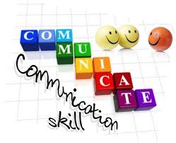Third, and final suggestion, is to communicate with me. Please do your homework before contacting me (the first and second recommendations) so that we can discuss grades from an enlightened position. You will have to complete the first two steps anyways, so you might as well get them over with before communicating with me.

I have met and had fantastic conversations with a good number of parents and students in the past several weeks. It is wonderful to sit down and make sure everyone is on the same page and to hash out any issues. Please let me know if you would like to have a conversation, but please do so sooner than later. My schedule is a bit hectic and I want to work with you to schedule meaningful time together.

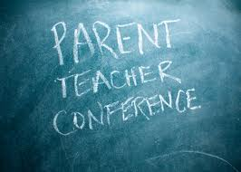**Conferences**

[repeated until conferences]

If you missed the PTSA meeting last Thursday (10/17) then you did not get first crack at signing up for a conference. Parent and teacher conferences are:

* Thursday, Nov. **21**st from 4pm-8pm
* Monday, Nov. **25**th from 8am-8pm
* Tuesday, Nov. **26**st from 8am-4pm

Please call the **da Vinci front office** (503-916-5356) to schedule a conference. I do not have the conference sign-up sheets, nor do I know which slots are available. It is easier and better for the front office to handle the conference scheduling. I am sure I would mess up my schedule somehow.

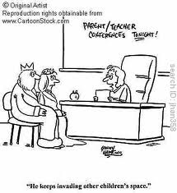There are a few notes regarding the scheduling of conferences. If you have met with me once or several times prior to conferences you might want to consider whether you need more face time. I am not trying to dissuade you, merely asking you to reflect on the limited time available for conferences and whether someone else could use the time with me.

Additionally, if your student is doing very well you might want to reflect on needing time with me. I love my overachieving and brilliant students. They deserve lots of compliments. All students deserve lots of compliments. If, however, you are only coming in to get a pat on the back and a “good job” from me…another family might need that time.

Again, in either situation (prior meetings or successful student) I do not want to scare you off from a conference time. I love meeting with all families. I am just asking you to think about the purpose and intent of the time you want with me.



**Conference Preparation**

Please come ready to discuss specifics. I generally find myself spouting the same message—[insert your student’s name] needs to use his/her class time better, use his/her planner more effectively, read and follow the directions, and give him/herself enough time with the work to be successful. There…that part is done.

Now what I want you to do is focus on an assignment, project, or aspect of the curriculum as related to your child’s educational, emotional, and social development. How comfortable are they with reading? Can they make an 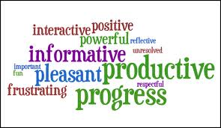independent and age-appropriate choice? Can they summarize what they read? Can they make connections, inferences, analyze, synthesize, recognize use of a variety of literary devices, etc.? Do they know the parts of speech? Do they have a grasp of how words work together to create engaging and effective sentences? Can they write for a variety of purposes and audiences? Do they know how to read a textbook for information? Can they understand and relate the significance of a historical period? Do they know where places are in the world? Do they know their name?

The list can go on and on, but I think you get the point. Please come prepared with specific questions or you will get the generic experience instead of the individualized one. If you are unfamiliar with the work of your student or what we are doing in class then you have some homework before conferences. Ask your student about their work. Look it over with him/her to determine what s/he did well and what s/he needs to work on. Additionally, read the newsletters and handouts for assignments. Good luck…there will be a quiz.

♠



**Reading**

**Reading log #3**

[repeated]

Students are expected to average twenty or more minutes of reading each night. The goal is at least **ten** pages a day. It is not an unrealistic goal and it is something that has been discussed many times in class.

A good number of students were not able to meet the first or second installment of their reading log goal simply because they had not taken the time to read or because they did not complete the summary with full and honest effort (missing the author, two sentences to summarize two hundred pages of reading, etc.). Please help to provide a structured time and encouragement for students to meet this goal.

Thank you in advance for whatever you can do.

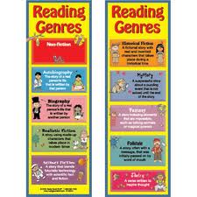**Reading**

**Reading “Logs” 4-6**

Students are still required to read at least ten pages per day (on average), but the “logs” for the second quarter will be projects. Reading Log #4 will be bookmarks for their current reading. Students will have to create several bookmarks for each novel. Bookmarks will focus on characters, setting, plot, vocabulary, literary devices, and theme. Each bookmark needs to contain the author, title, and number of pages read in the novel.

I will review and practice the new assignment with the students next week, as well as provide handouts and upload items to the website.

**Short Stories**

This week students will be reading another Edgar Allan Poe short story, “The Purloined Letter.”

"**The Purloined Letter**" is a short story by American author [Edgar Allan Poe](http://en.wikipedia.org/wiki/Edgar_Allan_Poe). It is the third of his three detective stories featuring the fictional C. Auguste Dupin, the other two being "The Murders in the Rue Morgue" and "The Mystery of Marie Rogêt". These stories are considered to be important early forerunners of the modern detective story. It first appeared in the literary annual *The Gift for 1845* (1844) and was soon reprinted in numerous journals and newspapers.

The unnamed narrator is discussing with the famous Parisian amateur detective C. Auguste Dupin some of his most celebrated cases when they are joined by the [Prefect](http://en.wikipedia.org/wiki/Prefect) of the Police, a man known as G—. The Prefect has a case he would like to discuss with Dupin.

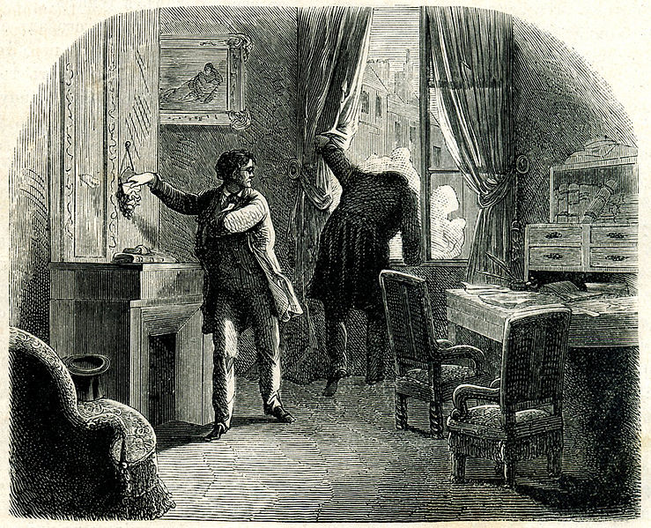A letter has been stolen from the boudoir of an unnamed female by the unscrupulous Minister D—. It is said to contain compromising information. D was in the room, saw the letter, and switched it for a letter of no importance. He has been [blackmailing](http://en.wikipedia.org/wiki/Blackmail) his victim.

The Prefect makes two deductions with which Dupin does not disagree:

* The contents of the letter have not been revealed, as this would have led to certain circumstances that have not arisen. Therefore Minister D— still has the letter in his possession.
* The ability to produce the letter at a moment’s notice is almost as important as possession of the letter itself. Therefore he must have the letter close at hand.

The Prefect says that he and his police detectives have searched the Ministerial hotel where D— stays and have found nothing. They checked behind the wallpaper and under the carpets. His men have examined the tables and chairs with microscopes and then probed the cushions with needles but have found no sign of interference; the letter is not hidden in these places. Dupin asks the Prefect if he knows what he is looking for and the Prefect reads off a minute description of the letter, which Dupin memorizes. The Prefect then bids them good day.

A month later, the Prefect returns, still bewildered in his search for the missing letter. He is motivated to continue his fruitless search by the promise of a large reward, recently doubled, upon the letter's safe return, and he will pay 50,000 francs to anyone who can help him. Dupin asks him to write that check now and he will give him the letter. The Prefect is astonished but knows that Dupin is not joking. He writes the check and Dupin produces the letter. The Prefect determines that it is genuine and races off to deliver it to the victim.

How did he do it?

♠

**Writing**

**Vocabulary #5**

The vocabulary #5 quiz is Thursday (11/14). The quiz will be a normal quiz—as far as normal goes.

The only change is for regular vocabulary students. I will no longer be collecting the lists. At this point students should have learned how to write the part of speech, definition, antonyms, and synonyms for the benefit of understanding. Students (in regular vocabulary) will, however, now have the choice between writing sentences or creating cartoons.

The sentence guidelines remain the same—spell and use the word correctly, mark it, and provide sufficient context. The cartoon guidelines are quite similar, but with a few minor exceptions. Students do need to spell and use the word correctly, but the “marking” is the vocabulary word as a title for the cartoon and the context can come visually or in written form (caption, dialogue bubbles, or labels).

The W3 assignments remain the same…sorry.

**

**Detective Story**

We continue the process of writing our first significant piece, a detective story. Students have created the protagonist (detective), antagonist (criminal), crime and setting, plot outline, the solution, clues to embed in the story, the exposition, and the initial rising action. Students will work on the middle of their rising action and have an edited and revised copy by Thursday of this week (11/14).

We will be working on further developing the story this week. How should the characters, clues, and conflict be developed for the reader? The pace and scaffolding provides students time and space to mentally edit, revise, and evaluate their story ideas before writing and developing their stories.

We will be working on:

1. Introduce the suspects and witnesses. (eg. Annie entered the office. She was a tall woman with thin legs and hands. Her face looks like a diamond...). Be sure to give the reader a vivid picture of each one.
2. Build suspense. The more suspense you put, the more interesting the story will be. Make the protagonist get stuck in a couple of impossible-seeming situations and obstacles. Don't make the mystery too easy to solve!
3. Read some mystery books to get more ideas. There are plenty at your library, or if you are seriously taking up mystery writing, you should buy a good collection of mystery books.

♠

History

**Current Event #5**

Missing or make-up presentations will take place Tuesday (11/12). The group current event quiz is Friday (11/115) and it will contain questions about our short stories.

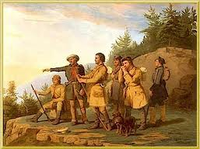The quiz will contain questions about the most significant/interesting news items presented in the last two weeks. The quiz is a group quiz. Students discuss their ideas with their group and select the answer to the question. I emphasize the key phrases in the question to help the students (ie: **what country**). Included with the quiz, but scored as a “Reading” grade, will be questions on the short stories we have been reading.

**Exploration of the AMericas**

Most of the week will be spent working on the diary or journal entry(ies). The “paper” that students will be writing is a 2-3 day vivid diary entry from a fictional member of the exploration team. The diary needs to have historically accurate details and description and not just a telling (list) of generic events that could apply to any time period.

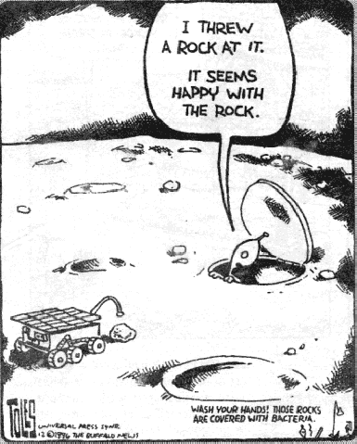Please review the research paper guidelines that were distributed to students or access it online at my HISTORY web page.

♠

Planner **November 11 - 17**

|  |  |  |  |  |  |  |
| --- | --- | --- | --- | --- | --- | --- |
|  | **Monday 11/11** | **Tuesday 11/12** | **Wednesday 11/13** | **Thursday 11/14** | **Friday**  **11/15** | **Weekend 11/16-17** |
| **Writing**  **Veterans Day**  (Language Arts) |  | **Detective Story**  -creating the middle paragraphs of the rising action that provide additional background information, use various literary techniques, develop the characters further, clues, and tension-first draft  **Analogies**  -determining the relationship | **Vocab #5 Quiz [11/14]**  -regular = fill-in-the-blank sentences  -W3 = stems & mystery questions  **Analogies**  -practice  **Middle Rising Action**  -draft shared in small table groups & students edit & revise based on feedback [11/13]  -middle rising action due **beginning** of class [**11/14**]  -written: first draft as well as an edited and revised version of the middle paragraphs of the rising action that provide additional background information, use various literary techniques, develop the characters further, clues, and tension | | **Detective Story**  -creating the final paragraphs of the rising action that provide any critical background information, use various literary techniques, develop the characters further, clues, and bring the tension-toward the climax | **Vocabulary #6**  -words and work 11/18-19  *assignment due 11/22  -quiz **12/5**  **Detective Story**  -work time to draft the end of the rising action  *edited & revised draft of the end of the rising action due by 11/21 |
| **Reading** |  | **20’ Reading**  -student book of choice  -student meetings  **“The Purloined Letter” by Edgar Allan Poe**  -read aloud  -literary devices, elements of detective fiction, plot line, connections, etc. | **20’ Reading**  -student book of choice  -student meetings  **“The Purloined Letter” by Edgar Allan Poe**  -read aloud  -literary devices, elements of detective fiction, plot line, connections, etc. | | **Log/Project #3**  -due at **beginning** of class  -representing 250+ pages of reading (750+ pages total)  **“The Purloined Letter” by Edgar Allan Poe**  -read aloud  -literary devices, elements of detective fiction, plot line, connections, etc. | **“The Avenging Chance” by Anthony Berkeley [Cox]**  -read aloud  -class review & discussion  **Reading Log/Project #4**  *due 12/6 representing 250+ pages of reading (for a total of 1000 pages) |
| **History**  **(Social Studies)** |  | **Current Event #5**  -make-up & missing presentations 11/12  **Exploration of the Americas**  -time to write | **Current Event #5**  -review 11/13  **Exploration of the Americas**  *draft of two days (or two-thirds) of the diary/journal [11/13]  -share in small table groups  -edit and revise based on feedback | | **Current Event #5 Quiz**  -group quiz  -individual & group short story quiz aspects (reading grade) | **Current Event #6**  -presentations 11/18-22  -make-up & missing presentations **12/2**  -individual quiz 12/6  **Exploration of the Americas**  -time to write the diary/journal  *finalized diary/journal 11/19 |
| **Other**  Contact Information for Binder  **da Vinci:** 503-916-5356 ext 79140 **Home**: 503-640-5265  voicemail: 503-916-3600 ext 79140  email: [pbinder@pps.net](mailto:pbinder@pps.net)  **WEB PAGE** <http://733257565503770808.weebly.com/> | **no school** | Leo Leader lunch | **Periods 1-7**  **Chloe Wright**’s birthday  **Drama Pull-Out** | **Periods 1-7** | **“I Ain’t Got No Home”** 7:00pm @ da Vinci | 11/16 **“I Ain’t Got No Home”** 7:00pm  11/18 BSU 3:30-4:30pm  11/20 QSA 3-4:30pm  11/21 **Conferences** 4-8:00pm  11/22-23 **“I Ain’t Got No Home”** 7:00pm  11/25 **Conferences** 8:00am-8:00pm  11/26 **Conferences** 8:00am-4:00pm |