******Binder Core: 11/4/2013**

**Quarter’s End**

The 1st quarter ends Thursday (11/7). Last Friday (11/1) was the last day for late or missing work. I will not accept work after that. If a student is or has been significantly absent, please communicate with me to arrange an extension or alternatives. Friday (11/8), is a teacher work day to finish grades—students do not have classes.



**Grades**

I have received a lot of emails, phone calls, and other communications regarding grades. Allow me a little time and space to offer global comments.

My first recommendation is to have a conversation with your student(s). Communication with a middle-school student can be difficult (to put it mildly). It is the best starting point. I ask the students to do the same thing—communicate with the parents. Going around people, asking not to tell “so-and-so”, and other tactics do not support good communication. Please do not ask me to do something I would not do with my children. Communicate…communicate…communicate. If at first you do not succeed, try again, but use a different approach.

My second recommendation is to use Synergy. I spend a lot of time entering grades and comments in a timely manner. Please read the assignment description (the narrative explaining the assignment) and any comments I entered regarding the assignment of the student. In most cases, if the grade is 79% or below I enter specific comments about the student’s performance. If the assignment was a multiple-choice quiz, however, I just enter the score. There is little comment necessary.

Synergy will provide a sensible and appropriate snapshot of the student’s grade. At the beginning of a new grading period it is a little skewed, however, owing to the lack of assignments. A poor performance on one of the two assignments at the beginning of the grading period will have a large influence on the grade at the time. If you do not have access to Synergy, check with the office for instructions on how to access the system.

Third, and final suggestion, is to communicate with me. Please do your homework before contacting me (the first and second recommendations) so that we can discuss grades from an enlightened position. You will have to complete the first two steps anyways, so you might as well get them over with before communicating with me.

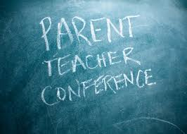I have met and had fantastic conversations with a good number of parents and students in the past several weeks. It is wonderful to sit down and make sure everyone is on the same page and to hash out any issues. Please let me know if you would like to have a conversation, but please do so sooner than later. My schedule is a bit hectic and I want to work with you to schedule meaningful time together.

**Conferences**

[repeated until conferences]

If you missed the PTSA meeting last Thursday (10/17) then you did not get first crack at signing up for a conference. Parent and teacher conferences are:

* Thursday, Nov. **21**st from 4pm-8pm
* Monday, Nov. **25**th from 8am-8pm
* Tuesday, Nov. **26**st from 8am-4pm

Please call the **da Vinci front office** (503-916-5356) to schedule a conference. I do not have the conference sign-up sheets, nor do I know which slots are available. It is easier and better for the front office to handle the conference scheduling. I am sure I would mess up my schedule somehow.

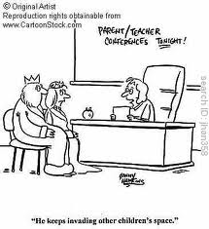There are a few notes regarding the scheduling of conferences. If you have met with me once or several times prior to conferences you might want to consider whether you need more face time. I am not trying to dissuade you, merely asking you to reflect on the limited time available for conferences and whether someone else could use the time with me.

Additionally, if your student is doing very well you might want to reflect on needing time with me. I love my overachieving and brilliant students. They deserve lots of compliments. All students deserve lots of compliments. If, however, you are only coming in to get a pat on the back and a “good job” from me…another family might need that time.

Again, in either situation (prior meetings or successful student) I do not want to scare you off from a conference time. I love meeting with all families. I am just asking you to think about the purpose and intent of the time you want with me.

**Conference Preparation**

Please come ready to discuss specifics. I generally find myself spouting the same message—[insert your student’s name] needs to use his/her class time better, use his/her planner more effectively, read and follow the directions, and give him/herself enough time with the work to be successful. There…that part is done.

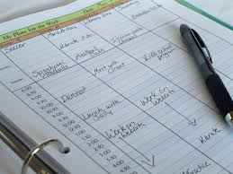Now what I want you to do is focus on an assignment, project, or aspect of the curriculum as related to your child’s educational, emotional, and social development. How comfortable are they with reading? Can they make an independent and age-appropriate choice? Can they summarize what they read? Can they make connections, inferences, analyze, synthesize, recognize use of a variety of literary devices, etc.? Do they know the parts of speech? Do they have a grasp of how words work together to create engaging and effective sentences? Can they write for a variety of purposes and audiences? Do they know how to read a textbook for information? Can they understand and relate the significance of a historical period? Do they know where places are in the world? Do they know their name?

The list can go on and on, but I think you get the point. Please come prepared with specific questions or you will get the generic experience instead of the individualized one. If you are unfamiliar with the work of your student or what we are doing in class then you have some homework before conferences. Ask your student about their work. Look it over with him/her to determine what s/he did well and what s/he needs to work on. Additionally, read the newsletters and handouts for assignments. Good luck…there will be a quiz.

♠



**Reading**

**Reading log #3**

[repeated]

Students are expected to average twenty or more minutes of reading each night. The goal is at least **ten** pages a day. It is not an unrealistic goal and it is something that has been discussed many times in class.

A good number of students were not able to meet the first or second installment of their reading log goal simply because they had not taken the time to read or because they did not complete the summary with full and honest effort (missing the author, two sentences to summarize two hundred pages of reading, etc.). Please help to provide a structured time and encouragement for students to meet this goal.

Thank you in advance for whatever you can do.

**Short Stories**

This week we will be reading “The Murders in the Rue Morgue” by Edgar Allan Poe. The story is posted to the “READING” page on my web site.

"**The Murders in the Rue Morgue**" is a short story by Edgar Allan Poe published in *Graham's Magazine* in 1841. It has been recognized as the first detective story; Poe referred to it as one of his "tales of ratiocination" (ra·ti·o·ci·na·tion. noun \-ˌō-sə-ˈnā-shən, -ˌnä-\. 1. : the process of exact thinking : reasoning. 2. : a reasoned train of thought). Two works that share some similarities predate Poe's stories, including *Das Fräulein von Scuderi* (1819) by E.T.A. Hoffmann and *Zadig* (1748) by Voltaire.

C. Auguste Dupin is a man in Paris who solves the mystery of the brutal murder of two women. Numerous witnesses heard a suspect, though no one agrees on what language was spoken. At the murder scene, Dupin finds a hair that does not appear to be human.

Writing the first true detective in fiction, Poe's Dupin originated many literary conventions which would be used in future fictional detectives including Sherlock Holmes and Hercule Poirot. Many later characters, for example, follow Poe's model of the brilliant detective, his personal friend who serves as narrator, and the final revelation being presented before the reasoning that leads up to it. Dupin himself reappears in "The Mystery of Marie Rogêt" and "The Purloined Letter". (*Wikipedia*)

The story does have a violent scene/graphic description of a murder. If you are at all concerned, please read it prior to the read aloud in the classroom. If you have significant reservations, please let me know and we can arrange an alternative.

♠

**

**Writing**

**Vocabulary #5**

We will be working on the newest vocabulary list on Monday and Tuesday (11/4-5). The assignment is due **Thursday** (11/9) at the beginning of class because there is no school on Friday. The quiz is next Thursday (11/14). The quiz will be a normal quiz—as far as normal goes.

The only change is for regular vocabulary students. I will no longer be collecting the lists. At this point students should have learned how to write the part of speech, definition, antonyms, and synonyms for the benefit of understanding. Students (in regular vocabulary) will, however, now have the choice between writing sentences or creating cartoons.

The sentence guidelines remain the same—spell and use the word correctly, mark it, and provide sufficient context. The cartoon guidelines are quite similar, but with a few minor exceptions. Students do need to spell and use the word correctly, but the “marking” is the vocabulary word as a title for the cartoon and the context can come visually or in written form (caption, dialogue bubbles, or labels).

The W3 assignments remain the same…sorry.

**Detective Story**

The saga continues. We have worked through the first eight of thirteen steps. Over the next couple of weeks we will be progressing into and through the others. Students have created the protagonist (their detective), antagonist (criminal), crime and setting, the solution, clues to embed in the story, a plot outline, and an exposition. Students will be creating the start of the rising action—the first 1/3 of the rising action plot line. A “finalized” version is due by Thursday of this week (11/7).

Almost all week we will be working on creating the initial rising action: the first several paragraphs of the rising action that provide background information, use various literary techniques, develop the characters, clues, and tension.

We will be working on:

1. Begin writing. Start with an introductory paragraph or two, to introduce the characters and setting. Then make the crime scene happen.
2. Introduce the suspects and witnesses. (eg. Annie entered the office. She was a tall woman with thin legs and hands. Her face looks like a diamond...). Be sure to give the reader a vivid picture of each one.
3. Build suspense. The more suspense you put, the more interesting the story will be. Make the protagonist get stuck in a couple of impossible-seeming situations and obstacles. Don't make the mystery too easy to solve!
4. Read some mystery books to get more ideas. There are plenty at your library, or if you are seriously taking up mystery writing, you should buy a good collection of mystery books.

♠

History

**Current Event #5**

Current event #5 presentations take place Monday through Thursday (11/4-7) this week. There is no school Friday (11/8) so Friday presenters can present any day this week, but must present by Thursday (11/7). Missing or make-up presentations will take place next Tuesday (11/12)—there is no school on Monday, November 11.

The group current event quiz is next Friday (11/15). The quiz will contain questions about the most significant/interesting news items presented in the last two weeks. Included with the quiz, but scored as a “Reading” grade, will be questions on the short stories we have been reading.

**Exploration of the AMericas**

Most of the week will be spent working on the beginning of the “paper” that students will be writing—a 2-3 day vivid diary entry from a fictional member of the exploration team. A draft of one day will be due next Wednesday (11/6).

Please review the research paper guidelines that were distributed to students or access it online at my HISTORY web page.

♠

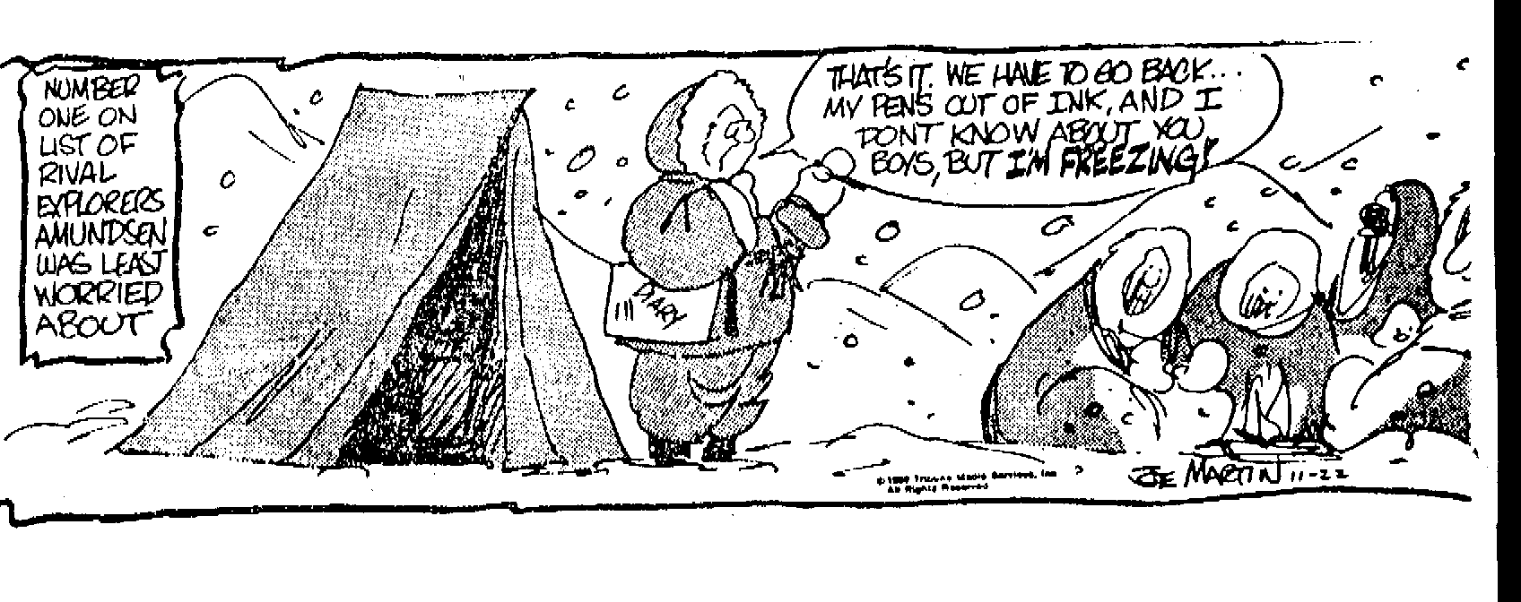

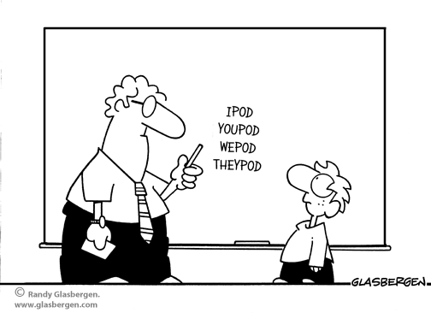

Planner **November 4 - 10**

|  |  |  |  |  |  |  |
| --- | --- | --- | --- | --- | --- | --- |
|  | **Monday 11/4** | **Tuesday 11/5** | **Wednesday 11/6** | **Thursday 11/7** | **Friday**  **11/8** | **Weekend 11/9-10** |
| **Writing**  (Language Arts) | **Vocabulary #5**  -regular = words #1-10  -W3 sentences  **POS: Nouns**  -focus on verb vs. noun  **Detective Story**  -creating the initial rising action: provide background information, use various literary techniques, develop the characters, clues, and tension  -first draft | **Vocabulary #5**  -regular = words #11-20  -W3 sentences & analogies  **Homophones**  -how POS clarifies the difference  **Detective Story**  -creating the initial rising action: provide background information, use various literary techniques, develop the characters, clues, and tension  -first draft | **\*vocab #5 assignment** [11/7]  -due **beginning** of class  -regular vocabulary = 5 sentences  -W3 = flashcards, sentences, & analogies  **Analogies**  -introduction and problem solving  **Initial Rising Action**  -first draft shared in small table groups…edit and revise based on feedback  -due **beginning** of class [11/7]  -written: first draft as well as an edited and revised version of the rising action that provide background information, use various literary techniques, develop the characters, clues, and tension | |  | **Vocabulary #5**  -quiz 11/14  **Detective Story**  -work time to draft the middle of the rising action  *edited & revised draft of the middle of the rising action due by 11/14 |
| **Reading** | **20’ Reading**  -student book of choice  -student meetings  **“The Murders in the Rue Morgue” by Edgar Allan Poe**  -read aloud  -literary devices, elements of detective fiction, plot line, connections, etc. | **20’ Reading**  -student book of choice  -student meetings  **“The Murders in the Rue Morgue” by Edgar Allan Poe**  -read aloud  -literary devices, elements of detective fiction, plot line, connections, etc. | **20’ Reading**  -student book of choice  -student meetings  **“The Murders in the Rue Morgue” by Edgar Allan Poe**  -read aloud  -literary devices, elements of detective fiction, plot line, connections, etc. | |  | **“The Purloined Letter” by Edgar Allan Poe**  -read aloud  -class review & discussion  **Reading Log #3**  *due 11/15 representing 250+ pages of reading (for a total of 750 pages) |
| **History**  **(Social Studies)** | **Current Event #5**  -News Shark (AM) & Wake Up da Vinci (PM)  -Galloping Pigz (AM) & Le Group de Friday (PM) presentations any day…but by 10117  **Exploration of the Americas**  -creating a fictionalized person and account of exploration | **Current Event #5**  -Jackson’s Harem (AM) & #Molivia (PM)  -Galloping Pigz (AM) & Le Group de Friday (PM) presentations any day…but by 11/7  **Exploration of the Americas**  -creating a fictionalized person and account of exploration | **Current Event #5**  -AZOJSS (AM) & Ginger Afros (PM) [11/6]  -Larry Zarry (AM) & Numm-Nummz (PM) [11/7]  -Galloping Pigz (AM) & Le Group de Friday (PM) presentations any day…but by 11/7  **Exploration of the Americas**  -creating a fictionalized person and account of exploration  **\*draft of one day (or one typed page)** [11/6]  -edit and revise with a partner | | **Grading Day** | **Current Event #5**  -make-up & missing presentations 11/12  -group quiz 11/15  **Exploration of the Americas**  -writing of the diary/journal  *draft of another day (or page) 11/13 |
| **Other**  Contact Information for Binder  **da Vinci:** 503-916-5356 ext 79140 **Home**: 503-640-5265  voicemail: 503-916-3600 ext 79140  email: [pbinder@pps.net](mailto:pbinder@pps.net)  **WEB PAGE** <http://733257565503770808.weebly.com/> | **Molly Jones**’s birthday |  | **Periods: 2, 4, 6, & FLEX** | **End of 1st Quarter**  **Periods 1, 3, 5, & 7** | teacher grading day—no students | 11/11 **Veterans’ Day** no school  11/13 drama pull-outs  11/15-16 ***I Ain’t Got No Home*** 7:00pm |