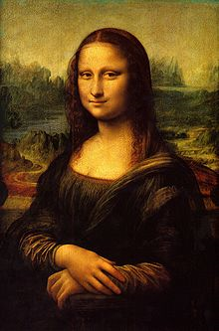**Binder Core: 10/21/2013**

**Conferences**

If you missed the PTSA meeting last Thursday (10/17) then you did not get first crack at signing up for a conference. Parent and teacher conferences are:

* Thursday, Nov. **21**st from 4pm-8pm
* Monday, Nov. **25**th from 8am-8pm
* Tuesday, Nov. **26**st from 8am-4pm

Please call the **da Vinci front office** (503-916-5356) to schedule a conference. I do not have the conference sign-up sheets, nor do I know which slots are available. It is easier and better for the front office to handle the conference scheduling. I am sure I would mess up my schedule somehow.

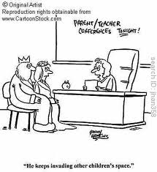There are a few notes regarding the scheduling of conferences. If you have met with me once or several times prior to conferences you might want to consider whether you need more face time. I am not trying to dissuade you, merely asking you to reflect on the limited time available for conferences and whether someone else could use the time with me.

Additionally, if your student is doing very well you might want to reflect on needing time with me. I love my overachieving and brilliant students. They deserve lots of compliments. All students deserve lots of compliments. If, however, you are only coming in to get a pat on the back and a “good job” from me…another family might need that time.

Again, in either situation (prior meetings or successful student) I do not want to scare you off from a conference time. I love meeting with all families. I am just asking you to think about the purpose and intent of the time you want with me.



**Conference Prep**

Please come ready to discuss specifics. I generally find myself spouting the same message—[insert your student’s name] needs to use his/her class time better, use his/her planner more effectively, read and follow the directions, and give him/herself enough time with the work to be successful. There…that part is done.

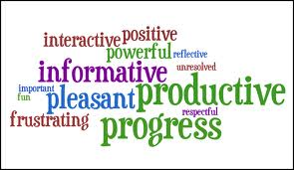Now what I want you to do is focus on an assignment, project, or aspect of the curriculum as related to your child’s educational, emotional, and social development. How comfortable are they with reading? Can they make an independent and age-appropriate choice? Can they summarize what they read? Can they make connections, inferences, analyze, synthesize, recognize use of a variety of literary devices, etc.? Do they know the parts of speech? Do they have a grasp of how words work together to create engaging and effective sentences? Can they write for a variety of purposes and audiences? Do they know how to read a textbook for information? Can they understand and relate the significance of a historical period? Do they know where places are in the world? Do they know their name?

The list can go on and on, but I think you get the point. Please come prepared with specific questions or you will get the generic experience instead of the individualized one. If you are unfamiliar with the work of your student or what we are doing in class then you have some homework before conferences. Ask your student about their work. Look it over with him/her to determine what s/he did well and what s/he needs to work on. Additionally, read the newsletters and handouts for assignments. Good luck…there will be a quiz.

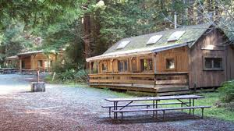**Outdoor School**

I will be with the 6th graders at Outdoor School from Sunday through Tuesday (October 20-22). I will be unavailable for questions while at Outdoor School as my time and attention are required by the staff, students, and site needs. It is our third time with the abbreviated Outdoor School program—and, hopefully, it continues to be as important, educational, and as pivotal of an event that it has in the past.

6th graders have a few postponed or abbreviated assignments this week **if** they are attending Outdoor School. Those not attending Outdoor School are required to attend school.

1. **vocabulary #4 assignment** students will be given a printed list. On Wednesday we will go over antonyms and synonyms for each word. Students will be given work time on Wednesday, and the list and sentences are due on Friday (10/25).
2. **reading response #2** will be discussed and started early in the week (Monday & Tuesday 10/15-16). Students should have time to complete and submit the assignment before going to Outdoor School, but if they are running short of time they can submit it by the beginning of class next Tuesday (10/24).
3. **current event #4 presentation** will be excused for students who go to Outdoor School—they do not have to complete one. Students can, if they desire, complete one to make up for a low score on a current event or they should complete one to make up a missing current event.
4. **bibliography cards & note cards**—students will be given until Friday to complete the research assignment. If students can complete and submit the assignment prior to Outdoor School it would make everyone’s life much easier.

♠

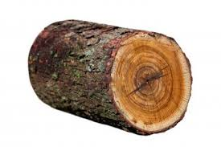

**Reading**

**Reading log #3**

Students are expected to average twenty or more minutes of reading each night. The goal is at least **ten** pages a day. It is not an unrealistic goal and it is something that has been discussed many times in class.

A good number of students were not able to meet the first or second installment of their reading log goal simply because they had not taken the time to read or because they did not complete the summary with full and honest effort (missing the author, two sentences to summarize two hundred pages of reading, etc.). Please help to provide a structured time and encouragement for students to meet this goal.

Thank you in advance for whatever you can do.

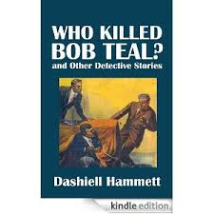**Short Stories**

Okay, this week we will be reading “Who Killed Bob Teal” by Dashiell Hammett. The story is posted to the “READING” page on my web site.

Dashiell Hammett first submitted “Who Killed Bob Teal?” to Black Mask, but the editor rejected it, along with another story, “Women, Politics, and Murder.” Hammett famously — if somewhat disingenuously — apologized for these sub-par efforts in a letter to the editor (Black Mask, August 1924):

*. . . this sleuth of mine has degenerated into a meal ticket. I liked him at first and used to enjoy putting him through his tricks; but recently I’ve fallen into the habit of bringing him out and running him around whenever the landlord, or the butcher, or the grocer shows signs of nervousness.*

*There are men who can write like that, but I am not one of them. If I stick to the stuff I want to write — the stuff I enjoy writing —I can make a go of it, but when I try to grind out a yarn because I think there is a market for it, I flop.*

*Whenever, from now on, I get hold of a story that fits my sleuth, I shall put him to work, but I’m through with trying to run him on a schedule.*



He declined to revise and resubmit the two stories to Black Mask (“neither is worth the trouble”); however, something changed the editor’s mind about “Women, Politics, and Murder,” because it was published the following month.

Hammett didn’t just stick “Who Killed Bob Teal?” in a drawer and forget about it. Instead he sent it to True Detective Mysteries, who soon published it in their November 1924 issue; one can assume they were thrilled to get a Hammett story, even if it was a reject from Black Mask.

Given the name of the pulp, however, they tried to create the fiction that the tale was a true story from Hammett’s time as a private investigator — the title page credits the story to “Dashiell Hammett of the Continental Detective Agency”.

The title character, Bob Teal, was a young detective who had appeared previously in two tales, “Slippery Fingers” and “Zigzags of Treachery.” As the story opens, the Old Man informs the detectives that “Teal was killed last night.” While not among the top tier of detective stories, “Who Killed Bob Teal?” is significant because Hammett tries out an idea that he would re-use, to better effect, in *The Maltese Falcon*.

♠

**Writing**

**Vocabulary #4**

Vocabulary students should review for **five minutes each day**. Studying can be done on the bus, in carpool, before or after school, or just about any time that five minutes can be squeezed into a busy day. Rote memorization is terrific, but it is the application and adoption of the words that matters the most. Please review old quizzes to help guide future study.

Vocabulary #4 begins this week and the assignment is due at the beginning of class on Friday (10/25).



**Detective Story**

We are continuing the process of writing our first significant piece, a detective story. We have worked through the first two, of thirteen steps over the next couple of weeks. Students have created the protagonist (their detective), antagonist (criminal), crime and setting. Additionally, they will have finalized the solution and the clues by Thursday of this week (10/24).

We will be working on how the crime is solved and the clues that will be embedded in the story this week. The pace and scaffolding provides students time and space to mentally edit, revise, and evaluate their initial story ideas before writing and developing their stories.

We will be working on:

1. Think of a plot and a mystery.
   1. Use Who? What? When? Where? Why? How? questions to get you started: Who committed the crime and who did they do it to? What was the crime? When did it happen (morning, evening, afternoon, dead of night)? Where did it happen? Why did they do it? How did they do it?
   2. Use this skeleton to more fully sketch out a summary of your plot, with as many details as you can think of at this point. By now, plot ideas will be boiling around in your brain. Don't even worry about putting them in order, just WRITE THEM DOWN somewhere so that you don't forget them later!
2. Think about the crime scene. This is an especially important part of your story, so take the time to really develop it fully. Try and describe every single detail so the reader can picture the crime scene. What does it look like? Is it different in day and in night? What are the differences between the first and the second crime scene? What are all of the details of the crime? You may want to write out a first draft of this scene so that you get the basic idea.
3. Make an antagonist. Go back and look at the questions you did for the protagonist, and develop their personality as fully. Especially think about their relationship to the protagonist.
4. Think deeply about the mystery, suspects, antagonist, etc. Make sure you have all of your ducks in a row before you begin writing.
   1. Make a list of the suspects. Detail their basic personality, using some of the questions in step 1.
   2. Do the same for witnesses and any other characters.
   3. Be sure to have in mind how the mystery is solved!
5. Think of the type of the detective work. The detective work must be good. Develop how your protagonist ultimately solves the case, keeping their personality and qualities in mind. Make sure it isn't cheesy or too obvious.

♠

History

**Current Event #4**

[some repeated]

Current event #4 presentations will be from Monday (10/21) through Friday (10/25) this week. Missing or make-up presentations will take place next Monday (10/28). The individual current event quiz is next Friday (11/1).

The quiz will contain questions about the most significant/interesting news items presented in the last two weeks. The quiz is multiple choice. Students read and select the answer to the question. I bold the key phrases in the question to help the students (ie: **what country**). Included with the quiz, but scored as a “Reading” grade, will be questions on the short stories we have been reading.

Students are doing very well with the presentations, but their understanding and summarization of the news item needs a little work. If you want to help…have the student practice the presentation. See if you can understand the news item and ask them questions to hone their comprehension of the event. You might even be able to provide a little background knowledge that your student can use in the presenation. 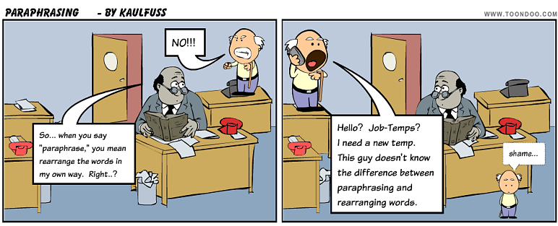

Another area that needs help is paraphrasing. Students can copy the “who, when, and where” directly from the article. It is fairly impossible to restate Portland, Oregon in any other comprehensible way. The “what”, however, needs to be in the words of the student. This aspect is not going well. Simply rearranging the words or substituting one word is not using one’s own form of expression. It is still plagiarism.

I have been highlighting, underlining, circling, etc. the offending “paraphrasing” and lines from the actual article. I have had a lot of individual and class conversations. I reinforce, reteach, and offer my services to help summarize the article in one’s authentic phrasing. After this, students will receive a “0” for the summary. Plagiarism is not allowed.

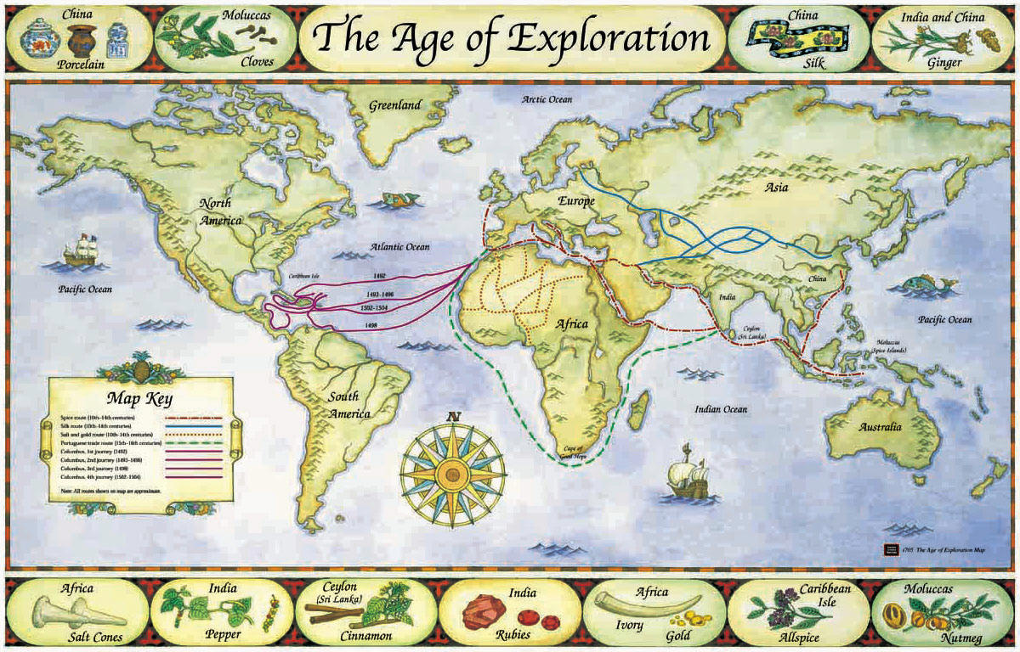You can help by working with the student and checking their wording. I have even added a “quote” portion to the assignment for students to properly attribute credit and use a particulary well-worded sentence or statement. I do take this seriously and students do have class time to complete this work, but ask to see their summary if you have concerns or questions.

**Exploration of the AMericas**

Most of the week will be spent researching. Students need to bring in research materials to help supplement our meager library stock and computer access. Students do need a variety of sources—reference books, online resources, and other print media. Students are required to have a minimum of 5 bibliography sources of at least three different types. Students should also be taking categorized notes about their explorer.

Please review the research paper guidelines that were distributed to students or access it online at my HISTORY web page.

♠

Planner **October 21- 27**

|  |  |  |  |  |  |  |
| --- | --- | --- | --- | --- | --- | --- |
|  | **Monday 10/21** | **Tuesday 10/22** | **Wednesday 10/23** | **Thursday 10/24** | **Friday**  **10/25** | **Weekend 10/26-27** |
| **Writing**  (Language Arts) | **Vocabulary #4**  -regular = words #1-10  -W3 sentences  **Detective Story**  -creating the solution & clues  -written and dimensional form integrating both | **Vocabulary #4**  -regular = words #11-20  -W3 sentences  **Detective Story**  -creating the solution & clues  -written and dimensional form integrating both | **Detective Story**  -creating the solution & clues  -written and dimensional form integrating both  **Solution & Clues**  -due **beginning** of class [10/24]  -written: narrative of the solution and list of the clues and how they will be revealed (obvious & subtle)  -dimensional representation: shoe-box diorama, 2D rendering, 3D animated composition, etc. | | **\*vocab #4 assignment**  -due **beginning** of class  -regular vocab = list & 5 sentences  -W3 = flashcards, sentences, & analogies  **Detective Story**  -starting to put the pieces together  -drafting the exposition | **Vocabulary #4**  -words & work 10/21-25  *assignment due 10/25  -***slightly larger quiz*** 10/31  **Detective Story**  -work time to draft the exposition  *edited & revised draft of exposition due by 10/31 |
| **Reading** | **20’ Reading**  -student book of choice  -student meetings | **20’ Reading**  -student book of choice  -student meetings | **20’ Reading**  -student book of choice  -student meetings | | **20’ Reading**  -student book of choice  -student meetings  **Novel Share v2**  -share a good novel you have, are, or want to read | **“One Hour” by Dashiell Hammett**  -read aloud  -class review & discussion  **Reading Log #3**  *due 11/15 representing 250+ pages of reading (for a total of 750 pages) |
| **History**  **(Social Studies)** | **Current Event #4**  -News Shark (AM) & Wake Up da Vinci (PM)  **Exploration of the Americas**  -research | **Current Event #4**  -Jackson’s Harem (AM) & #Molivia (PM)  **Exploration of the Americas**  -research | **Current Event #4**  -AZOJSS (AM) & Ginger Afros (PM) [10/23]  -Larry Zarry (AM) & Numm-Nummz (PM) [10/24]  **Exploration of the Americas**  -research time  **\*3 bibliography cards** and **15 note cards**[10/16]  -each bibliography card must be from a different type of source (internet, reference book , book, magazine, etc.) | | **Current Event #4**  -Galloping Pigz (AM) & Le Group de Friday (PM)  **Exploration of the Americas**  -research time | **Current Event #4**  -make-up & missing presentations 10/28  -individual quiz 11/1  **Exploration of the Americas**  -research  *35 note “cards” 10/30 |
| **Other**  Contact Information for Binder  **da Vinci:** 503-916-5356 ext 79140 **Home**: 503-640-5265  voicemail: 503-916-3600 ext 79140  email: [pbinder@pps.net](mailto:pbinder@pps.net)  **WEB PAGE** <http://733257565503770808.weebly.com/> | **Outdoor School**  **BSU** 3:00-4:00 | **Outdoor School**  Leo Leader lunch | **Periods: 2, 4, 6, & FLEX** | **Dana Pearson**’s birthday  **Periods 1, 3, 5, & 7** |  | 10/26 **Johnathan Price**’s birthday  10/30 **Spooky** Talent Show during FLEX  11/11 **Veterans’ Day** no school |