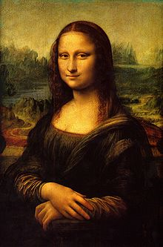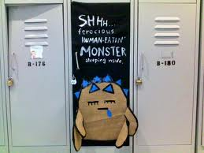**Binder Core: 10/14/2013**

**Lockers**

Thank you so much to all who helped with the locker decoration event. Many of you helped in front of and behind the scenes. It was a rousing success and it continues to get better every year. I am continually amazed at the multiplicity of ideas and mediums students use to adorn their home-away-from-home. As you stroll the halls, please take a minute—not to smell the roses—but to take in the expression of individuality that pervades our hallways.

Students who were not able to finish in the time provided are more than welcome to work on their locker after school or during late start days with **responsible adult supervision**. The adult is not a teacher in their classroom, but an adult who is right their with the child. The adult needs to supervise the decorating and clean-up process…as well as making sure the bathroom or sink used to help the clean-up process is, in fact, left in good condition.

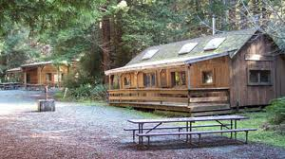**Outdoor School**

I will be with the 6th graders at Outdoor School from Sunday through Tuesday (October 20-22). I will be unavailable for questions while at Outdoor School as my time and attention are required by the staff, students, and site needs. It is our third time with the abbreviated Outdoor School program—and, hopefully, it continues to be as important, educational, and as pivotal of an event that it has in the past.

6th graders have a few postponed or abbreviated assignments next week **if** they are attending Outdoor School. Those not attending Outdoor School are required to attend school.

1. **vocabulary #4 assignment** students will be given a printed list. On Wednesday we will go over antonyms and synonyms for each word. Students will be given work time on Wednesday, and the list and sentences are due on Friday (10/25).
2. **Solution & Clues** will have been discussed and started in the previous week (Thursday & Friday 10/17-18). Students should have time to complete and submit the assignment Wednesday and Thursday after going to Outdoor School, but if they are running short of time they can submit it by the beginning of class Friday (10/25).
3. **current event #4 presentation** will be excused for students who go to Outdoor School—they do not have to complete one. Students can, if they desire, complete one to make up for a low score on a current event or they should complete one to make up a missing current event.
4. **bibliography cards & note cards**—students will be given until Friday (10/25) to complete the research assignment. If students can complete and submit the assignment prior to Outdoor School it would make everyone’s life much easier.

**Breathing Room**

The year began at a somewhat frantic pace. We had a small project and a larger test in the first month (My Summer Movie Poster and Geography of the Americas). Students and staff tackled a difficult schedule… many are still trying to figure out the block periods. Locker decorating, Outdoor School on the horizon, new electronic hazards (email and online gradebook) and the middle of October witnesses a somewhat haggard da Vinci populace. Fear not! A little breathing room has opened along the horizon.

The pace, pacing, and pressure will abate. We will stretch, breathe, and settle in to our curriculum. Students who continue to struggle should sign up for “Binder Time.” I have been holding meetings with each student, but often that is not enough. Many students will be challenged to perform above their current level, but it should be done with support and encouragement.

♠



**Reading**

**Reading log #3**

Students are expected to average twenty or more minutes of reading each night. The goal is at least **ten** pages a day. It is not an unrealistic goal and it is something that has been discussed many times in class.

A good number of students were not able to meet the first or second installment of their reading log goal simply because they had not taken the time to read or because they did not complete the summary with full and honest effort (missing the author, two sentences to summarize two hundred pages of reading, etc.). Please help to provide a structured time and encouragement for students to meet this goal.

Thank you in advance for whatever you can do.

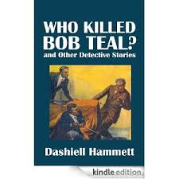**Short Stories**

This week we will be reading “Who Killed Bob Teal” by Dashiell Hammett. The story is posted to the “READING” page on my web site.

Dashiell Hammett first submitted “Who Killed Bob Teal?” to Black Mask, but the editor rejected it, along with another story, “Women, Politics, and Murder.” Hammett famously — if somewhat disingenuously — apologized for these sub-par efforts in a letter to the editor (Black Mask, August 1924):

*. . . this sleuth of mine has degenerated into a meal ticket. I liked him at first and used to enjoy putting him through his tricks; but recently I’ve fallen into the habit of bringing him out and running him around whenever the landlord, or the butcher, or the grocer shows signs of nervousness.*

*There are men who can write like that, but I am not one of them. If I stick to the stuff I want to write — the stuff I enjoy writing —I can make a go of it, but when I try to grind out a yarn because I think there is a market for it, I flop.*

*Whenever, from now on, I get hold of a story that fits my sleuth, I shall put him to work, but I’m through with trying to run him on a schedule.*



He declined to revise and resubmit the two stories to Black Mask (“neither is worth the trouble”); however, something changed the editor’s mind about “Women, Politics, and Murder,” because it was published the following month.

Hammett didn’t just stick “Who Killed Bob Teal?” in a drawer and forget about it. Instead he sent it to True Detective Mysteries, who soon published it in their November 1924 issue; one can assume they were thrilled to get a Hammett story, even if it was a reject from Black Mask.

Given the name of the pulp, however, they tried to create the fiction that the tale was a true story from Hammett’s time as a private investigator — the title page credits the story to “Dashiell Hammett of the Continental Detective Agency”.

The title character, Bob Teal, was a young detective who had appeared previously in two tales, “Slippery Fingers” and “Zigzags of Treachery.” As the story opens, the Old Man informs the detectives that “Teal was killed last night.” While not among the top tier of detective stories, “Who Killed Bob Teal?” is significant because Hammett tries out an idea that he would re-use, to better effect, in *The Maltese Falcon*.

♠

**Writing**

**Vocabulary #3**

Vocabulary students should review for **five minutes each day**. Studying can be done on the bus, in carpool, before or after school, or just about any time that five minutes can be squeezed into a busy day.

The vocabulary #3 quiz is on Thursday (10/17). The quiz dates are in the year-long syllabus, each quiz is listed and discussed in the newsletter and planner page, quiz dates are posted on the ginormous orange calendar in the room, and we talk about the upcoming quizzes during and at the end of each class. I was, therefore, a bit shocked by how few of the students seemed unprepared for vocabulary #2 quiz. Many commented, “I forgot to study.”

**Detective Story**

We are continuing the process of writing our first significant piece, a detective story. We have worked through the first two, of thirteen steps over the next couple of weeks. Students have created the protagonist (their detective) and antagonist (criminal). Additionally, they will have finalized the crime and the setting by Thursd of this week (10/17).

We will be working on how the crime is solved and the clues that will be embedded in the story this week. The pace and scaffolding provides students time and space to mentally edit, revise, and evaluate their initial story ideas before writing and developing their stories.

We will be working on:

1. Think of a plot and a mystery.
   1. Use Who? What? When? Where? Why? How? questions to get you started: Who committed the crime and who did they do it to? What was the crime? When did it happen (morning, evening, afternoon, dead of night)? Where did it happen? Why did they do it? How did they do it?
   2. Use this skeleton to more fully sketch out a summary of your plot, with as many details as you can think of at this point. By now, plot ideas will be boiling around in your brain. Don't even worry about putting them in order, just WRITE THEM DOWN somewhere so that you don't forget them later!
2. Think about the crime scene. This is an especially important part of your story, so take the time to really develop it fully. Try and describe every single detail so the reader can picture the crime scene. What does it look like? Is it different in day and in night? What are the differences between the first and the second crime scene? What are all of the details of the crime? You may want to write out a first draft of this scene so that you get the basic idea.
3. Make an antagonist. Go back and look at the questions you did for the protagonist, and develop their personality as fully. Especially think about their relationship to the protagonist.
4. Think deeply about the mystery, suspects, antagonist, etc. Make sure you have all of your ducks in a row before you begin writing.
   1. Make a list of the suspects. Detail their basic personality, using some of the questions in step 1.
   2. Do the same for witnesses and any other characters.
   3. Be sure to have in mind how the mystery is solved!
5. Think of the type of the detective work. The detective work must be good. Develop how your protagonist ultimately solves the case, keeping their personality and qualities in mind. Make sure it isn't cheesy or too obvious.

**

♠

History

**Current Event #3**

[some repeated]

All missing or make-up current event #3 presentations will take place Monday (10/14).

Students are doing very well with the presentations, but their understanding and summarization of the news item needs a little work. If you want to help…have the student practice the presentation. See if you can understand the news item and ask them questions to hone their comprehension of the event. You might even be able to provide a little background knowledge that your student can use in the presenation.

Another area that needs help is paraphrasing. Students can copy the “who, when, and where” directly from the article. It is fairly impossible to restate Portland, Oregon in any other comprehensible way. The “what”, however, needs to be in the words of the student. This aspect is not going well. Simply rearranging the words or substituting one word is not using one’s own form of expression. It is still plagiarism.

I have been highlighting, underlining, circling, etc. the offending “paraphrasing” and lines from the actual article. I have had a lot of individual and class conversations. I reinforce, reteach, and offer my services to help summarize the article in one’s authentic phrasing. After this, students will receive a “0” for the summary. Plagiarism is not allowed.

You can help by working with the student and checking their wording. I have even added a “quote” portion to the assignment for students to properly attribute credit and use a particulary well-worded sentence or statement. I do take this seriously and students do have class time to complete this work, but ask to see their summary if you have concerns or questions.

The group current event quiz is Friday (10/18). The quiz will contain questions about the most significant/interesting news items presented in the last two weeks and the most recent short stories. Groups quietly and discretely discuss their answer before determining the best choice to write on their answer sheet. Students need to pay attention to the current event presentations as well as the updates and review of the current events in order to be successful. If nothing else, students should be reading, watching, and/or listening to the news on a daily basis.

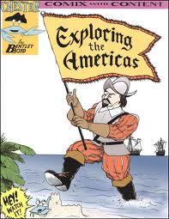**Exploration of the AMericas**

[some repeated]

Students learn how to do a formal research paper once in the three-year cycle. This is that once in a three-year cycle time. We will be spending most of the rest of the quarter and part of the next working on the project. I will introduce the project and go over due dates. Students should have chosen an explorer of the Americas by the end of class last Wednesday (10/9).

I will be teaching students the process of a research paper, but the end result will be something else entirely. Next week we will focus on the basics…I will teach them how to find information in various sources (print and electronic) and how to credit that source for the information gathered. Later in the week students will learn how to take notes and organize it within categories.

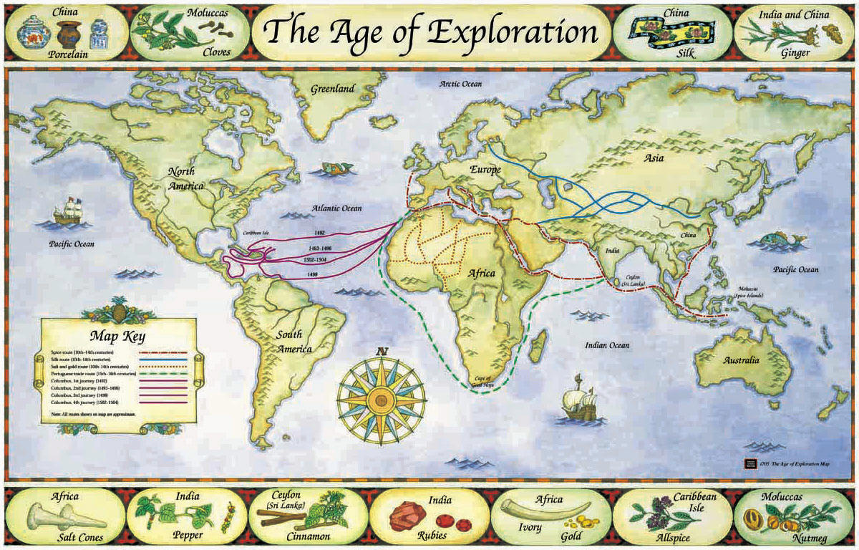Most of the week will be spent researching. Students need to bring in research materials to help supplement our meager library stock and computer access. Students do need a variety of sources—reference books, online resources, and other print media. Students are required to have a minimum of 5 bibliography sources of at least three different types. Please review the research paper guidelines that were distributed to students or access it online at my HISTORY web page.

♠

**Classroom Items Needed**

**MOST IN NEED OF:**

* Anti-bacterial countertop wipes (*Lysol* brand)
* Colored pencils - IN DESPERATE NEED OF THESE
* Colored printer paper *(regular stock and card stock)*
* Markers - THIN & THICK - DESPERATE NEED
* Rubber cement *(lots of art projects each year)*
* Black Fine or Pinpoint felt markers
* *Kleenex* tissue

**OTHER ITEMS WE USE & NEED** (not in any particular order):

* Metal hand held pencil sharpeners
* AA & AAA batteries
* College ruled loose leaf paper
* Card stock weight paper (various colors)
* Calligraphy pens/makers
* Word games (*Scrabble* isn't the only one out there. How about: FUNGLISH, PICTUREKA, BUZZ WORD, IN A PICKLE, LAST WORD, IMAGINE IF, MAD GAB, TABOO)
* Playground equipment: basketball, football, rubber 4-Square balls, hoola-hoops, soccer ball, sidewalk chalk, foxtails, large size kickball, beach balls
* Brita water filters—including the replacement filters
* Any technology
* Other?

Planner **October 14- 20**

|  |  |  |  |  |  |  |
| --- | --- | --- | --- | --- | --- | --- |
|  | **Monday 10/14** | **Tuesday 10/15** | **Wednesday 10/16** | **Thursday 10/17** | **Friday**  **10/18** | **Weekend 10/19-20** |
| **Writing**  (Language Arts) | **Detective Story**  -creating the crime & setting  -written and dimensional form integrating both | **Vocabulary #3**  -review time?  **Detective Story**  -creating the crime & setting  -written and dimensional form integrating both | **Vocab #3 Quiz [10/17]**  -regular = fill-in-the-blank sentences  -W3 = stems & mystery questions  **Crime & Setting**  -due **beginning** of class [10/17]  -written: narrative of the crime and spatial relationship of the setting(s)  -dimensional representation: shoe-box diorama, 2D rendering, 3D animated composition, etc. | | **Detective Story**  -creating the solution & clues  -written and dimensional form integrating both | **Vocabulary #4**  -words & work 10/21-25  *assignment due 10/25  -***slightly larger quiz*** 10/31  **Detective Story**  -work time to create the solution for the crime & clues to embed in the story  *solution & clues finalized by 10/24 |
| **Reading** | **20’ Reading**  -student book of choice  -student meetings  **“Who Killed Bob Teal” by Dashiell Hammett**  -read aloud  -literary devices, elements of detective fiction, plot line, connections, etc. | **20’ Reading**  -student book of choice  -student meetings  **“Who Killed Bob Teal” by Dashiell Hammett**  -read aloud  -literary devices, elements of detective fiction, plot line, connections, etc. | **20’ Reading**  -student book of choice  -student meetings  **“Who Killed Bob Teal” by Dashiell Hammett**  -read aloud  -watch the “Alfred Hitchcock Presents” episode  -literary devices, elements of detective fiction, plot line, connections, etc. | | **20’ Reading**  -student book of choice  -student meetings  **Log/Project #2**  -due at **beginning** of class  -representing 250+ pages of reading (for a total of 500 pages thus far) | **“One Hour” by Dashiell Hammett**  -read aloud  -class review & discussion  **Reading Log #3**  *due 11/15 representing 250+ pages of reading (for a total of 750 pages) |
| **History**  **(Social Studies)** | **Current Event #3**  -make-up & missing presentations  **Exploration of the Americas**  -research | **Current Event #3**  -update, new, & review  **Exploration of the Americas**  -research | **Exploration of the Americas**  -research time  **\*2 bibliography cards** [10/16]  -each bibliography card must be from a different type of source (internet, reference book , book, magazine, etc.) | | **Current Event #3 Quiz**  -group quiz  -includes questions on short stories (“Who Killed Bob Teal” & “The Hands of Mr. Ottermole”) | **Current Event #4**  -presentations 10/21-25  -make-up & missing presentations 10/28  -individual quiz 11/1  **Exploration of the Americas**  -research  *3 bibliography “cards” & 15 note “cards” 10/23  *35 note “cards” 10/30 |
| **Other**  Contact Information for Binder  **da Vinci:** 503-916-5356 ext 79140 **Home**: 503-640-5265  voicemail: 503-916-3600 ext 79140  email: [pbinder@pps.net](mailto:pbinder@pps.net)  **WEB PAGE** <http://733257565503770808.weebly.com/> |  | **Oscar Harold**’s birthday | **Solstice**’s birthday  **Mackenzie King**’s birthday  **late opening** at 10:15 & **periods: 2, 4, & 6**  **QSA** 3:00-4:30pm | **Periods 1, 3, 5, & 7**  **PTSA** 7:00-8:30pm |  | 10/19 **Wrigley Kline**’s birthday  10/20-22 **Outdoor School** for 6th graders |