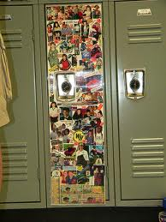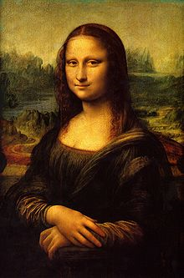**Binder Core: 10/07/2013**

**Lockers**

Locker decorating takes place this week. Locker decorating is a chance for students to make a statement and to express who they are for the school year. Students who do not wish to decorate their lockers will be part of “school beautification teams” roaming the halls and grounds and making our environment a better place.

On Wednesday (10/9) students will use the “FLEX” period (1:15ish-2:30) to start the adornment process. Students should change into old clothing, remove all items and their lock from their locker, and store the items in their Core class. Even if a student is not ornamenting his/her locker…neighbors are. Paint, glue, etc. can and does penetrate the small air vents and gaps around the door and neighboring doors. No one wants their purse, backpack, books, dance pants, etc. altered with a viscous or colorful fluid.

Ideally, those who will be decorating will have their lockers primed before Wednesday. The remaining time from 2:30-2:45 will be for cleaning. The 1st and 3rd floors will have paper on the floors to help keep the floors from being ornamented. The paper will remain in place until Thursday (10/10) when the process will continue. From 8:15-9:00 students will finalize their lockers. Again, students should keep any/all items in their Core room while decorating. From 9:00-9:15 students will clean, remove the “drop-paper,” and transition to their first period class.

The school is **not providing** any supplies. A few needed supplies to keep in mind

1. **old clothing**—nothing too shredded, but nothing that is newer or irreplaceable
2. **supplies**—pencils (for sketching/outlining the design), brushes in a variety of sizes, rigid containers for paint, glue, palette, etc.
3. **cleaning supplies**—mainly older rags to clean brushes, wipe off mistakes, etc.
4. 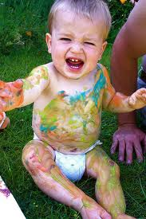**clear vision**—students have submitted a locker decorating diagram, but a clear idea and step-by-step process of how to accomplish the decorating are critical

Students who are not able to finish in the time provided are more than welcome to work on their locker after school or during late start days with **responsible adult supervision**. The adult is not a teacher in their classroom, but an adult who is right their with the child. The adult needs to supervise the decorating and clean-up process…as well as making sure the bathroom or sink used to help the clean-up process is, in fact, left in good condition.

♠

**Reading**

**Book Drive**

[repeat]

We are having a contest between the AM and PM Cores to see who can bring in the most books. Our classroom library has grown by leaps and bounds throughout the years, but new materials are always needed. Please donate any age appropriate novels that you do not need or gift certificates to a local bookstore.

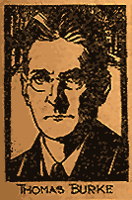I routinely pick up a novel while in an airport and then donate the lightly used book to the classroom. I always think that a true gem or a good “once read” deserves another set of eyes. Please help stir the literary passion of our students by donating what you can. Thank you in advance for whatever you can do.

**Short Stories**

This week we will be reading “The Hands of Mr. Ottermole” by Thomas Burke. The story is posted to the “READING” page on my web site.

The short story “The Hands of Mr. Ottermole” by Thomas Burke, published for the first time in 1931, was picked as one of the 12 best detective short stories (or was it the best?) ever written by a very distinguished panel of mystery authors and in the introduction to this story in the collection, Ellery Queen has this to say about it “No finer crime story has ever been written, period.” It does contain allusions to violence, but, unlike more modern thrillers, it is only implied and not followed in grisly and gruesome detail.

There are numerous novels about serial killers but how many short stories have been able to incorporate the theme of serial killer and multiple murders? A man with white hair and large white hands is terrorizing the streets of London by strangling people with no rhyme or reason. First victim is a man, second is a child and the third victim is a policeman, the fourth is a family of three and the fifth is the journalist who deduces who the murderer is! By the end of the story, the London Strangling Horrors account for 5 attacks with 7 victims, all having the characteristics of no motive, no pattern in the picking of victims and carried out right under the noses of the police force, accentuate the evocation of atmosphere and terror to its spine chilling best. This story can also boast of one other achievement – it conceals the identity of the murderer most cleverly by parading him right in front of the reader’s eyes, all the time.

♠



**Writing**

**Vocabulary #3**

All vocabulary students should be reviewing their lists for **five minutes each day**. Repeated exposure to the words or stems will help in the long-term retention of the meaning and lead to greater success. Students who cram the night before or day of generally do not score as well, nor do they remember the meanings down the road. I keep repeating this paragraph for a reason…hopefully it creates a movement that sweeps the nation.

This week students have time to work on their third vocabulary assignments. The assignment directions are online and students should have a copy of the directions. Please help out by reviewing the directions and expectations with your students. I do not just write the directions to kill trees, but even after repeated reteaching, small and large group conversations, and even sitting down individually with students and reviewing (and often helping to complete) vocabulary assignments the same mistakes continue to be made—often by the same individuals.

The vocabulary #3 assignments are due at the beginning of class on Thursday (10/10)—a day earlier due to no school on Friday. I am hoping and dreaming that we have all assignments completed and submitted on time.

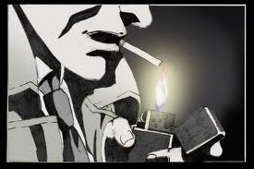

**Detective Story**

We are beginning the process of writing our first significant piece, a detective story. We will be working on the first two, of thirteen steps over the next couple of weeks. It provides students time and space to mentally edit, revise, and evaluate their initial story ideas.

We will be working on the following:

1. Choose a time period for your detective story. It can be any time, any place, from Ancient Egypt to the future or it could go to any kind of imaginary planet in a new galaxy.
   1. Do some research about what happened in any country; any kind of murder, any kind of strange case known. If the case never close, you could make the end anyway you please.
2. Develop the personality of your detective; he could be tough, comprehensive, patient or he could be even the murder of your story. Answering all of the following questions may be unnecessary. However, being thorough in this step can help you write a believable story based on a complete and rounded main character.
   1. Think of the basics. Boy or girl? What is their name? How old are they? What do they look like (hair color, eye color, and skin tone)? Where are they from? Where are they living when your story starts? How did they become part of the story? are they victims? Are they the cause of the problems in your story?
   2. Develop a family for your character. Parents? Siblings? Significant Other? Children? Other relations? Sociably problematic groups? A character which may know everything but has disappear...Make it as normal or as interesting as you want!
   3. What kind of life do they live? Are they famous, or are they just starting out? Are they unexpectedly smart? What kind of mysteries do they solve? (murder, theft, a combination, other kinds?)
   4. Develop their tastes. Favorite sentence to say? What is their favorite color? Place to be? Soft drink? Book? TV show? Movie? Music? Meal? What are they afraid of? How practical are they? Do they wear a scent, and if so, what scent? Strong, soft, nice or not pleasant?
   5. Come up with their religion. Do they have a religion? If so, what? Did they invent one or combine some to suit themselves? How does this influence their actions? Are they superstitious?
   6. Develop their relationships. Do they have a lot of friends? A best friend? Are they romantic? What first impression do they make? Do they like children? DO they like smokers? Do they like reading?
   7. How do they dress? Do they use makeup or hair dye? How about piercings or tattoos? How attractive are they, and how attractive do they think they are? Is there something they wish they could change, or something they are particularly happy with? How much time do they spend thinking about physical appearance?
   8. Though this may seem like a lot to worry about for a short story, having your characters developed to the fullest is an essential part of writing a good story.



♠

History

**Current Event #3**

Students who would normally present a current event on Friday can present any day, but must present by Thursday (10/10). All missing or make-up current event #3 presentations will take place Monday (10/14).

Students are doing very well with the presentations, but their understanding and summarization of the news item needs a little work. If you want to help…have the student practice the presentation. See if you can understand the news item and ask them questions to hone their comprehension of the event. You might even be able to provide a little background knowledge that your student can use in the presenation.

Another area that needs help is paraphrasing. Students can copy the “who, when, and where” directly from the article. It is fairly impossible to restate Portland, Oregon in any other comprehensible way. The “what”, however, needs to be in the words of the student. This aspect is not going well. Simply rearranging the words or substituting one word is not using one’s own form of expression. It is still plagiarism.

I have been highlighting, underlining, circling, etc. the offending “paraphrasing” and lines from the actual article. I have had a lot of individual and class conversations. I reinforce, reteach, and offer my services to help summarize the article in one’s authentic phrasing. After this, students will receive a “0” for the summary. Plagiarism is not allowed.

You can help by working with the student and checking their wording. I have even added a “quote” portion to the assignment for students to properly attribute credit and use a particulary well-worded sentence or statement. I do take this seriously and students do have class time to complete this work, but ask to see their summary if you have concerns or questions.

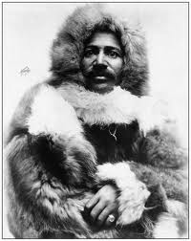The group current event quiz is next Friday (10/18). The quiz will contain questions about the most significant/interesting news items presented in the last two weeks and the most recent short stories. Groups quietly and discretely discuss their answer before determining the best choice to write on their answer sheet. Students need to pay attention to the current event presentations as well as the updates and review of the current events in order to be successful. If nothing else, students should be reading, watching, and/or listening to the news on a daily basis.

**Exploration of the AMericas**

We are venturing forth into our next unit of study, “Explorers of the Americas”.

Students learn how to do a formal research paper once in the three-year cycle. This is that once in a three-year cycle time. We will be spending most of the rest of the quarter and part of the next working on the project. I will introduce the project and go over due dates. Students will choose an explorer of the Americas by the end of class Thursday (4/21).

I will be teaching students the process of a research paper, but the end result will be something else entirely. Next week we will focus on the basics…I will teach them how to find information in various sources (print and electronic) and how to credit that source for the information gathered. Later in the week students will learn how to take notes and organize it within categories.

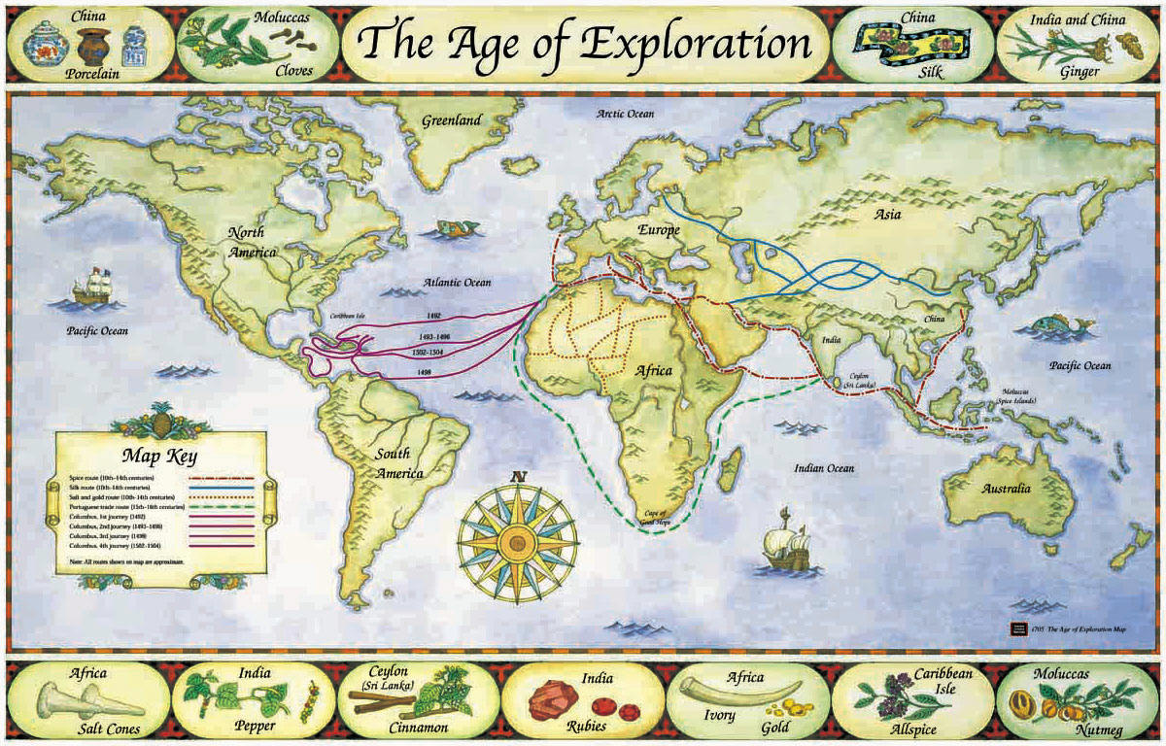Most of the week will be spent researching. Students need to bring in research materials to help supplement our meager library stock and computer access. Students do need a variety of sources—reference books, online resources, and other print media. Students are required to have a minimum of 5 bibliography sources of at least three different types. Please review the research paper guidelines that were distributed to students or access it online at my HISTORY web page.

♠

**Classroom Items Needed**

**MOST IN NEED OF:**

* Anti-bacterial countertop wipes (*Lysol* brand)
* Colored pencils - IN DESPERATE NEED OF THESE
* Colored printer paper *(regular stock and card stock)*
* Markers - THIN & THICK - DESPERATE NEED
* Rubber cement *(lots of art projects each year)*
* Composition notebooks (college ruled)
* Black Fine or Pinpoint felt markers *(for making good black lines on drawings, Papermate is best)*
* GRAPHIC DESIGN/PHOTO/IMAGE CATALOGUES OR BOOKS *(kids use these frequently in our class - if you are or know a graphic designer or anyone in the ad agency world, ask them if they have old books they'd like to donate)*
* *Kleenex* tissue

**OTHER ITEMS WE USE & NEED** (not in any particular order):

* Metal hand held pencil sharpeners
* AA & AAA batteries
* College ruled loose leaf paper
* Card stock weight paper (various colors)
* Multi-colored pocket folders
* Calligraphy pens/makers (with felt tips, especially during storyline units)
* Stencils (almost any kind)
* Stickers (any kind)
* Word games (*Scrabble* isn't the only one out there. How about: FUNGLISH, PICTUREKA, BUZZ WORD, IN A PICKLE, LAST WORD, IMAGINE IF, MAD GAB, TABOO)
* Playground equipment: basketball, football, rubber 4-Square balls, hoola-hoops, soccer ball, sidewalk chalk, foxtails, large size kickball, beach balls
* Brita water filters—including the replacement filters
* Any technology
* Other?

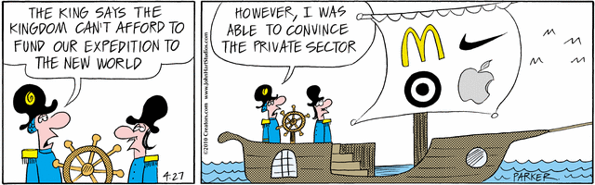

**Locker Painting Volunteers Needed:**

* lend your expertise to the creative process
* monitor students
* assist in clean up
* 10/9 from 1:15-2:45
* 10/10 from 8:15-9:15
* either or both days

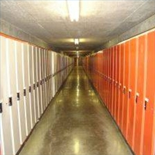

Planner **October 7- 14**

|  |  |  |  |  |  |  |
| --- | --- | --- | --- | --- | --- | --- |
|  | **Monday 10/7** | **Tuesday 10/8** | **Wednesday 10/9** | **Thursday 10/10** | **Friday**  **10/11** | **Weekend 10/12-13** |
| **Writing**  (Language Arts) | **Vocabulary #3**  -regular = words #1-10  -W3 sentences  **Detective Story**  -creating the antagonist character: physical & personality aspects  -written and dimensional form of character | **Vocabulary #3**  -regular = words #11-20  -W3 sentences & analogies  **Detective Story**  -creating the antagonist character: physical & personality aspects  -written and dimensional form of character | **\*vocab #3 assignment**  -due **beginning** of class [10/10]  -regular vocab = list & 5 sentences  -W3 = flashcards, sentences, & analogies  **“Criminal” Character Biography**  -due **beginning** of class [10/11]  -written: physical, personality, & other aspects  -dimensional representation: doll, puppet, caricature, etc. | | **INSERVICE** | **Vocabulary #3**  -quiz 10/17  **Detective Story**  -work time to create the crime & setting  -additional work time for solution & clues  *crime & setting need to be finalized by 10/17 |
| **Reading** | **20’ Reading**  -student book of choice  -student meetings  **“The Hands of Mr. Ottermole” by Thomas Burke**  -read aloud  -literary devices, elements of detective fiction, plot line, connections, etc. | **20’ Reading**  -student book of choice  -student meetings  **“The Hands of Mr. Ottermole” by Thomas Burke**  -read aloud  -literary devices, elements of detective fiction, plot line, connections, etc. | **20’ Reading**  -student book of choice  -student meetings  **“The Hands of Mr. Ottermole” by Thomas Burke**  -read aloud  -watch the “Alfred Hitchcock Presents” episode  -literary devices, elements of detective fiction, plot line, connections, etc. | |  | **“Who Killed Bob Teal” by Dashiell Hammett**  -read aloud  -class review & discussion  **Reading Log #2**  *due 10/18 representing 250+ pages of reading |
| **History**  **(Social Studies)** | **Current Event #3**  -News Shark (AM) & Wake Up da Vinci (PM)  -Galloping Pigz (AM) & Le Group de Friday (PM) presentations any day…but by 10/11  **Exploration of the Americas**  -introduction to project | **Current Event #3**  -Jackson’s Harem (AM) & #Molivia (PM)  -Galloping Pigz (AM) & Le Group de Friday (PM) presentations any day…but by 10/11  **Exploration of the Americas**  -expectations & timeline | **Current Event #3**  -AZOJSS (AM) & Ginger Afros (PM) [10/9]  -Larry Zarry (AM) & Numm-Nummz (PM) [10/10]  -Galloping Pigz (AM) & Le Group de Friday (PM) presentations any day…but by 10/11  **Exploration of the Americas**  *choice of explorer [10/9]  -research: “How to…”  -research explorer | |  | **Current Event #3**  -make-up & missing presentations 10/14  -group quiz 10/18  **Exploration of the Americas**  -research  *2 bibliography “cards” 10/16 |
| **Other**  Contact Information for Binder  **da Vinci:** 503-916-5356 ext 79140 **Home**: 503-640-5265  voicemail: 503-916-3600 ext 79140  email: [pbinder@pps.net](mailto:pbinder@pps.net)  **WEB PAGE** <http://733257565503770808.weebly.com/> | **Lyla Wolf**’s birthday | **MIDTERM** | **Kirstin Cornell**’s birthday  **Periods: 2, 4, & 6**  **Locker Painting** 1:15-2:45 | **Periods 1, 3, 5, & 7**  **Locker Painting** 8:15-9:15 | **no school**  **Shanti**’sbirthday | 10/12 **Aidan Rathbun**’s birthday  10/16 **late opening**  10/20-22 **Outdoor School** for 6th graders |