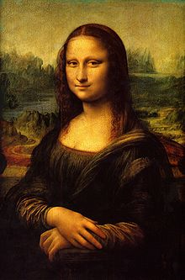**Binder Core: 6/9/2014**

**The End is Near**

It is really busy. We have Capstone B presentations, an 8th grade trip, promotion, an 8th grade talent show, and the end of the year picnic in this last week. Whew!

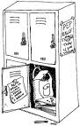Many students are already feeling the pressure and emotion of the end of another school year. The potential for frantic and frenzied students is in the air. Do what you can to help and please communicate any questions, concerns, or comments.

**Lockers**

Students should bring trash bags, bags and cleaning supplies to clean out their lockers and the classroom. As time permits I will have students clean out lockers periodically this week. I want them as close to clean and bare as possible by this Wednesday (6/11). I have talked with students about removing graffiti on the outside and inside of their lockers—the lockers need a bit of TLC. They are starting to get a little banged-up and a bit of an eye-sore. Please help if you can.



♠

**Reading**

**Summer Reading**

The research is clear that children who do not read during the summer can lose up to three months of reading progress and that loss has a cumulative, long-term effect. This week students will be suggesting 3 summer reads to stem the summer learning loss. Students just might discover great activities to encourage tem to learn, read, and have fun in the summer sun.

The suggestions should be accompanied by the novel, a synopsis (from an online or other print source), a link to an online source, or something tangible for the other students to peruse.

♠

**Writing**

**Writing NOtebook**

For the past couple of weeks, we have been engaged in (almost) daily writing prompts. We will be wrapping up the writing prompts this week. It has been a ton of fun.

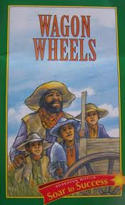Students are more than welcome to create their own prompt, or workshop a longer piece of written work as an alternative. Students are expected to use the 15 minutes effectively and produce in the neighborhood of 300 words for each prompt.

♠

History

**Reconstruction & Industrialization**

Students are finishing their historical children’s picture book. We went through the “plot pitch”, “storyboard”, and “drafting” stages last week. The finalized and published product is due at the beginning of class Tuesday (6/10).

Make sure that it includes:

1. **Front cover**—which includes a title, the authors, and a unique tagline and image.
2. **Title Page**—that includes the title, the name of the responsibility of each author (which role or which pages they completed), publishing, copyright information, and an original image.
3. **Story Pages**—each section of the history chapters should have its two (or more) pages with:
   1. a dominant **illustration** or image
   2. two to three **sentences** of text
4. **Back cover**—that includes a paragraph summary of the story (that does not give away the ending), your praise (pretend you’re a critic – look at the back of other books for a model), and a UPC or QR code.

Follow these guidelines, but be creative. The student handouts are available via the [US History](http://733257565503770808.weebly.com/us-history.html) page on the Core’s website:

♠

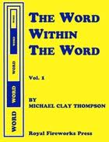

**Please return history books by Wednesday, June 11th.**

Please pay $20 for the Word Within the Word book by June 11th if you have not done so yet.

**Saying Goodbye**

It is nearly the end of another school year; almost twenty years of teaching are under my belt. Ten of those years have been with da Vinci. I am humbled, a bit tired, and oddly reflective. The feeling of panic has long since worn away.

I woke up the other night with the feeling that somehow I needed to impart to my students everything they will need to know about life in the next week, including, but not limited to: proper grammar, excellent time management skills, a deep love for learning, a hunger to read widely and often, the confidence to flex their own writing muscles, a need to make connection through history so that we stop stumbling down the same maniacal path, and a yearning to be a good person.

I woke up with an impending sense of finality. I would be ending my tenure with da Vinci.

I woke up because I realized how much I would miss the students, parents, and staff.

It’s all because I mocked my 4th grade teacher.

It was the last day of school and she was saying goodbye to our class. As the bell rang and we started to leave I noticed that she had shed a tear. I couldn’t help myself. I laughed (on the inside), sentencing myself to a lifetime of emotionally hidden goodbyes to my students. It is not that I do not care. I just have a hard time showing it.

Of course, she could have been shedding a tear of joy. I can’t be sure.

Although I don’t cry when a student exits my classroom for the last time as my pupil, I miss them more than they will ever know. They leave a hole in the classroom. They have left an impression on my life. I hope that their lives have been altered and improved by the time we spent together in the same way my life has.

I suspect that every teacher has some sort of emotional issue connected to the end of school and the departure of students. Most deny their attachments to students and focus on the end of the school year as a hard-won liberation. Some teachers are so “exhausted” that they act as if they are almost unable to make it across the finish line. I think it’s a diversion. That state of exhaustion may indeed be a result of a challenging school year, but I think those feelings are exacerbated by the impending loss of students. The departure of students might bring a tear to the eye, and that’s perfectly acceptable. For me, rather, it leaves a hole in what passes for my heart.

I hope my efforts have not been in vain. I hope my influence on their lives is permanent, positive and purposeful. I hope, in my own small way, I have helped to change the world for the better.

I thank you for your time, understanding, patience, and constant attempts to be the change we want to see in the world. I appreciate you and your efforts more than you know and more than I can show.

[Exit stage left as the sun goes down silhouetting a crooked-neck man as he leaves]

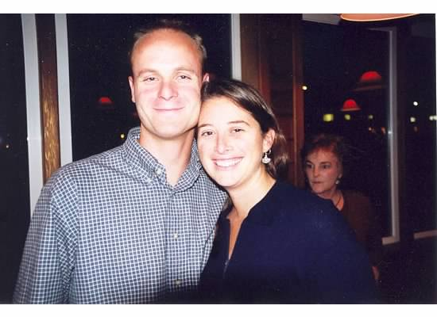

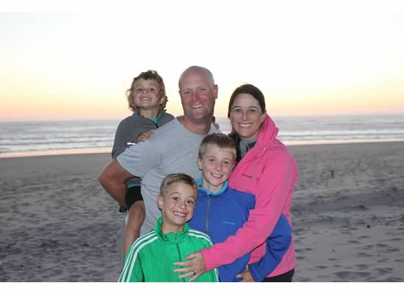

Planner **June 6 – 8**

|  |  |  |  |  |  |  |
| --- | --- | --- | --- | --- | --- | --- |
|  | **Monday 6/9** | **Tuesday 6/10** | **Wednesday 6/11** | **Thursday 6/12** | **Friday**  **6/13** | **Weekend 6/14-9/1** |
| **Writing**  (Language Arts) | **Writing Notebook:**  Write about two things that your family has taught you.  -entries should have a title “Family”, your name, and sufficient work to reflect the time given (at least 300 words). | **Writing Notebook:**  Name one thing you like about yourself and why you like it.  -entries should have a title “Like”, your name, and sufficient work to reflect the time given (at least 300 words). | **Writing Notebook:**  Describe the most difficult thing about being your age. [**6/11**]  -entries should have a title “Age”, your name, and sufficient work to reflect the time given (at least 300 words).  If you could be a character in any book, TV show, or movie, who would you be and why?  [**6/12**]  -entries should have a title “Character II”, your name, and sufficient work to reflect the time given (at least 300 words). | | **Writing Notebook:**  What will your summer consist of?  -entries should have a title “Summer”, your name, and sufficient work to reflect the time given (at least 300 words). | **SUMMER** |
| **Reading** | **ABC Project**  -share | **ABC Project**  -share  **Summer Reading**  -share **3** ideas | **Summer Reading**  -share **3** ideas | | **Summer Reading**  -share **3** ideas |  |
| **History**  **(Social Studies)** | **Reconstruction & Industrialization**  - "Reconstruction Era" (HA chapter 23: pages 322-335), "Tensions in the West" (HA chapter 24: pages 336-351), "Rise of Industry" (HA chapter 25: pages 352-369), "The Great Wave of Immigration" (HA chapter 26: pages 370-383), "Progressive Era" (HA chapter 27: pages 384-397), "America Becomes a World Power" (HA chapter 28: pages 398-415)  -finalize pages | **RECONSTRUCTION & INDUSTRIALIZATION CHILDREN’S PICTURE BOOK**  * due at the **beginning** of class  -share | **Reconstruction & Industrialization Children’s Picture Book**  -share | | **Reconstruction & Industrialization Children’s Picture Book**  -share |  |
| **Other**  Contact Information for Binder  **da Vinci:** 503-916-5356 ext 79140 **Home**: 503-640-5265  voicemail: 503-916-3600 ext 79140  email: [pbinder@pps.net](mailto:pbinder@pps.net)  **WEB PAGE** <http://733257565503770808.weebly.com/> | periods 1-7  Capstone B tech rehearsal (after school) | periods 1, 3, 5, 7 & **Capstone B** performances | periods 1-7  8th Wild Waves trip  7th “Mastery” meeting with art teachers | periods 1-7  Promotion Practice  -periods 2-4  **Promotion**  -8th graders arrive at Benson HS @ 3:45  -promotion starts 4:30 | 8th Talent Show  Lunch on the Lawn | 6/14-9/1 summer  9/2 school resumes |