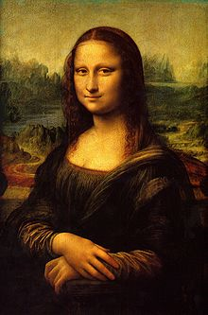**Binder Core: 6/2/2014**

**Capstones**

[mostly repeated]

Capstone rehearsal and panic is in the air. Please plan accordingly and manage time to avoid the traps and hazards of both. Many students are already feeling the pressure. Much of it is due to poor time management or groups that have fallen apart, but the potential for frantic and frenzied students is in the air. Please, please, please look at the upcoming days and weeks to avoid last-minute debacles.

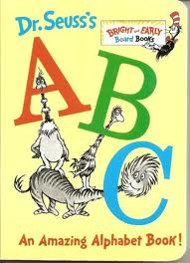Many students experience and suffer from the increased stress, lack of sleep, poor diet choices, and questionable time management. Everyone experiences these in varying degrees at sporadic times in life. It is an experience one must learn to adapt to and handle, but it can and will be hard.

♠

**Reading**

**ABC Books**

[mostly repeated]

In addition to reading a book for the discussion, students are expected to complete the following project:

As you read, look for literary elements such as characters, setting, conflicts, figures of speech, themes, issues, plot, foreshadowing, etc. and organize these elements using the letters of the alphabet. You are more than welcome to utilize significant characters or items from the novel as well. You will eventually be expected to create an ABC book where you give an example of any of these elements using each letter of the alphabet. You will eventually be asked to present at least part of your book in front of the class.

As you read, gather details from the book to create the individual pages for each letter of the alphabet. Be sure to record page numbers because you will need exact quotations.

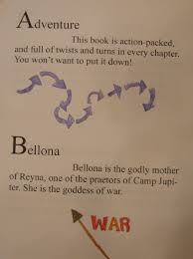

Make sure that you include:

1. Front cover – include full book title, the author, a unique tagline and image, and that it is an ABC book
2. Title Page – include full book title, the name of the author, publishing, copyright information, and an original image.
3. Each letter should have its own page with:
   1. the letter and word identified (literary device or significant item/character from the novel)
   2. the word or item/character used or referenced in context with proper page citation  (at least 3-4 specific references quoted from the text) [Example for dialect: “He ain’t company, Cal, he’s just a Cunningham“ (24).
   3. a dominant illustration or image (or a smaller one for each text reference)
   4. an explanation of what the word or item/character is and how it is important (or not) in the story
4. Back cover that includes: • a paragraph summary of the story that does not give away the ending • your praise (pretend you’re a critic – look at the back of other books for a model)

Follow these guidelines, but be creative. The student handout is available via the [READING](http://733257565503770808.weebly.com/reading.html) page on the Core’s website:

♠

**Writing**

**Writing NOtebook**

For the past couple of weeks, we have been engaged in (almost) daily writing prompts. I am way past due including a blurb in the newsletter.

Writing prompts can focus students and target specific skills. Some focus on creativity, others have students include dialogue, dialect, vivid description, etc. Many students thrive when prompted rather than being overwhelmed by choice (think of 37 varieties of ketchup vs. only having one container in front of you).

Writing prompts are a form of “safe writing.” Students can indicate whether the teacher should read, or simply scan to see that there is writing. Students can express themselves and not be judged. Students can “dump” their emotions onto paper and the catharsis is amazing.

Writing prompts can help foster a personal relationship. As I read, I ask about information contained in the writing (if I am allowed to read it), make connections, share tidbits, and bond. It really helps me get to know the students on another level and in another way.

Writing prompts can have unexpected benefits. It can help students’ better express themselves in math, science, art, etc. Prompts foster friendships, allow kids to share with one another, get them to laugh, and sometimes make them cry.

Writing prompts can improve writing. [Homer Simpson, “Doh!” moment.]

Over the next several weeks we will be slogging our way through several more prompts. Students are more than welcome to create their own prompt, or workshop a longer piece of written work as an alternative. Students are expected to use the 15 minutes effectively and produce in the neighborhood of 300 words for each prompt.

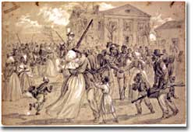

♠

History

**Reconstruction**

**Reconstruction** refers to the period following the Civil War of rebuilding the United States. It 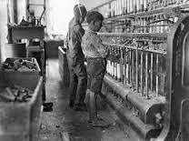was a time of great pain and endless questions. On what terms would the Confederacy be allowed back into the Union? Who would establish the terms, Congress or the President? What was to be the place of freed blacks in the South? Did Abolition mean that black men would now enjoy the same status as white men? What was to be done with the Confederate leaders, who were seen as traitors by many in the North?

Although the military conflict had ended, Reconstruction was in many ways still a war. Radical northerners who wanted to punish the South and Southerners who desperately wanted to preserve their way of life waged this important struggle.

The Industrial Revolution (1820-1870) was of great importance to the economic development of the United States. The first Industrial Revolution occurred in Great Britain and Europe during the late eighteenth century. It then centered on the United States and Germany.

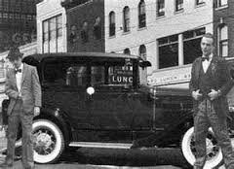The Industrial Revolution itself refers to a change from hand and home production to machine and factory. The first industrial revolution was important for the inventions of spinning and weaving machines operated by water power, which was eventually replaced by steam. This helped increase America’s growth. However, the industrial revolution truly changed American society and economy into a modern urban-industrial state.

Industrialization in America involved three important developments. First, transportation was expanded. Second, electricity was effectively harnessed. Third, improvements were made to industrial processes such as improving the refining process and accelerating production. The government helped protect American manufacturers by passing a protective tariff.

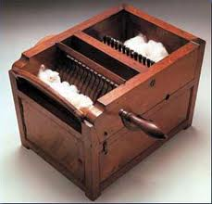In 1794, Eli Whitney invented the cotton gin, which made the separation of cotton seeds from fiber much faster. The South increased its cotton supply sending raw cotton north to be used in the manufacture of cloth. Francis C. Lowell increased the efficiency in the manufacture of cloth by bringing spinning and weaving processes together into one factory. This led to the development of the textile industry throughout New England.

In 1846, Elias Howe created the sewing machine, which revolutionized the manufacture of clothing. All of a sudden, clothing began to be made in factories as opposed to at home.

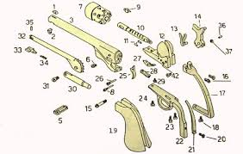Eli Whitney came up with the idea to use interchangeable parts in 1798 to make muskets. If standard parts were made by machine, then they could be assembled at the end much more quickly than before. This became an important part of American industry and the Second Industrial Revolution.

As industries and factories arose, people moved from farms to cities. This led to other issues including overcrowding and disease. However, advances were made in agriculture too including better machines and cultivators. For example, Cyrus McCormick created the reaper, which allowed quicker and cheaper harvesting of grain. John Deere created the first steel plow in 1837 helping speed up farming across the Midwest.

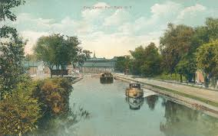With the increased size of the United States, better communication networks became ultra important. In 1844, Samuel F. B. Morse created the telegraph and by 1860, this network ranged throughout the eastern coast to the Mississippi.

The Cumberland Road, the first national road, was begun in 1811. This eventually became part of the Interstate 40. Further, Robert Fulton made river transportation efficient through the creation of the first steamboat, the Clermont. This was made possible by James Watt’s invention of the first reliable steam engine.

The creation of the Erie Canal created a route from the Atlantic Ocean to the Great Lakes thereby helping stimulate the economy of New York and making New York City a great trading center.

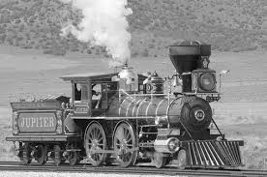Railroads were of supreme importance to the increase in trade throughout the United States. In fact, by the start of the Civil War, railroads linked the most important Mid West cities with the Atlantic coast. Railroads further opened the west and connected raw materials to factories and markets. A transcontinental railroad was completed in 1869 at Promontory, Utah.

With the great advances of the Industrial Revolution, inventors continued to work throughout the rest of the 19th and early 20th century on ways to make life easier while increasing productivity. The foundations set throughout the mid-1800's set the stage for inventions such as the light bulb (Thomas Edison), telephone (Alexander Bell), and the automobile (Karl Benz). Further, Ford's creation of the assembly line, which made manufacturing more efficient, helped form America into a modern industrialized nation. The impact of these and other inventions of the time cannot be underestimated.

♠

Planner **June 6 – 8**

|  |  |  |  |  |  |  |
| --- | --- | --- | --- | --- | --- | --- |
|  | **Monday 6/2** | **Tuesday 6/3** | **Wednesday 6/4** | **Thursday 6/5** | **Friday**  **6/6** | **Weekend 6/7-8** |
| **Writing**  (Language Arts) | **Writing Notebook:**  Write about a favorite childhood toy.  -entries should have a title “Toy”, your name, and sufficient work to reflect the time given (at least 300 words). | **Writing Notebook:**  Which character from a book would you most like to meet and why?  -entries should have a title “Hero”, your name, and sufficient work to reflect the time given (at least 300 words). | **Writing Notebook:**  Finish this thought: if I could change one thing about myself (if you can't think of anything, you might want to consider telling how you got to be perfect!)…[**6/4**]  -entries should have a title “Change”, your name, and sufficient work to reflect the time given (at least 300 words).  Write about a day you would like to forget. [**6/5**]  -entries should have a title “Forget”, your name, and sufficient work to reflect the time given (at least 300 words). | | **Writing Notebook:**  Three goals I have set for myself and how I am going to achieve them are…  -entries should have a title “Goals”, your name, and sufficient work to reflect the time given (at least 300 words). | **Writing Notebook** or **Workshop**  -20’ daily entries or student project of choice  -explanation, expectations, and timeline |
| **Reading** | **ABC Project**  *final page #5 due at **beginning** of class | **ABC Project**  *draft page #6 due at **beginning** of class | **ABC Project**  -edit & revise pages  *final page #6 due at the **beginning** of class [**6/5**]  **ABC Project**  *book due by the **end** of class [**6/5**]  -share | | **Last Day for Late & Missing Work** | **Summer Reading**  -share ideas |
| **History**  **(Social Studies)** | **Reconstruction & Industrialization**  - "Reconstruction Era" (HA chapter 23: pages 322-335), "Tensions in the West" (HA chapter 24: pages 336-351), "Rise of Industry" (HA chapter 25: pages 352-369), "The Great Wave of Immigration" (HA chapter 26: pages 370-383), "Progressive Era" (HA chapter 27: pages 384-397), "America Becomes a World Power" (HA chapter 28: pages 398-415)  -finish storyboard | **Reconstruction & Industrialization**  - "Reconstruction Era" (HA chapter 23: pages 322-335), "Tensions in the West" (HA chapter 24: pages 336-351), "Rise of Industry" (HA chapter 25: pages 352-369), "The Great Wave of Immigration" (HA chapter 26: pages 370-383), "Progressive Era" (HA chapter 27: pages 384-397), "America Becomes a World Power" (HA chapter 28: pages 398-415)  *storyboard due at the beginning of class | **Reconstruction & Industrialization**  - "Reconstruction Era" (HA chapter 23: pages 322-335), "Tensions in the West" (HA chapter 24: pages 336-351), "Rise of Industry" (HA chapter 25: pages 352-369), "The Great Wave of Immigration" (HA chapter 26: pages 370-383), "Progressive Era" (HA chapter 27: pages 384-397), "America Becomes a World Power" (HA chapter 28: pages 398-415)  -groups will read and create a children’s book for their assigned chapter  -work on drafts of front & back cover, title page, and 2+ pages for each section in the chapter | | **Reconstruction & Industrialization**  - "Reconstruction Era" (HA chapter 23: pages 322-335), "Tensions in the West" (HA chapter 24: pages 336-351), "Rise of Industry" (HA chapter 25: pages 352-369), "The Great Wave of Immigration" (HA chapter 26: pages 370-383), "Progressive Era" (HA chapter 27: pages 384-397), "America Becomes a World Power" (HA chapter 28: pages 398-415)  *drafts of front & back cover, title page, and 2+ pages for each section in the chapter due at beginning of class | **Reconstruction & Industrialization**  -chapters 23-28  -children’s book project  *project due 6/10 at **beginning** of class  -share |
| **Other**  Contact Information for Binder  **da Vinci:** 503-916-5356 ext 79140 **Home**: 503-640-5265  voicemail: 503-916-3600 ext 79140  email: [pbinder@pps.net](mailto:pbinder@pps.net)  **WEB PAGE** <http://733257565503770808.weebly.com/> | periods 1-7  Visual Arts Capstone reception @5:30pm | periods 1-7 | periods 1-7  Junior Rose Parade  -students are **not** allowed to leave mid-day | periods 1-7  Visual Arts Capstone walk through  Capstone A tech rehearsal (after school) | periods 2, 4, 6 & **Capstone A** performances  -55 minute classes  Visual Arts Capstone walk through | 6/9 Capstone B tech rehearsal (after school)  6/10 periods 1, 3, 5, & 7 & **Capstone B**  6/11 8th grade “Wild Waves” trip, & 7th “Mastery” meeting with art teachers  6/12 promotion practice periods 2-4, 3:45 8th arrive at Benson, & 4:30pm **Promotion**  6/13 **8th Talent Show** and Lunch on the Lawn |