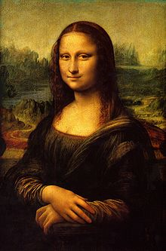**Binder Core: 5/26/2014**

**Capstones**

[mostly repeated]

Capstone rehearsal and panic is in the air. Please plan accordingly and manage time to avoid the traps and hazards of both. Many students are already feeling the pressure. Much of it is due to poor time management or groups that have fallen apart, but the potential for frantic and frenzied students is in the air. Please, please, please look at the upcoming days and weeks to avoid last-minute debacles.

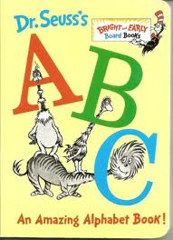Many students experience and suffer from the increased stress, lack of sleep, poor diet choices, and questionable time management. Everyone experiences these in varying degrees at sporadic times in life. It is an experience one must learn to adapt to and handle, but it can and will be hard.

♠

**Reading**

**ABC Books**

[mostly repeated]

In addition to reading a book for the discussion, students will also be expected to complete the following project:

As you read, look for literary elements such as characters, setting, conflicts, figures of speech, themes, issues, plot, foreshadowing, etc. and organize these elements using the letters of the alphabet. You are more than welcome to utilize significant characters or items from the novel as well. You will eventually be expected to create an ABC book where you give an example of any of these elements using each letter of the alphabet. You will eventually be asked to present at least part of your book in front of the class.

As you read, gather details from the book to create the individual pages for each letter of the alphabet. Be sure to record page numbers because you will need exact quotations.

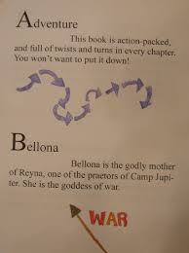For every discussion, the group will create 7 (or more) pages. At last count, there were 26 letters in the American alphabet. There are 4 discussions. 4x7= 28. That is more letters than exist. Additionally, some of the letters might be difficult to use (“x”, “q”, etc.). Several of the letters can be skipped and several of the letters can be used more than once. It is up to the group to plan accordingly.

Make sure that you include:

1. Front cover – include full book title, the author, a unique tagline and image, and that it is an ABC book
2. Title Page – include full book title, the name of the author, publishing, copyright information, and an original image.
3. Each letter should have its own page with:
   1. the letter and word identified (literary device or significant item/character from the novel)
   2. the word or item/character used or referenced in context with proper page citation  (at least 3-4 specific references quoted from the text) [Example for dialect: “He ain’t company, Cal, he’s just a Cunningham“ (24).
   3. a dominant illustration or image (or a smaller one for each text reference)
   4. an explanation of what the word or item/character is and how it is important (or not) in the story
4. Back cover that includes: • a paragraph summary of the story that does not give away the ending • your praise (pretend you’re a critic – look at the back of other books for a model)

Follow these guidelines, but be creative. The student handout is available via the [READING](http://733257565503770808.weebly.com/reading.html) page on the Core’s website:

♠

**Writing**

**Vocabulary Final**

[mostly repeated]

I've been waiting for you, Obi-Vocabulary. We meet again, at last. The circle is now complete. When I left you, I was but the learner; now *I* am the master.

There will be a week of study and review before the end-of-the-year vocabulary final. We will take a little time during the week of 15th-24th to individually and collaboratively review. The final takes place over two days; Thursday, May 29th and Friday, May 30th.

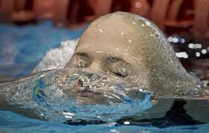The final is cumulative. I have been talking to and warning the students all year that words from each list this year will be a part of the final. Word Within the Word students have it easier; they are constantly being assessed on a cumulative basis. Regular vocabulary students have had periodic reviews—at the end of each quarter—and I have been using words from previous lists in the fill-in-the-blank sentences to help establish context.

For both Cores, Thursday (5/29) will be the fill-in-the-blank portion for the regular vocabulary students and the “other” portions for the Word Within the Word students. The “other” portions for the W3 students can include some or all of the following: decoding, opposites, cartoons, odd-one-out, numbers, matching, mystery questions, and/or flip side.

On the second day, Friday (5/30), regular vocabulary students will complete two different crossword puzzles—one for 6 & 7 letter words and another for 8 & 9 letter words. W3 students complete stem and word definitions.

The lists for W3 students are online and a review list for regular vocabulary students has been online for several weeks.

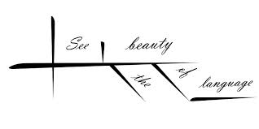

**Sentence diagrams**

[mostly repeated]

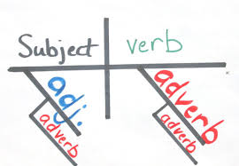Most methods of diagramming in pedagogy are based on the work of Alonzo Reed and Brainerd Kellogg in their book *Higher Lessons in English,* first published in 1877, though the method has been updated with recent understanding of grammar. Reed and Kellogg were preceded, and their work probably informed, by W. S. Clark, who published his "balloon" method of depicting grammar in his 1847 book *A Practical Grammar: In Which Words, Phrases & Sentences are Classified According to Their Offices and Their Various Relationships to Each Another.*

Some people continue to use the Reed-Kellogg system in teaching grammar, but others have discouraged it in favor of more modern tree diagrams. However, these modern tree structures draw on techniques that were already present in Reed-Kellogg diagrams.

The fact that the pictorial diagram groups the parts of a sentence according to their offices and relations, and not in the order of speech, has been spoken of as a fault. It is, however, a merit. It teaches the student to look through the literary order and discover the logical order. S/he learns what the literary order really is, and sees that this may be varied indefinitely, so long as the logical relations are kept clear.

The diagram drives the student to a most searching examination of the sentence, brings him/her face to face with every difficulty, and compels a decision on every point. (<http://en.wikipedia.org/wiki/Sentence_diagram>)

Over the next several weeks we will be slogging our way through the glory and divinity that is sentence diagramming. Do not be surprised if, in the upcoming weeks, your student cries foul over the use of a “red herring”.

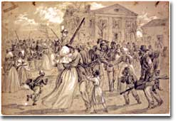

♠

History

**Reconstruction**

**Reconstruction** refers to the period following the Civil War of rebuilding the United States. It was a time of great pain and endless questions. On what terms would the Confederacy be allowed back into the Union? Who would establish the terms, Congress or the President? What was to be the place of freed blacks in the South? Did Abolition mean that black men would now enjoy the same status as white men? What was to be done with the Confederate leaders, who were seen as traitors by many in the North?

Although the military conflict had ended, Reconstruction was in many ways still a war. Radical northerners who wanted to punish the South and Southerners who desperately wanted to preserve their way of life waged this important struggle.

Slavery, in practical terms, died with the end of the Civil War. Three Constitutional amendments altered the nature of African-American rights. The Thirteenth Amendment formally abolished slavery in all states and territories. The Fourteenth Amendment prohibited states from depriving any male citizen of equal protection under the law, regardless of race.

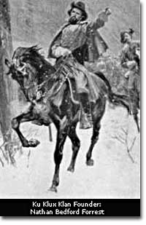The Fifteenth Amendment granted the right to vote to African-American males. Ratification of these amendments became a requirement for Southern states to be readmitted into the Union. Although these measures were positive steps toward racial equality, their enforcement proved extremely difficult.

The period of Presidential Reconstruction lasted from 1865 to 1867. Andrew Johnson, as Lincoln's successor, proposed a very lenient policy toward the South. He pardoned most Southern whites, appointed provisional governors and outlined steps for the creation of new state governments. Johnson felt that each state government could best decide how they wanted blacks to be treated. Many in the North were infuriated that the South would be returning their former Confederate leaders to power. They were also alarmed by Southern adoption of Black Codes that sought to maintain white supremacy. Recently freed blacks found the postwar South very similar to the prewar South.

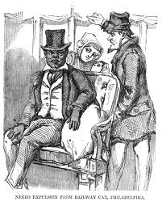The congressional elections of 1866brought Radical Republicans to power. They wanted to punish the South, and to prevent the ruling class from continuing in power. They passed the Military Reconstruction Acts Of 1867, which divided the South into five military districts and outlined how the new governments would be designed. Under federal bayonets, blacks, including those who had recently been freed, received the right to vote, hold political offices, and become judges and police chiefs. They held positions that formerly belonged to Southern Democrats. Many in the South were aghast. President Johnson vetoed all the Radical initiatives, but Congress overrode him each time. It was the Radical Republicans who impeached President Johnson in 1868. The Senate, by a single vote, failed to convict him, but his power to hinder radical reform was diminished.

Not all supported the Radical Republicans. Many Southern whites could not accept the idea that former slaves could not only vote but hold office. It was in this era that the Ku Klux Klan was born. A reign of terror was aimed both at local Republican leaders as well as at blacks seeking to assert their new political rights. Beatings, lynchings, and massacres, were all in a night's work for the clandestine Klan. Unable to protect themselves, Southern blacks and Republicans looked to Washington for protection. After ten years, Congress and the radicals grew weary of federal involvement in the South.

The withdrawal of Union troops In 1877 brought renewed attempts to strip African-Americans of their newly acquired rights.

♠

Planner **May 26 – June 1**

|  |  |  |  |  |  |  |
| --- | --- | --- | --- | --- | --- | --- |
|  | **Monday 5/26** | **Tuesday 5/27** | **Wednesday 5/28** | **Thursday 5/29** | **Friday**  **5/30** | **Weekend 5/31-6/1** |
| **Writing**  (Language Arts) | **MEMORIAL DAY** | **Writing Notebook:**  Describe someone who is a hero to you and why  -entries should have a title “Hero”, your name, and sufficient work to reflect the time given (at least 300 words).  **Vocabulary Final**  -review | **Writing Notebook:**  I have never been more frightened than when…[**5/28**]  -entries should have a title “Frightened”, your name, and sufficient work to reflect the time given (at least 300 words).  **Vocab Final [5/29]**  -regular = fill-in-the-blank sentences [5/29]  -W3 = “other” portions (antonyms, synonyms, mystery questions, cartoons, etc.) [5/29] | | **Vocab Final**  -regular = crossword puzzle  -W3 = stems & word definitions | **Writing Notebook** or **Workshop**  -20’ daily entries or student project of choice  -explanation, expectations, and timeline |
| **Reading** |  | **ABC Project**  *draft page #4 due at **beginning** of class | **ABC Project**  -edit & revise pages  *final page #4 due at the **beginning** of class [**5/29**] | | **ABC Project**  *draft page #5 due at **beginning** of class | **ABC Project**  -final page #5 6/2  -draft #6 6/3 & final 6/5  *ABC book compiled and due at the end of class **6/5** |
| **History**  **(Social Studies)** |  | **Reconstruction & Industrialization**  - "Reconstruction Era" (HA chapter 23: pages 322-335), "Tensions in the West" (HA chapter 24: pages 336-351), "Rise of Industry" (HA chapter 25: pages 352-369), "The Great Wave of Immigration" (HA chapter 26: pages 370-383), "Progressive Era" (HA chapter 27: pages 384-397), "America Becomes a World Power" (HA chapter 28: pages 398-415)  -groups will read and create a children’s book for their assigned chapter | **Reconstruction & Industrialization**  - "Reconstruction Era" (HA chapter 23: pages 322-335), "Tensions in the West" (HA chapter 24: pages 336-351), "Rise of Industry" (HA chapter 25: pages 352-369), "The Great Wave of Immigration" (HA chapter 26: pages 370-383), "Progressive Era" (HA chapter 27: pages 384-397), "America Becomes a World Power" (HA chapter 28: pages 398-415)  -groups will read and create a children’s book for their assigned chapter | | **Reconstruction & Industrialization**  - "Reconstruction Era" (HA chapter 23: pages 322-335), "Tensions in the West" (HA chapter 24: pages 336-351), "Rise of Industry" (HA chapter 25: pages 352-369), "The Great Wave of Immigration" (HA chapter 26: pages 370-383), "Progressive Era" (HA chapter 27: pages 384-397), "America Becomes a World Power" (HA chapter 28: pages 398-415)  -groups will read and create a children’s book for their assigned chapter | **Reconstruction & Industrialization**  -chapters 23-28  -children’s book project  *project due 6/10 at **beginning** of class  -share |
| **Other**  Contact Information for Binder  **da Vinci:** 503-916-5356 ext 79140 **Home**: 503-640-5265  voicemail: 503-916-3600 ext 79140  email: [pbinder@pps.net](mailto:pbinder@pps.net)  **WEB PAGE** <http://733257565503770808.weebly.com/> | no school | Leo Leader lunch | **Periods: 2, 4, 6, & Flex**  -music teaser during FLEX | **Periods 1, 3, 5, & 7**  **Grace Kuhn**’s bday |  | 6/2 Visual Arts capstone reception @5:30pm  6/4 Jr. Rose Festival  6/5 Capstone A tech rehearsal (after school)  6/6 periods 2, 4, 6 & Capstone A  6/7 **Anderson Fletcher** & **Ivy-Jean**’s bday |