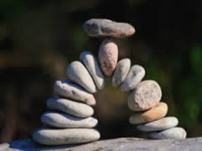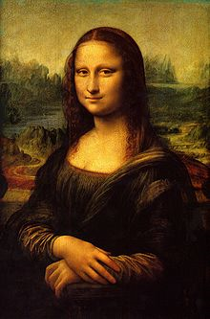**Binder Core: 5/19/2014**

**Capstones**

[mostly repeated]

The curtain has fallen on the dance concert. Capstone rehearsal and panic is in the air. Please plan accordingly and manage time to avoid the traps and hazards of both. Many students are already feeling the pressure. Much of it is due to poor time management or groups that have fallen apart, but the potential for frantic and frenzied students is in the air.

Please, please, please look at the upcoming days and weeks to avoid last-minute debacles.

Many students experience and suffer from the increased stress, lack of sleep, poor diet choices, and questionable time management. Everyone experiences these in varying degrees at sporadic times in life. It is an experience one must learn to adapt to and handle, but it can and will be hard.

Good luck. Be proactive rather than reactive, and remember that the “inhibition” portion of the adolescent brain shuts down during puberty. Before you ask them, “Why did you do that?” remember that they really were not thinking and they cannot legitimately answer you—Catch 22, is it not?



♠

**Reading**

**Discussion #8**

Students will be reading and finishing the fourth and final assignment of the fourth quarter’s discussions this week. The list of chapters or pages to read and each person’s assignment is listed on the “bookmarks” that were handed to each student. The assignments for the fourth quarter and the bookmarks are available on the “[Reading](http://733257565503770808.weebly.com/reading.html)” page of my website.

I recommend keeping the bookmark and assignment with the novels the students are reading. Students should work on the assignment as they read, not try and cull meaningful quotes or descriptions after reading the entire section. The only exception might be the summarizer, but even then the student could be summarizing each chapter into a sentence as s/he goes. Yes, reality says that most students will not do that. It would, however, make their lives a lot easier.

Discussion #8 assignments are due at the beginning of class on Thursday (5/22) and the discussion is Friday (5/23). Students will complete the “post discussion” portion of the assignment after the discussion and submit it to the correct (AM or PM) reading tray.

The assignments, like all good things, have changed slightly. All students are being asked to create two generic and two specific discussion questions as well as listing and evaluating two quotes. Other portions of the assignment ask students to describe characters, the setting, and the plot. As always, directions should clearly delineate the expectations.

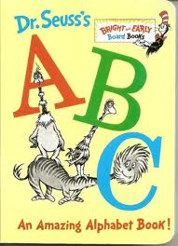**ABC Books**

[mostly repeated]

In addition to reading a book for the discussion, students will also be expected to complete the following project:

As you read, look for literary elements such as characters, setting, conflicts, figures of speech, themes, issues, plot, foreshadowing, etc. and organize these elements using the letters of the alphabet. You will eventually be expected to create an ABC book where you give an example of any of these elements using each letter of the alphabet. You will eventually be asked to present at least part of your book in front of the class.

As you read, gather details from the book to create the individual pages for each letter of the alphabet. Be sure to record page numbers because you will need exact quotations.

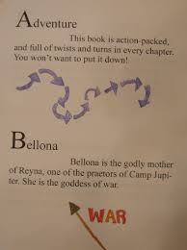For every discussion, the group will create 7 (or more) pages. At last count, there were 26 letters in the American alphabet. There are 4 discussions. 4x7= 28. That is more letters than exist. Additionally, some of the letters might be difficult to use (“x”, “q”, etc.). Several of the letters can be skipped and several of the letters can be used more than once. It is up to the group to plan accordingly.

Make sure that you include:

1. Front cover – include full book title, the author, a unique tagline and image, and that it is an ABC book
2. Title Page – include full book title, the name of the author, publishing, copyright information, and an original image.
3. Each letter should have its own page with:
   1. the letter and word identified (literary device or significant item/character from the novel)
   2. the word or item/character used or referenced in context with proper page citation  (at least 3-4 specific references quoted from the text) [Example for dialect: “He ain’t company, Cal, he’s just a Cunningham“ (24).
   3. a dominant illustration or image (or a smaller one for each text reference)
   4. an explanation of what the word or item/character is and how it is important (or not) in the story
4. Back cover that includes: • a paragraph summary of the story that does not give away the ending • your praise (pretend you’re a critic – look at the back of other books for a model)

Follow these guidelines, but be creative. The student handout is available via the [READING](http://733257565503770808.weebly.com/reading.html) page on the Core’s website:

♠

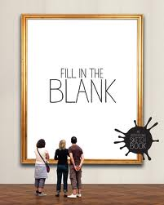**Writing**

**Vocabulary Final**

[mostly repeated]

I've been waiting for you, Obi-Vocabulary. We meet again, at last. The circle is now complete. When I left you, I was but the learner; now *I* am the master.

There will be a week of study and review before the end-of-the-year vocabulary final. We will take a little time during the week of 15th-24th to individually and collaboratively review. The final takes place over two days; Thursday, May 29th and Friday, May 30th.

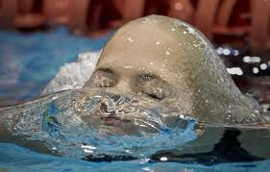The final is cumulative. I have been talking to and warning the students all year that words from each list this year will be a part of the final. Word Within the Word students have it easier; they are constantly being assessed on a cumulative basis. Regular vocabulary students have had periodic reviews—at the end of each quarter—and I have been using words from previous lists in the fill-in-the-blank sentences to help establish context.

For both Cores, Thursday (5/29) will be the fill-in-the-blank portion for the regular vocabulary students and the “other” portions for the Word Within the Word students. The “other” portions for the W3 students can include some or all of the following: decoding, opposites, cartoons, odd-one-out, numbers, matching, mystery questions, and/or flip side.

On the second day, Friday (5/30), regular vocabulary students will complete two different crossword puzzles—one for 6 & 7 letter words and another for 8 & 9 letter words. W3 students complete stem and word definitions.

The lists for W3 students are online and a review list for regular vocabulary students has been online for several weeks.

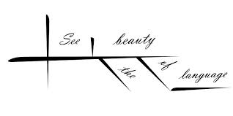

**Sentence diagrams**

[mostly repeated]

Most methods of diagramming in pedagogy are based on the work of Alonzo Reed and Brainerd Kellogg in their book *Higher Lessons in English,* first published in 1877, though the method has been updated with recent understanding of grammar. Reed and Kellogg were preceded, and their work probably informed, by W. S. Clark, who published his "balloon" method of depicting grammar in his 1847 book *A Practical Grammar: In Which Words, Phrases & Sentences are Classified According to Their Offices and Their Various Relationships to Each Another.*

Some people continue to use the Reed-Kellogg system in teaching grammar, but others have discouraged it in favor of more modern tree diagrams. However, these modern tree structures draw on techniques that were already present in Reed-Kellogg diagrams.

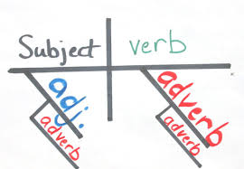The fact that the pictorial diagram groups the parts of a sentence according to their offices and relations, and not in the order of speech, has been spoken of as a fault. It is, however, a merit. It teaches the student to look through the literary order and discover the logical order. S/he learns what the literary order really is, and sees that this may be varied indefinitely, so long as the logical relations are kept clear.

The diagram drives the student to a most searching examination of the sentence, brings him/her face to face with every difficulty, and compels a decision on every point. (<http://en.wikipedia.org/wiki/Sentence_diagram>)

Over the next several weeks we will be slogging our way through the glory and divinity that is sentence diagramming. Do not be surprised if, in the upcoming weeks, your student cries foul over the use of a “red herring”.

♠

History

**Current Event Final**

[mostly repeated]

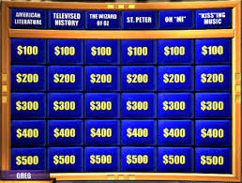The culmination for history involves a multiple-day extravaganza of knowledge, luck, and jocularity. Each day students will be a part of a group. Students **may not** partner with the same student more than once—thus, each group will be different. Groups will earn points for each task, and individuals within the group will add the points they (the group each student is in) earn from each of the four days. A final Jeopardy round, in which students can wager little to all, will determine the winner.

The current events final is a four-day affair. On day 1 (Monday 6/10), students participate in a “Core Apples to Apples” challenge. Instead of receiving cards with words, they get blank cards and the ability to create an answer.

Students will be in groups and the points they earn carry over into the following days.

Day 2 (Tuesday 6/11) involves a different group and maps. Students will get a series of maps with randomly identified nations. Their task is to identify at least fifty of the fifty-seven nations. Again, it is a small group task and the points they earn carry over into the following days.

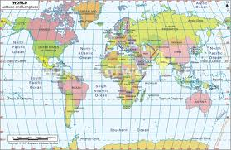Day 3 and 4 are the Jeopardy finals. Day 3 (Wednesday 6/12) is the history final. Students will be in another new group and will answer a series of questions based on the historical units presented throughout the academic year.

Day 4 (Friday 6/14) includes news items from throughout the academic year. Students will once again be in a new group and will answer questions based on the significant news from this past academic year.

An overall winner in each class will be crowned. Prizes, glory, and admiration will be showered upon the winner and life will be good.

♠

Planner **May 19 – 25**

|  |  |  |  |  |  |  |
| --- | --- | --- | --- | --- | --- | --- |
|  | **Monday 5/19** | **Tuesday 5/20** | **Wednesday 5/21** | **Thursday 5/22** | **Friday**  **5/23** | **Weekend 5/24-25** |
| **Writing**  (Language Arts) | **Writing Notebook:**  Create a constellation and the backstory.  -entries should have a title “Stars”, your name, and sufficient work to reflect the time given (at least 300 words).  **Vocabulary Final**  -review | **Writing Notebook:**  If and when I raise children, I will never…  -entries should have a title “Children”, your name, and sufficient work to reflect the time given (at least 300 words).  **Vocabulary Final**  -review | **Writing Notebook:**  Five years from now I will be…[**5/21**]  -entries should have a title “5 Years”, your name, and sufficient work to reflect the time given (at least 300 words).  Invent and describe a new food. [**5/22**]  -entries should have a title “5 Years”, your name, and sufficient work to reflect the time given (at least 300 words).  **Vocabulary Final**  -review | | **Writing Notebook:**  Make a list of 50 things that make you feel good or smile.  -entries should have a title “Children”, your name, and sufficient work to reflect the time given (at least 300 words).  **Vocabulary Final**  -review | **Vocabulary Final**  -review and work time  *final **5/29** & **5/30**  **Writing Notebook** or **Workshop**  -20’ daily entries or student project of choice  -explanation, expectations, and timeline |
| **Reading** | **20’ Reading**  -student book of choice  -student meetings  -work time for discussion assignment  **ABC Project**  -finalize page #3 | **20’ Reading**  -student book of choice  -student meetings  -work time for discussion assignments  **ABC Project**  -finalize page #3 | **20’ Reading**  -student book of choice  -student meetings  -work time for discussion assignments  **ABC Project**  -edit & revise page  *final page #3 due at the beginning of class [**5/22**]  **Discussion #8**  *assignment due at the beginning of class [**5/22**] | | **Discussion #8**  -AM = 10:30-11:15  -PM = 1:45-2:30  *post-discussion reflection due after the meeting | **ABC Project**  -draft #4 5/27 & final 5/29  -draft #5 5/30 & final 6/2  -draft #6 6/3 & final 6/5  *ABC book compiled and due at the end of class **6/5** |
| **History**  **(Social Studies)** | **History Extravaganza: US History Jeopardy**  -group jeopardy | **History Extravaganza: Current Event Jeopardy**  -group jeopardy | **History Extravaganza:**  **Core & da Vinci Jeopardy [5/21]**  -group jeopardy  **History Extravaganza:**  **Map Final [5/22]**  -group map quiz | | **History Extravaganza:**  **Core Apples to Apples**  -group game  **History Extravaganza:**  **Final Jeopardy**  -individual question | **Reconstruction & Industrialization**  -chapters 23-28  -children’s book project |
| **Other**  Contact Information for Binder  **da Vinci:** 503-916-5356 ext 79140 **Home**: 503-640-5265  voicemail: 503-916-3600 ext 79140  email: [pbinder@pps.net](mailto:pbinder@pps.net)  **WEB PAGE** <http://733257565503770808.weebly.com/> |  |  | **late opening (10:15)**  **Periods: 2, 4, & 6** | **Periods 1, 3, 5, & 7**  **Tabor Bergh**’s bday | **6th** & **7th Talent Show**  Grand Slam Round I  -3:30-6:00pm | 5/24 **Sophia Maghran**’s birthday  5/26 Memorial Day (no school)  5/27 Leo Leader lunch  5/28 Flex & music teaser  5/29 **Grace Kuhn**’s bday |