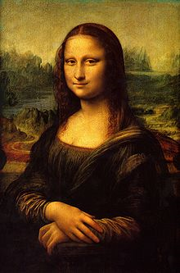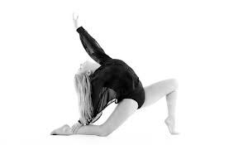**Binder Core: 5/12/2014**

**Dance & Capstones**

The curtain has fallen on the dance concert. Capstone rehearsal and panic is in the air. Please plan accordingly and manage time to avoid the traps and hazards of both. Many students are already feeling the pressure. Much of it is due to poor time management or groups that have fallen apart, but the potential for frantic and frenzied students is in the air.

Please, please, please look at the upcoming days and weeks to avoid last-minute debacles.

Many students experience and suffer from the increased stress, lack of sleep, poor diet choices, and questionable time management. Everyone experiences these in varying degrees at sporadic times in life. It is an experience one must learn to adapt to and handle, but it can and will be hard.

Good luck. Be proactive rather than reactive, and remember that the “inhibition” portion of the adolescent brain shuts down during puberty. Before you ask them, “Why did you do that?” remember that they really were not thinking and they cannot legitimately answer you—Catch 22, is it not?



♠

**Reading**

**Discussion #8**

Students will be reading and finishing the fourth and final assignment of the fourth quarter’s discussions this week. The list of chapters or pages to read and each person’s assignment is listed on the “bookmarks” that were handed to each student. The assignments for the fourth quarter and the bookmarks are available on the “[Reading](http://733257565503770808.weebly.com/reading.html)” page of my website.

I recommend keeping the bookmark and assignment with the novels the students are reading. Students should work on the assignment as they read, not try and cull meaningful quotes or descriptions after reading the entire section. The only exception might be the summarizer, but even then the student could be summarizing each chapter into a sentence as s/he goes. Yes, reality says that most students will not do that. It would, however, make their lives a lot easier.

Discussion #8 assignments are due at the beginning of class on Thursday (5/22) and the discussion is Friday (5/23). Students will complete the “post discussion” portion of the assignment after the discussion and submit it to the correct (AM or PM) reading tray.

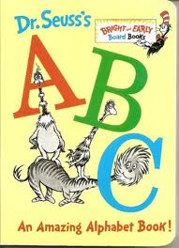The assignments, like all good things, have changed slightly. All students are being asked to create two generic and two specific discussion questions as well as listing and evaluating two quotes. Other portions of the assignment ask students to describe characters, the setting, and the plot. As always, directions should clearly delineate the expectations.

**ABC Books**

[mostly repeated]

In addition to reading a book for the discussion, students will also be expected to complete the following project:

As you read, look for literary elements such as characters, setting, conflicts, figures of speech, themes, issues, plot, foreshadowing, etc. and organize these elements using the letters of the alphabet. You will eventually be expected to create an ABC book where you give an example of any of these elements using each letter of the alphabet. You will eventually be asked to present at least part of your book in front of the class.

As you read, gather details from the book to create the individual pages for each letter of the alphabet. Be sure to record page numbers because you will need exact quotations.

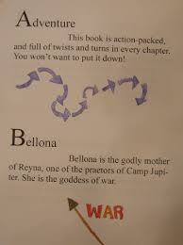For every discussion, the group will create 7 (or more) pages. At last count, there were 26 letters in the American alphabet. There are 4 discussions. 4x7= 28. That is more letters than exist. Additionally, some of the letters might be difficult to use (“x”, “q”, etc.). Several of the letters can be skipped and several of the letters can be used more than once. It is up to the group to plan accordingly.

Make sure that you include:

1. Front cover
2. Title Page – include full book title, the name of the author, publishing, and copyright information
3. Each letter should have its own page with:  • word identified • the word used in context with proper page citation  Example: “He ain’t company, Cal, he’s just a Cunningham“ (24). • an illustration or image
4. Back cover that includes: • a paragraph summary of the story that does not give away the ending • your praise (pretend you’re a critic – look at the back of other books for a model)

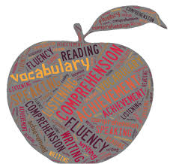Follow these guidelines, but be creative. The student handout is available via the [READING](http://733257565503770808.weebly.com/reading.html) page on the Core’s website:

♠

**Writing**

**Vocabulary #15**

This is the last list. The end is definitely near. Is there anything faster than minute rice in the microwave?

The quiz will be Thursday (5/15). It will be a “standard” quiz for all groups. Regular vocabulary students fill in blanks. It sounds easy, but it is not. Students must use context, their inherent knowledge of grammar, and a bit of educational guessing to fulfill a required number of blanks (6th = 12 and 7th = 14).

Word Within the Word students on lists #1-20 have stems and mystery questions. Students on lists #21+ have who words, stems, and a flip-side section to complete.

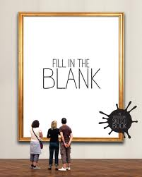

**Vocabulary Final**

[mostly repeated]

I've been waiting for you, Obi-Vocabulary. We meet again, at last. The circle is now complete. When I left you, I was but the learner; now *I* am the master.

There will be a week of study and review before the end-of-the-year vocabulary final. We will take a little time during the week of 15th-24rd to individually and collaboratively review. The final takes place over two days; Thursday, May 29th and Friday, May 30th.

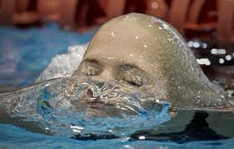The final is cumulative. I have been talking to and warning the students all year that words from each list this year will be a part of the final. Word Within the Word students have it easier; they are constantly being assessed on a cumulative basis. Regular vocabulary students have had periodic reviews—at the end of each quarter—and I have been using words from previous lists in the fill-in-the-blank sentences to help establish context.

I offered an incentive for completing assignments on time and to the best of a student’s ability. Students earned a percentage off of the final for each completed vocabulary assignment—as long as it was on time and to the best of the student’s ability. I will inform students how much “off” they earned and what that means for the final.

For both Cores, Thursday (5/29) will be the fill-in-the-blank portion for the regular vocabulary students and the “other” portions for the Word Within the Word students. The “other” portions for the W3 students can include some or all of the following: decoding, opposites, cartoons, odd-one-out, numbers, matching, mystery questions, and/or flip side.

On the second day, Friday (5/30), regular vocabulary students will complete two different crossword puzzles—one for 6 & 7 letter words and another for 8 & 9 letter words. W3 students complete stem and word definitions.

The lists for W3 students are online and a review list for regular vocabulary students has been online for several weeks.

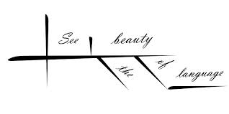

**Sentence diagrams**

[mostly repeated]

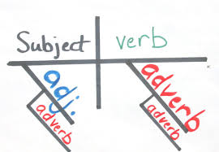Most methods of diagramming in pedagogy are based on the work of Alonzo Reed and Brainerd Kellogg in their book *Higher Lessons in English,* first published in 1877, though the method has been updated with recent understanding of grammar. Reed and Kellogg were preceded, and their work probably informed, by W. S. Clark, who published his "balloon" method of depicting grammar in his 1847 book *A Practical Grammar: In Which Words, Phrases & Sentences are Classified According to Their Offices and Their Various Relationships to Each Another.*

Some people continue to use the Reed-Kellogg system in teaching grammar, but others have discouraged it in favor of more modern tree diagrams. However, these modern tree structures draw on techniques that were already present in Reed-Kellogg diagrams.

The fact that the pictorial diagram groups the parts of a sentence according to their offices and relations, and not in the order of speech, has been spoken of as a fault. It is, however, a merit. It teaches the student to look through the literary order and discover the logical order. S/he learns what the literary order really is, and sees that this may be varied indefinitely, so long as the logical relations are kept clear.

The diagram drives the student to a most searching examination of the sentence, brings him/her face to face with every difficulty, and compels a decision on every point. (<http://en.wikipedia.org/wiki/Sentence_diagram>)

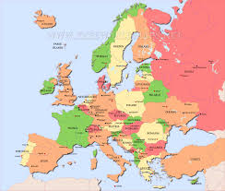Over the next several weeks we will be slogging our way through the glory and divinity that is sentence diagramming. Do not be surprised if, in the upcoming weeks, your student cries foul over the use of a “red herring”.

♠

History

**Current Event #15**

Current event #15 focuses on articles and news items from our last world region of study: Europe. Make-up and missing current events need to be presented Monday (5/12). In addition to the group news quiz on Friday (5/16), students will take an individual quiz on the nations and significant bodies of water of Europe.

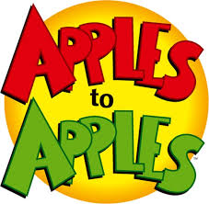The current events for the semester are by continent/world region. There are specific assignments sheets for each current event region already posted to the [CURRENT EVENT](http://733257565503770808.weebly.com/current-events.html) website.

**Current Event Final**

[mostly repeated]

The culmination for history involves a multiple-day extravaganza of knowledge, luck, and jocularity. It all starts in a couple of weeks. Each day students will be a part of a group. Students **may not** partner with the same student more than once—thus, each group will be different. Groups will earn points for each task, and individuals within the group will add the points they (the group each student is in) earn from 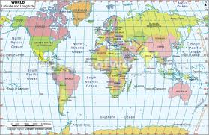each of the four days. A final Jeopardy round, in which students can wager little to all, will determine the winner.

The current events final is a four-day affair. On day 1 (Monday 6/10), students participate in a “Core Apples to Apples” challenge. Instead of receiving cards with words, they get blank cards and the ability to create an answer.

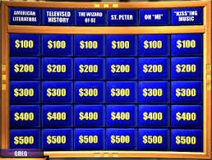Students will be in groups and the points they earn carry over into the following days.

Day 2 (Tuesday 6/11) involves a different group and maps. Students will get a series of maps with randomly identified nations. Their task is to identify at least fifty of the fifty-seven nations. Again, it is a small group task and the points they earn carry over into the following days.

Day 3 and 4 are the Jeopardy finals. Day 3 (Wednesday 6/12) is the history final. Students will be in another new group and will answer a series of questions based on the historical units presented throughout the academic year.

Day 4 (Friday 6/14) includes news items from throughout the academic year. Students will once again be in a new group and will answer questions based on the significant news from this past academic year.

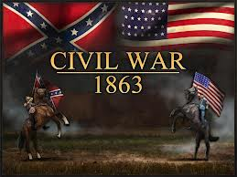An overall winner in each class will be crowned. Prizes, glory, and admiration will be showered upon the winner and life will be good.

**Civil War**

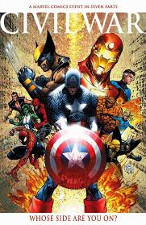Expansion westward seemed perfectly natural to many Americans in the mid-nineteenth century. Like the Massachusetts Puritans who hoped to build a "city upon a hill, "courageous pioneers believed that America had a divine obligation to stretch the boundaries of their noble republic to the Pacific Ocean. Independence had been won in the Revolution and reaffirmed in the War of 1812. The spirit of nationalism that swept the nation in the next two decades demanded more territory. The "every man is equal" mentality of the Jacksonian Era fueled this optimism. Now, with territory up to the Mississippi River claimed and settled and the Louisiana Purchase explored, Americans headed west in droves. Newspaper editor John O'Sullivan coined the term "manifest destiny" in 1845 to describe the essence of this mindset.

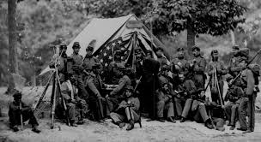The religious fervor spawned by the Second Great Awakening created another incentive for the drive west. Indeed, many settlers believed that God himself blessed the growth of the American nation. The Native Americans were considered heathens. By Christianizing the tribes, American missionaries believed they could save souls and they became among the first to cross the Mississippi River.

Economic motives were paramount for others. European trading companies had dominated the fur trade since colonial times. German immigrant John Jacob Astor was one of the first American entrepreneurs to challenge the Europeans. He became a millionaire in the process. The desire for more land brought aspiring homesteaders to the frontier. When gold was discovered in California in 1848, the number of migrants increased even more.

At the heart of manifest destiny was the pervasive belief in American cultural and racial superiority. Native Americans had long been perceived as inferior, and efforts to "civilize" them had been widespread since the days of John Smith and Miles Standish. The Hispanics who ruled Texas and the lucrative ports of California were also seen as "backward."

In 1840, the entire southwestern corner of the United States was controlled by foreign powers (shown in orange), and the territorial dispute over the Oregon Territory (light green) had not been settled. By 1850 the U.S. had control of lands from the Atlantic to the Pacific, covering almost all of today's continental United States.

Expanding the boundaries of the United States was in many ways a cultural war as well. The desire of southerners to find more lands suitable for cotton cultivation would eventually spread slavery to these regions. North of the Mason-Dixon line, many citizens were deeply concerned about adding any more slave states. Manifest destiny touched on issues of religion, money, race, patriotism, and morality. These clashed in the 1840s as a truly great drama of regional conflict began to unfold. (<http://www.ushistory.org/us/29.asp>)

This week, students will read chapter 18 dealing with the dichotomy between the North and the South. Next week students will read chapter 19 dealing with African Americans and take a quiz over chapter 19-20. It will be rolled into the current events #14 and Oceania map quiz on Friday (5/2).

♠

Planner **May 5 – 11**

|  |  |  |  |  |  |  |
| --- | --- | --- | --- | --- | --- | --- |
|  | **Monday 5/12** | **Tuesday 5/13** | **Wednesday 5/14** | **Thursday 5/15** | **Friday**  **5/16** | **Weekend 5/17-18** |
| **Writing**  (Language Arts) | **Grammar #15**  -good beginnings & good endings…rules, proper nouns, proper adjectives, & when not to capitalize  -practice | **Grammar #15**  -good beginnings & good endings…question marks, period, exclamation points, and when not to use  -practice | **Sentence Diagrams**  -subject, predicate, horizontal line, vertical line, and modifiers  -Type 1-IV review diagrams  -practice (sidewalk chalk?)  **grammar #15 assignment**  -due **beginning** of class [5/14]  **Vocab #15 Quiz [5/15]**  -regular = fill-in-the-blank sentences  -W3 #1-20 = stems & mystery questions  -W3 #21+ = words, definitions, stems & flip side | | **Sentence Diagrams**  -subject, predicate, horizontal line, vertical line, and modifiers  -Type V+ diagrams  - more practice (sidewalk chalk?) | **Vocabulary Final**  -review and work time 5/19-  *grammar assignment due 5/14  -quiz 5/15  **Writing Notebook** or **Workshop**  -20’ daily entries or student project of choice  -explanation, expectations, and timeline |
| **Reading** | **20’ Reading**  -student book of choice  -student meetings  -work time for discussion assignment  **ABC Project**  -draft 7 pages as a group | **20’ Reading**  -student book of choice  -student meetings  -work time for discussion assignments  **ABC Project**  -draft 7 pages as a group | **20’ Reading**  -student book of choice  -student meetings  -work time for discussion assignments  **ABC Project**  -edit & revise pages…should have 21 completed pages | | **20’ Reading**  -student book of choice  -student meetings  -work time for discussion assignments | **Discussion #8**  -assignment due 5/22  -discussion 5/23  **ABC Project**  -total of 28 pages edited & revised by 5/29, with the process of putting it all together |
| **History**  **(Social Studies)** | **Current Event #15: Europe**  -make-up & missing  **Civil War**  - "The Civil War" (HA chapter 22: pages 302-321)  -lecture & presentation | **Current Event #15: Europe**  -update & review  **Civil War**  - "The Civil War" (HA chapter 22: pages 302-321)  -lecture & presentation | **Civil War**  - "The Civil War" (HA chapter 22: pages 302-321)  -lecture & presentation  **History Extravaganza**  -review of the format, events, and grouping  -students submit lists of groupings | | **Current Event #15 Quiz**  -group current event #15, & chapters 21-22  -individual Europe map quiz | **Reconstruction & Industrialization**  -chapters 23-28  -children’s book project  **History Extravaganza**  -day 1 (5/19): History Jeopardy  -day 2 (5/20): Current Events Jeopardy  -day 3 (5/21): Core & da Vinci Jeopardy  -day 4 (5/22): map final  -day 5 (5/23): Core “Apples to Apples” & Final Jeopardy |
| **Other**  Contact Information for Binder  **da Vinci:** 503-916-5356 ext 79140 **Home**: 503-640-5265  voicemail: 503-916-3600 ext 79140  email: [pbinder@pps.net](mailto:pbinder@pps.net)  **WEB PAGE** <http://733257565503770808.weebly.com/> |  | **midterm**  end of the year **Talent** **Show** auditions during lunch | **Periods: 2, 4, 6, & Flex**  end of the year **Talent** **Show** auditions during lunch | **Periods 1, 3, 5, & 7**  end of the year **Talent** **Show** auditions during lunch | **Periods: 1-7**  **Student Dance** 3-5:00 | 5/21 late opening & **QSA** 3-4:30pm  5/22 **Tabor Bergh**’s bday & Slam Round I 3:30-6:00pm  5/23 **6th & 7th Talent Show** & Grand Slam |