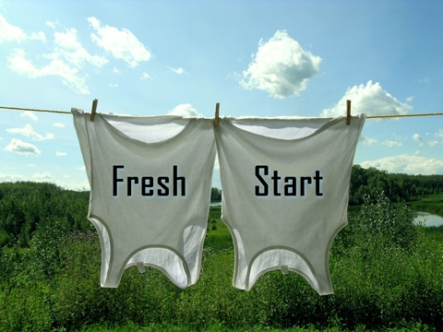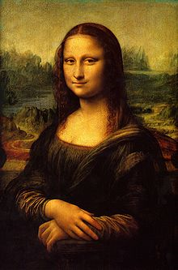**Binder Core: 4/21/2014**

**Another Fresh Start**

[mostly repeated]

The fourth quarter has begun. Everyone has a fresh start. It is a time to cast off the old, and start with something new…a new attitude (hopefully, a good one), a new energy, and a new purpose.

It is a long push to the end with only Memorial Day to break up the journey. This is the time of year when apathy and procrastination take hold. Keep your heads up. Although it is a long push, it goes by incredibly fast. The sheer multiplicity of events, shows, pull-outs, etc., wreaks havoc and mayhem on our schedule and student organization.

Use the Google calendar, planner, Synergy, and time management skills to keep track of work and plan ahead. Use a reward system, take things away, etc. to motivate students. Communicate any issues or concerns.



♠

**Reading**

**Discussion #6**

The assignments, like all good things, have changed slightly. All students are being asked to create two generic and two specific discussion questions as well as listing and evaluating two quotes. Other portions of the assignment ask students to describe characters, the setting, and the plot. As always, directions should clearly delineate the expectations and the point values. Questions should be asked earlier, rather than later.

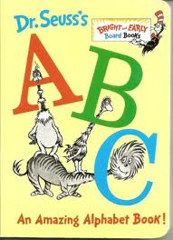The assignment for the discussion, #6, is due Thursday (4/24) and the discussion is Friday (4/25). The assignment is due a day **before** the discussion so that I have time to evaluate and provide feedback on the assignment. It is something that I have learned over the years and it has generated better discussions. The post-discussion reflection is due **after** the discussion.

**ABC Books**

In addition to reading a book for the discussion, students will also be expected to complete the following project:

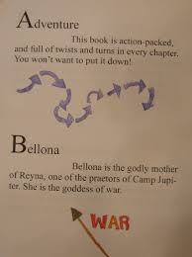As you read, look for literary elements such as characters, setting, conflicts, figures of speech, themes, issues, plot, foreshadowing, etc. and organize these elements using the letters of the alphabet. You will eventually be expected to create an ABC book where you give an example of any of these elements using each letter of the alphabet. You will eventually be asked to present at least part of your book in front of the class.

As you read, gather details from the book to create the individual pages for each letter of the alphabet. Be sure to record page numbers because you will need exact quotations.

Make sure that you include:

1. Front cover
2. Title Page – include full book title, the name of the author, publishing, and copyright information
3. Each letter should have its own page with:  • word identified • the word used in context with proper page citation  Example: “He ain’t company, Cal, he’s just a Cunningham“ (24). • an illustration or image
4. Back cover that includes: • a paragraph summary of the story that does not give away the ending • your praise (pretend you’re a critic – look at the back of other books for a model)

Follow these guidelines, but be creative.

♠

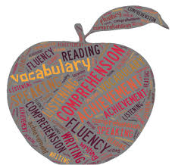

**Writing**

**Vocabulary #14**

We will work on vocabulary #14 list Monday and Tuesday (4/21-22). The vocabulary #14 assignment is due Friday (4/25). The quiz will be the following Thursday (5/1). The end is near…can you see it?

The quizzes continue to follow the same format. Regular vocabulary students attempt to change the color of their toad and Word Within the Word students practice their “swish and flick” maneuver. Codswallop! That is *Harry Potter*?

Regular vocabulary students fill in blanks. It sounds easy, but it is not. Students must use context, their inherent knowledge of grammar, and a bit of educational guessing to fulfill a required number of blanks (6th = 12 and 7th = 14).

Word Within the Word students on lists #1-20 have stems and mystery questions. Students on lists #21+ have who words, stems, and a flip-side section to complete.

**Sentence diagrams**

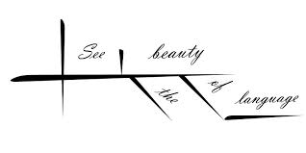Most methods of diagramming in pedagogy are based on the work of Alonzo Reed and Brainerd Kellogg in their book *Higher Lessons in English,* first published in 1877, though the method has been updated with recent understanding of grammar. Reed and Kellogg were preceded, and their work probably informed, by W. S. Clark, who published his "balloon" method of depicting grammar in his 1847 book *A Practical Grammar: In Which Words, Phrases & Sentences are Classified According to Their Offices and Their Various Relationships to Each Another.*

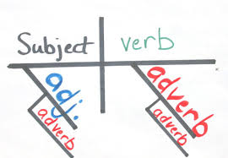Some people continue to use the Reed-Kellogg system in teaching grammar, but others have discouraged it in favor of more modern tree diagrams. However, these modern tree structures draw on techniques that were already present in Reed-Kellogg diagrams.

The fact that the pictorial diagram groups the parts of a sentence according to their offices and relations, and not in the order of speech, has been spoken of as a fault. It is, however, a merit. It teaches the student to look through the literary order and discover the logical order. S/he learns what the literary order really is, and sees that this may be varied indefinitely, so long as the logical relations are kept clear.

The diagram drives the student to a most searching examination of the sentence, brings him/her face to face with every difficulty, and compels a decision on every point. (<http://en.wikipedia.org/wiki/Sentence_diagram>)

Over the next several weeks we will be slogging our way through the glory and divinity that is sentence diagramming. Do not be surprised if, in the upcoming weeks, your students cries foul over the use of a “red herring”.

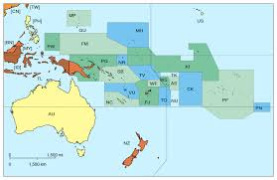

♠

History

**Current Event #14**

Current event #14 focuses on articles and news items from our smallest and least populated world region of study: Oceania. Presentations are this week Monday through Friday (4/21-25). Make-up and missing current events need to be presented Monday (4/28). In addition to the individual news quiz on Friday (5/2), students will take an individual quiz on the nations and significant bodies of water of Oceania.

The current events for the rest of the semester are by continent/world region. There are specific assignments sheets for each current event region already posted to the [CURRENT EVENT](http://733257565503770808.weebly.com/current-events.html) website.

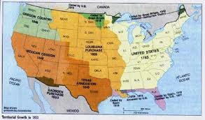

**Manifest Destiny**

Expansion westward seemed perfectly natural to many Americans in the mid-nineteenth century. Like the Massachusetts Puritans who hoped to build a "city upon a hill, "courageous pioneers believed that America had a divine obligation to stretch the boundaries of their noble republic to the Pacific Ocean. Independence had been won in the Revolution and reaffirmed in the War of 1812. The spirit of nationalism that swept the nation in the next two decades demanded more territory. The "every man is equal" mentality of the Jacksonian Era fueled this optimism. Now, with territory up to the Mississippi River claimed and settled and the Louisiana Purchase explored, Americans headed west in droves. Newspaper editor John O'Sullivan coined the term "manifest destiny" in 1845 to describe the essence of this mindset.

The religious fervor spawned by the Second Great Awakening created another incentive for the drive west. Indeed, many settlers believed that God himself blessed the growth of the American nation. The Native Americans were considered heathens. By Christianizing the tribes, American missionaries believed they could save souls and they became among the first to cross the Mississippi River.

Economic motives were paramount for others. The fur trade had been dominated by European trading companies since colonial times. German immigrant John Jacob Astor was one of the first American entrepreneurs to challenge the Europeans. He became a millionaire in the process. The desire for more land brought aspiring homesteaders to the frontier. When gold was discovered in California in 1848, the number of migrants increased even more.

At the heart of manifest destiny was the pervasive belief in American cultural and racial superiority. Native Americans had long been perceived as inferior, and efforts to "civilize" them had been widespread since the days of John Smith and Miles Standish. The Hispanics who ruled Texas and the lucrative ports of California were also seen as "backward."

In 1840, the entire southwestern corner of the United States was controlled by foreign powers (shown in orange), and the territorial dispute over the Oregon Territory (light green) had not been settled. By 1850 the U.S. had control of lands from the Atlantic to the Pacific, covering almost all of today's continental United States.

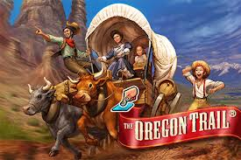Expanding the boundaries of the United States was in many ways a cultural war as well. The desire of southerners to find more lands suitable for cotton cultivation would eventually spread slavery to these regions. North of the Mason-Dixon line, many citizens were deeply concerned about adding any more slave states. Manifest destiny touched on issues of religion, money, race, patriotism, and morality. These clashed in the 1840s as a truly great drama of regional conflict began to unfold. (<http://www.ushistory.org/us/29.asp>)

This week, students will read chapter 18 dealing with the dichotomy between the North and the South. Next week students will read chapter 19 dealing with African Americans and take a quiz over chapter 19-20. It will be rolled into the current events #14 and Oceania map quiz on Friday (5/2).

♠

Planner **April 21 – 20**

|  |  |  |  |  |  |  |
| --- | --- | --- | --- | --- | --- | --- |
|  | **Monday 4/21** | **Tuesday 4/22** | **Wednesday 4/23** | **Thursday 4/24** | **Friday**  **4/25** | **Weekend 4/26-27** |
| **Writing**  (Language Arts) | **Vocabulary #14**  -regular = words #1-10  -W3 #1-20 = sentences  -W3 #21+ = list | **Vocabulary #14**  -regular = words #11-20  -W3 #1-20 = sentences  -W3 #21+ = list & ideas | **Sentence Diagrams**  -introduction  -subject, predicate, horizontal line, vertical line, and modifiers  -Type I diagrams  -practice (sidewalk chalk?) | | **\*vocab #14 assignment**  -due **beginning** of class  -regular vocabulary = 5 cartoons **or** sentences  -W3 #1-20 = flashcards & sentences  -W3 #21+ = flashcards & ideas  **Sentence Diagrams**  -subject, predicate, horizontal line, vertical line, and modifiers  -Type II diagrams  - more practice (sidewalk chalk?) | **Vocabulary #14**  -grammar #14 guidance & work 4/28-29  *grammar assignment due 4/30  -quiz 5/1  **Sentence Diagrams**  -the journey continues with types III and more |
| **Reading** | **20’ Reading**  -student book of choice  -student meetings  -work time for discussion assignments | **20’ Reading**  -student book of choice  -student meetings  -work time for discussion assignments | **20’ Reading**  -student book of choice  -student meetings  -work time for discussion assignments  **ABC Project**  -edit & revise pages  **Discussion #6**  *assignment due at the beginning of class [**4/24**] | | **Discussion #6**  -AM = 10:30-11:15  -PM = 1:45-2:30  *post-discussion reflection due after the meeting | **Discussion #7**  -assignment due 5/8  -discussion 5/9  **ABC Project**  -draft 7 more pages by 4/30  **Chains**  -novel read aloud |
| **History**  **(Social Studies)** | **Current Event #14: Oceania**  -Daily Show groups Spaceballs  **Manifest Destiny Quiz**  -chapters 16-18  -students can use their notes | **Current Event #14: Oceania**  -Daily Show groups Animal Lovers & Jiffy Lube  **Manifest Destiny**  -"The Worlds of North and South" (chapter 19: pages 252-267)  -lecture & presentation | **Current Event #14: Oceania**  -Daily Show groups 1/6 & Mocking Ninnies [4/23]  -Daily Show groups Bulbous Daily Show & Hello Show [4/24]  **Manifest Destiny**  -"The Worlds of North and South" (chapter 19: pages 252-267)  -lecture & presentation | | **Current Event #14: Oceania**  -Daily Show groups Dragons & Flandersons  **Manifest Destiny**  -"African Americans at Mid-Century" (HA chapter 20: pages 268-283)  -lecture & presentation | **Current Event #14: Oceania**  -make-up & missing 4/28  -individual current event & individual Asia map quiz 5/2  **Manifest Destiny**  -"African Americans at Mid-Century" (HA chapter 20: pages 268-283)  -quiz on chapters 19-20 part of individual current event #14 quiz 5/2 |
| **Other**  Contact Information for Binder  **da Vinci:** 503-916-5356 ext 79140 **Home**: 503-640-5265  voicemail: 503-916-3600 ext 79140  email: [pbinder@pps.net](mailto:pbinder@pps.net)  **WEB PAGE** <http://733257565503770808.weebly.com/> |  | Leo Leader lunch | **Periods: 2, 4, 6, & Flex**  **FLEX** = 6th & 7th forecasting | **Periods 1, 3, 5, & 7**  **Zoë Neilson**’s bday |  | 4/28-5/2 dance blackout  4/29 periods 2, 4, 6, & Flex  4/30 periods 1-7  5/1 periods 1, 3, 5, & 7  5/2 **Kylie Ristvedt**’s bday  5/3 **Killian Anreise**’s bday |