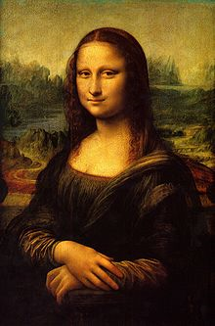**Binder Core: 4/7/2014**

**Grades**

I have been receiving a lot of emails, phone calls, and other communications regarding grades. Please allow me time and space to offer global comments.

My first recommendation is to have a **conversation** with your student(s). Communication with a middle-school student can be difficult (to put it mildly). It is the best starting point. I ask the students to do the same thing—communicate with the parents. Going around people, asking not to tell “so-and-so”, and other tactics do not support good communication. Please do not ask me to do something I would not do with my children. Communicate…communicate…communicate. If at first you do not succeed, try again, but use a different approach.

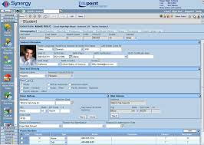My second recommendation is to use **Synergy**. I spend a lot of time entering grades and comments in a timely manner. Please read the assignment description (the narrative explaining the assignment) and any comments I entered regarding the assignment of the student. In most cases, if the grade is 79% or below I enter specific comments about the student’s performance. If the assignment was a multiple-choice quiz, however, I just enter the score. There is little comment necessary.

Part of this, however, is reviewing the assignment with the student. What did they complete, or in some cases—not complete? Did they read and follow the directions? Did they give themselves enough time to complete the assignment well? Did they review the assignment for errors in conventions? Etc…etc…etc.

Synergy will provide a sensible and appropriate **snapshot** of the student’s grade. At the beginning of a new grading period it is a little skewed, however, owing to the lack of assignments. A poor performance on one of the two assignments at the beginning of the grading period will have a large influence on the grade at the time. If you do not have access to Synergy, check with the office for instructions on how to access the system.

Third, and final suggestion is to communicate with me. Please do your homework before contacting me (the first and second recommendations) so that we can discuss grades from an enlightened position. You will have to complete the first two step anyways, so you might as well get them over with before communicating with me.

I have met and had fantastic conversations with a good number of parents and students in the past several weeks. It is wonderful to sit down and make sure everyone is on the same page and to hash out any issues. Please let me know if you would like to have a conversation, but please do so sooner than later. My schedule is a bit hectic and I want to work with you to schedule meaningful time together.

♠

**Reading**

**Discussion #5**

The assignments, like all good things, have changed slightly. All students are being asked to create two generic and two specific discussion questions as well as listing and evaluating two quotes. Other portions of the assignment ask students to describe characters, the setting, and the plot. As always, directions should clearly delineate the expectations and the point values. Questions should be asked earlier, rather than later.

The choice of a novel is often a contentious and touchy issue. I do not wish to step on any toes or push a student into reading a subject matter they are not ready for or comfortable with. Your help, respect, communication, and diligence are appreciated.

The assignment for the discussion, #5, is due Wednesday (4/9) and the discussion is Thursday (4/10)—it is the end of the third quarter that week and there are no students on Friday, thus, the earlier discussion assignment due date and discussion. The assignment is due a day **before** the discussion so that I have time to evaluate and provide feedback on the assignment. It is something that I have learned over the years and it has generated better discussions. The post-discussion reflection is due **after** the discussion.

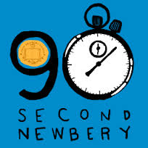

**90” Films**

*courtesy of James Kennedy*

The 90-Second Newbery Film Festival is a video contest in which filmmakers of any age make movies that tell the entire story of a Newbery award-winning book in 90 seconds or less. Not all 3rd quarter novels are Newbery winners, but all discussion groups will complete a 90" film.

Ever since 1922, the Newbery Medal has been recognized as the most prestigious award in children’s literature. But it turns out that any book, no matter how worthy and somber, becomes pleasingly ludicrous when compressed into 90 seconds.

Everyone enters. Everyone wins! There will be awards.

The rules:

1. Your video should be 90 seconds or less. (Okay, okay: if it’s two minutes long but absolute genius, we’ll bend the rules for you. But let’s try to keep them short.)
2. No book trailers! No video book reports! We’re looking for full-on dramatizations, with mostly child actors, that manage to tell the entire story of the book in 90 seconds.
3. Upload your videos to YouTube or Vimeo or whatever and send Binder the the link at pbinder@pps.net and kennedyjames@gmail.com (if your novel is a Newbery novel). For Mr. Kennedy, make the subject line be “90 SECOND NEWBERY” and please tell me your name, age, where you’re from, and whatever other comments you’d like to include, including whether you’d like me to link to your personal site. You can give an alias if you want; I understand privacy concerns.
4. Sending the link to Mr. Kennedy grants him (James Kennedy) the right to post it on his blog and to other websites where he sometimes posts content (like Facebook, Twitter, etc.) and to share at public readings, school visits—and hopefully the “90-Second Newbery” Film Festival screenings!

Intimidated? Don’t know where to start? I recommend checking out this handy guide of tips, tricks, and strategies for making a 90-Second Newbery.

[http://houston.kidsoutandabout.com/sites/default/files/images/Curriculum for Creating a 90-Second Newbery Film.pdf](http://houston.kidsoutandabout.com/sites/default/files/images/Curriculum%20for%20Creating%20a%2090-Second%20Newbery%20Film.pdf)

♠

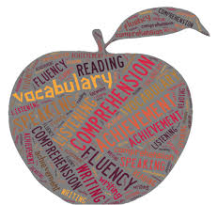

**Writing**

**Vocabulary #13**

We will work on vocabulary #13 list Monday and Tuesday (4/7-8). Due to the shortened week, the vocabulary #13 assignment is due Thursday (4/10). The quiz will be the following Thursday (4/17).

With regards to vocabulary assignments, we continue to struggle with the same issues. Many regular vocabulary students are using part, parts, or all of the definition to provide context for the vocabulary words. Many Word Within the Word students are still not rereading the example sentences with the definition they created to see if their definition “fits and makes sense” in the example sentence. I have pontificated on this subject ad nauseum. I will simply hand back the entire assignment for revision from now on. My repeated requests and offers for help have fallen upon deaf ears (what?).

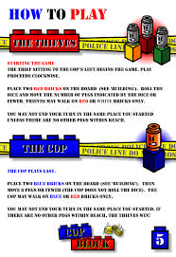

**Create-a-Board-Game**

[mostly repeated]

Students will research, design, and create a game board. The board game can be a card game, but the cards cannot be a standard 52 card (54 with Jokers) deck.

1. Design and make a board game.
   1. Use cardboard, tag board, construction paper, legal sized file folders, augment an older board game, etc.
   2. Decorate the board and box with art that relates to the game.
   3. There should be a START and FINISH box connected by at least a 50-space path.
   4. Create playing pieces that relate to the game (a minimum of 4).
2. Make up and write the rules for the game.
3. Playtest the game in various draft forms.  Adjust (correct) parts of your game as needed.
4. Exchange and play the games of other students.
5. Complete an evaluation form for each game played.

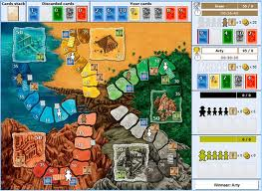Students have researched board games and submitted a premise of their idea for their board game projects. We will have time this week to finish drafting our rulebooks. However, students should be prepared to work on rulebook rough drafts at home if they don’t use their class time wisely.

Here are a couple of due dates to keep in mind:

* Rough draft of rules due today: Monday, March 10
* First test of draft game board: Monday-Thursday, March 17-20
* Second test of draft game board: Monday-Friday, March 31-April 4
* Final project due: **Monday, April 14**

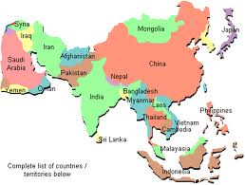

♠

History

**Current Event #13**

Current event #13 focuses on articles and news items from Asia. Current event presentations are this week, 4/7-4/10. Friday daily show participants need to present an article at any time during the week. Make-up and missing current events need to be presented Monday 4/14. In addition to the group news quiz on Friday (4/18), students will take an individual quiz on the nations and significant bodies of water of Asia. The quiz has an increasing level of expectation for each grade level for the map.

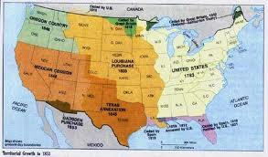The current events for the rest of the semester are by continent/world region. There are specific assignments sheets for each current event region already posted to the [CURRENT EVENT](http://733257565503770808.weebly.com/current-events.html) website.

**Manifest Destiny**

Expansion westward seemed perfectly natural to many Americans in the mid-nineteenth century. Like the Massachusetts Puritans who hoped to build a "city upon a hill, "courageous pioneers believed that America had a divine obligation to stretch the boundaries of their noble republic to the Pacific Ocean. Independence had been won in the Revolution and reaffirmed in the War of 1812. The spirit of nationalism that swept the nation in the next two decades demanded more territory. The "every man is equal" mentality of the Jacksonian Era fueled this optimism. Now, with territory up to the Mississippi River claimed and settled and the Louisiana Purchase explored, Americans headed west in droves. Newspaper editor John O'Sullivan coined the term "manifest destiny" in 1845 to describe the essence of this mindset.

The religious fervor spawned by the Second Great Awakening created another incentive for the drive west. Indeed, many settlers believed that God himself blessed the growth of the American nation. The Native Americans were considered heathens. By Christianizing the tribes, American missionaries believed they could save souls and they became among the first to cross the Mississippi River.

Economic motives were paramount for others. The fur trade had been dominated by European trading companies since colonial times. German immigrant John Jacob Astor was one of the first American entrepreneurs to challenge the Europeans. He became a millionaire in the process. The desire for more land brought aspiring homesteaders to the frontier. When gold was discovered in California in 1848, the number of migrants increased even more.

At the heart of manifest destiny was the pervasive belief in American cultural and racial superiority. Native Americans had long been perceived as inferior, and efforts to "civilize" them had been widespread since the days of John Smith and Miles Standish. The Hispanics who ruled Texas and the lucrative ports of California were also seen as "backward."

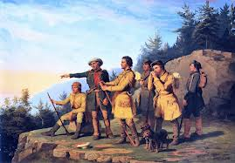In 1840, the entire southwestern corner of the United States was controlled by foreign powers (shown in orange), and the territorial dispute over the Oregon Territory (light green) had not been settled. By 1850 the U.S. had control of lands from the Atlantic to the Pacific, covering almost all of today's continental United States.

Expanding the boundaries

of the United States was in many

ways a cultural war as well. The

desire of southerners to find more

lands suitable for cotton cultivation

would eventually spread slavery to

these regions. North of the Mason-Dixon line, many citizens were deeply concerned about adding any more slave states. Manifest destiny touched on issues of religion, money, race, patriotism, and morality. These clashed in the 1840s as a truly great drama of regional conflict began to unfold. (<http://www.ushistory.org/us/29.asp>)

Next week, students will take a quiz over chapter 16-18. It will be rolled into the current events #13 and Asia map quiz on Friday (4/18).

♠

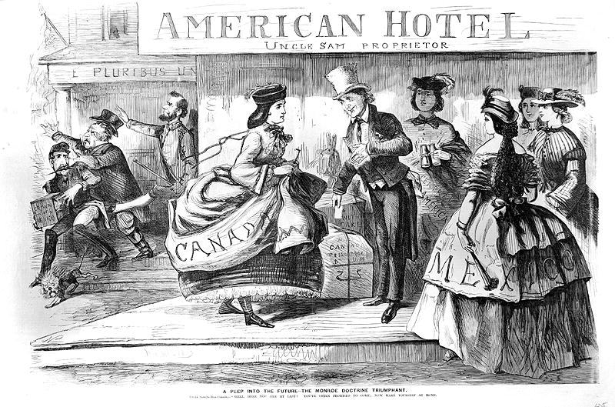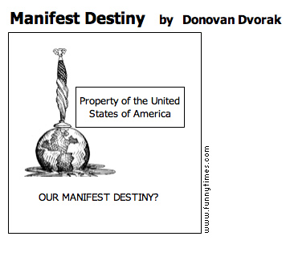

Planner **April 7 – 13**

|  |  |  |  |  |  |  |
| --- | --- | --- | --- | --- | --- | --- |
|  | **Monday 4/7** | **Tuesday 4/8** | **Wednesday 4/9** | **Thursday 4/10** | **Friday**  **4/11** | **Weekend 4/12-13** |
| **Writing**  (Language Arts) | **Vocabulary #13**  -regular = words #1-10  -W3 #1-20 = sentences  -W3 #21+ = list  **Create-a-Board-Game**  -revise board game for final draft  -box/container creation  -finalize rulebook  -make-up missing playtesting time | **Vocabulary #13**  -regular = words #11-20  -W3 #1-20 = sentences  -W3 #21+ = list & ideas  **Create-a-Board-Game**  -revise board game for final draft  -box/container creation  -finalize rulebook  -make-up missing playtesting time | **Create-a-Board-Game**  -revise board game for final draft  -box/container creation  -finalize rulebook  -make-up missing playtesting time  **\*vocab #13 assignment**  -due **beginning** of class [4/10]  -regular vocabulary = 5 cartoons **or** sentences  -W3 #1-20 = flashcards & sentences  -W3 #21+ = flashcards & ideas | | Grading Day | **Vocabulary #13**  -grammar #13 guidance & work 4/14-15  *grammar assignment due 4/16  -quiz 4/17  √  **Create-a-Board Game (CABG)**  -final product due 4/14 |
| **Reading** | **90” Film**  *project due at **beginning** of class  -share  **20’ Reading**  -student book of choice  -student meetings | **20’ Reading**  -student book of choice  -student meetings  -work time for discussion assignments | **20’ Reading**  -student book of choice  -student meetings  **Discussion #5**  *assignment due at the beginning of class [**4/9**]  **Discussion #5 [4/10]**  -AM = 10:30-11:15  -PM = 1:45-2:30  *post-discussion reflection due after the meeting | |  | **Discussion #6**  -assignment due 4/24  -discussion 4/25  **ABC Project**  -draft 7 pages  **Chains**  -novel read aloud |
| **History**  **(Social Studies)** | **Current Event #13: Asia**  -Daily Show groups Team II & Spaceballs  **Manifest Destiny**  -"Mexicano Contributions to the Southwest" (chapter 17: pages 228-239)  -lecture & presentation | **Current Event #13: Asia**  -Daily Show groups Animal Lovers & Jiffy Lube  **Manifest Destiny**  -"Mexicano Contributions to the Southwest" (chapter 17: pages 228-239)  -lecture & presentation | **Current Event #13: Asia**  -Daily Show groups Hungry Cows & Mocking Ninnies [4/9]  -Daily Show groups Bulbous Daily Show & Hello Show [4/10]  **Manifest Destiny**  -"Mexicano Contributions to the Southwest" (chapter 17: pages 228-239)  -"An Era of Reform" (chapter 18: pages 240-251)  -lecture & presentation | |  | **Current Event #13: Asia**  -presentations 4/7-10# (Friday people present any day)  -make-up & missing presentations 4/14  -group current event & individual Asia map quiz 4/18  **Manifest Destiny**  -"An Era of Reform" (chapter 18: pages 240-251)  -quiz on chapters 16-18 part of group current event #13 quiz |
| **Other**  Contact Information for Binder  **da Vinci:** 503-916-5356 ext 79140 **Home**: 503-640-5265  voicemail: 503-916-3600 ext 79140  email: [pbinder@pps.net](mailto:pbinder@pps.net)  **WEB PAGE** <http://733257565503770808.weebly.com/> | **Ivy Foxall**’s birthday | **Periods 1, 3, 5, & 7**  Leo Leader lunch | **Periods: 2, 4, 6, & FLEX (Run for the Arts)**  Site Council 4-5:30 | End of 3rd Quarter  **Chloe Daugherty-Brunak**’s birthday | teacher grading day  **Isaac Sten**’s birthday | 4/16 **Zach Powers**’s birthday, **late opening**, & **QSA** 3-4:30pm  4/17 **Zoë Neilson**’s birthday  4/21-25 dance blackout  4/22 Leo Leader lunch  4/23 FLEX for 6th & 7th = forecasting |