**Binder Core: 3/31/2014**

**Quarter’s End**

****The 3rd quarter ends Thursday (4/10). Friday (4/11), is a teacher work day to finish grades—students do not have classes. For the most part, work completed this week will start off the 4th quarter grade.

**Post Spring**

**Break Blahs**

It is a long push to the end with only Memorial Day to break up the journey. This is the time of year when apathy and procrastination take hold. Keep your heads up. Although it is a long push, it goes by incredibly fast. The sheer multiplicity of events, shows, pull-outs, etc. wreaks havoc and mayhem on our schedule and student organization.

****Use the Google calendar, planner, Synergy, and time management skills to keep track of work and plan ahead. Use a reward system, take things away, etc. to motivate students. Communicate any issues or concerns.

♠

**Reading**

**4th Quarter Discussion Groups**

We will gather and go through the recommendations in class on Monday and Tuesday (3/17-18). Unlike third quarter, students will be placed into groups first, and then the groups will list their top choices. Students (and parental units) will have a little time and wiggle room to alter choices and groupings, but by Monday, March 31st students need to have a copy of the novel they will be reading. Students who cannot obtain a copy or reserve a copy for check-out or purchase will be corralled into a group and select a novel from da Vinci’s library.

The choice of a novel is often a contentious and touchy issue. I do not wish to step on any toes or push a student into reading a subject matter they are not ready for or comfortable with. Your help, respect, communication, and diligence are appreciated.

****The assignment for the discussion, #5, is due Wednesday (4/9) and the discussion is Thursday (4/10)—it is the end of the third quarter that week and there are no students on Friday, thus, the earlier discussion assignment due date and discussion. The assignment is due a day **before** the discussion so that I have time to evaluate and provide feedback on the assignment. It is something that I have learned over the years and it has generated better discussions. The post-discussion reflection is due **after** the discussion.

**90” Films**

The 90-Second Newbery Film Festival is a video contest in which filmmakers of any age make movies that tell the entire story of a Newbery award-winning book in 90 seconds or less. Not all 3rd quarter novels are Newbery winners, but all discussion groups will complete a 90" film.

Ever since 1922, the Newbery Medal has been recognized as the most prestigious award in children’s literature. But it turns out that any book, no matter how worthy and somber, becomes pleasingly ludicrous when compressed into 90 seconds.

Everyone enters. Everyone wins! There will be awards.

The rules:

1. Your video should be 90 seconds or less. (Okay, okay: if it’s two minutes long but absolute genius, we’ll bend the rules for you. But let’s try to keep them short.)
2. No book trailers! No video book reports! We’re looking for full-on dramatizations, with mostly child actors, that manage to tell the entire story of the book in 90 seconds.
3. Upload your videos to YouTube or Vimeo or whatever and send Binder the the link at pbinder@pps.net and kennedyjames@gmail.com (if your novel is a Newbery novel). For Mr. Kennedy, make the subject line be “90 SECOND NEWBERY” and please tell me your name, age, where you’re from, and whatever other comments you’d like to include, including whether you’d like me to link to your personal site. You can give an alias if you want; I understand privacy concerns.
4. Sending the link to Mr. Kennedy grants him (James Kennedy) the right to post it on his blog and to other websites where he sometimes posts content (like Facebook, Twitter, etc.) and to share at public readings, school visits—and hopefully the “90-Second Newbery” Film Festival screenings!

Intimidated? Don’t know where to start? I recommend checking out this handy guide of tips, tricks, and strategies for making a 90-Second Newbery.

[http://houston.kidsoutandabout.com/sites/default/files/images/Curriculum for Creating a 90-Second Newbery Film.pdf](http://houston.kidsoutandabout.com/sites/default/files/images/Curriculum%20for%20Creating%20a%2090-Second%20Newbery%20Film.pdf)

♠

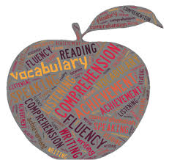

**Writing**

**Vocabulary #13**

Vocabulary #13 will not start until next week. We have only 3 lists left. There will be a quiz for each list, and a cumulative final Thursday and Friday, May 29-30.

We will work on vocabulary #13 list next Monday and Tuesday (4/7-8). Due to the shortened week, the vocabulary #13 assignment is due Thursday (4/10). The quiz will be the following Thursday (4/17).

With regards to vocabulary assignments, we continue to struggle with the same issues. Many regular vocabulary students are using part, parts, or all of the definition to provide context for the vocabulary words. Many Word Within the Word students are still not rereading the example sentences with the definition they created to see if their definition “fits and makes sense” in the example sentence. I have pontificated on this subject ad nauseum. I will simply hand back the entire assignment for revision from now on. My repeated requests and offers for help have fallen upon deaf ears (what?).

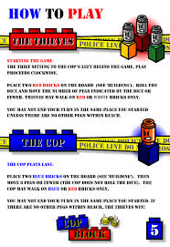

**Create-a-Board-Game**

[mostly repeated]

Students will research, design, and create a game board. The board game can be a card game, but the cards cannot be a standard 52 card (54 with Jokers) deck.

1. Design and make a board game.
   1. Use cardboard, tag board, construction paper, legal sized file folders, augment an older board game, etc.
   2. Decorate the board and box with art that relates to the game.
   3. There should be a START and FINISH box connected by at least a 50-space path.
   4. Create playing pieces that relate to the game (a minimum of 4).
2. Make up and write the rules for the game.
3. Playtest the game in various draft forms.  Adjust (correct) parts of your game as needed.
4. Exchange and play the games of other students.
5. Complete an evaluation form for each game played.

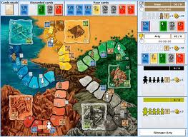Students have researched board games and submitted a premise of their idea for their board game projects. We will have time this week to finish drafting our rulebooks. However, students should be prepared to work on rulebook rough drafts at home if they don’t use their class time wisely.

Here are a couple of due dates to keep in mind:

* Rough draft of rules due today: Monday, March 10
* First test of draft game board: Monday-Thursday, March 17-20
* Second test of draft game board: Monday-Friday, **March 31-April 4**
* 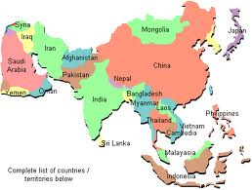Final project due: Monday, April 14

♠

History

**Current Event #13**

Much like vocabulary, current event #13 presentations will not start until next week. Current event #13 focuses on articles and news items from Asia. Current event presentations will take place 4/7-4/10. Friday daily show participants need to present an article at any time during the week. Make-up and missing current events need to be presented Monday 4/14. In addition to the group news quiz on Friday (4/18), students will take an individual quiz on the nations and significant bodies of water of Asia. The quiz has an increasing level of expectation for each grade level for the map.

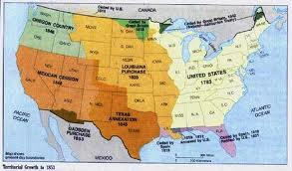The current events for the rest of the semester are by continent/world region. There are specific assignments sheets for each current event region already posted to the [CURRENT EVENT](http://733257565503770808.weebly.com/current-events.html) website.

**Manifest Destiny**

Expansion westward seemed perfectly natural to many Americans in the mid-nineteenth century. Like the Massachusetts Puritans who hoped to build a "city upon a hill, "courageous pioneers believed that America had a divine obligation to stretch the boundaries of their noble republic to the Pacific Ocean. Independence had been won in the Revolution and reaffirmed in the War of 1812. The spirit of nationalism that swept the nation in the next two decades demanded more territory. The "every man is equal" mentality of the Jacksonian Era fueled this optimism. Now, with territory up to the Mississippi River claimed and settled and the Louisiana Purchase explored, Americans headed west in droves. Newspaper editor John O'Sullivan coined the term "manifest destiny" in 1845 to describe the essence of this mindset.

The religious fervor spawned by the Second Great Awakening created another incentive for the drive west. Indeed, many settlers believed that God himself blessed the growth of the American nation. The Native Americans were considered heathens. By Christianizing the tribes, American missionaries believed they could save souls and they became among the first to cross the Mississippi River.

Economic motives were paramount for others. The fur trade had been dominated by European trading companies since colonial times. German immigrant John Jacob Astor was one of the first American entrepreneurs to challenge the 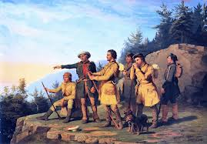Europeans. He became a millionaire in the process. The desire for more land brought aspiring homesteaders to the frontier. When gold was discovered in California in 1848, the number of migrants increased even more.

At the heart of manifest destiny was the pervasive belief in American cultural and racial superiority. Native Americans had long been perceived as inferior, and efforts to "civilize" them had been widespread since the days of John Smith and Miles Standish. The Hispanics who ruled Texas and the lucrative ports of California were also seen as "backward."

In 1840, the entire southwestern corner of the United States was controlled by foreign powers (shown in orange), and the territorial dispute over the Oregon Territory (light green) had not been settled. By 1850 the U.S. had control of lands from the Atlantic to the Pacific, covering almost all of today's continental United States.

Expanding the boundaries of the United States was in many ways a cultural war as well. The desire of southerners to find more lands suitable for cotton cultivation would eventually spread slavery to these regions. North of the Mason-Dixon line, many citizens were deeply concerned about adding any more slave states. Manifest destiny touched on issues of religion, money, race, patriotism, and morality. These clashed in the 1840s as a truly great drama of regional conflict began to unfold. (<http://www.ushistory.org/us/29.asp>)

In a few weeks, students will take a quiz over chapter 16-18. It will be rolled into the current events #13 and Asia map quiz.

♠

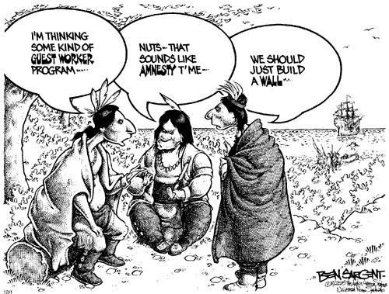

Planner **March 31 – April**

|  |  |  |  |  |  |  |
| --- | --- | --- | --- | --- | --- | --- |
|  | **Monday 3/31** | **Tuesday 4/1** | **Wednesday 4/2** | **Thursday 4/3** | **Friday**  **4/4** | **Weekend 4/5-6** |
| **Writing**  (Language Arts) | **CABG Playtest II**  *revised draft of game due at **beginning** of class  -playtesting within Core  *peer review form | **CABG Playtest II**  *revised draft of game due at **beginning** of class  -playtesting within Core  *peer review form | **CABG Playtest II**  [4/2]  *revised draft of game due at **beginning** of class  -playtesting within Core  *peer review form  [4/3]  -revise board game for final draft  -box/container creation | | **Create-a-Board-Game**  -revise board game for final draft  -box/container creation  -finalize rulebook | **Vocabulary #13**  -words & work 4/7-8  *vocab assignment due 4/10  -grammar #13 guidance & work 4/14-15  *grammar assignment due 4/16  -quiz 4/17  **Create-a-Board Game (CABG)**  -final product due 4/14 |
| **Reading** | **20’ Reading**  -student book of choice  -student meetings  **90” Film**  -90” film work time  **4th Quarter Discussions**  *novel due  -groups decide pacing, jobs, etc. | **OAKS Testing**  -round I in room 106  **90” Film**  -90” film work time  **4th Quarter Discussions**  -bookmark review  -discussion #5 assignment | **OAKS Testing**  -round I in room 106  **20’ Reading**  -student book of choice  -student meetings  **90” Film**  -90” film work time  **4th Quarter Discussions**  -bookmarks provided  -discussion #5 assignment: review directions | | **20’ Reading**  -student book of choice  -student meetings  **90” Film**  -90” film work time | **4th Quarter Discussion**  *discussion assignment due beginning of class **4/9**  -discussion **Thursday**, 4/10  **90” Film**  *project due at **beginning** of class 4/7  **Chains**  -novel read aloud |
| **History**  **(Social Studies)** | **Manifest Destiny**  -"Life in the West" (chapter 16: pages 210-227)  -lecture & presentation | **Manifest Destiny**  -"Life in the West" (chapter 16: pages 210-227)  -lecture & presentation | **Manifest Destiny**  -"Life in the West" (chapter 16: pages 210-227)  -lecture & presentation | | **Manifest Destiny**  -"Mexicano Contributions to the Southwest" (chapter 17: pages 228-239)  -lecture & presentation | **Current Event #13: Asia**  -presentations 4/7-10# (Friday people present any day)  -make-up & missing presentations 4/14  -group current event & individual Asia map quiz 4/18  **Manifest Destiny**  -"Mexicano Contributions to the Southwest" (chapter 17: pages 228-239)  -"An Era of Reform" (chapter 18: pages 240-251)  -quiz on chapters 16-18 part of group current event #13 quiz |
| **Other**  Contact Information for Binder  **da Vinci:** 503-916-5356 ext 79140 **Home**: 503-640-5265  voicemail: 503-916-3600 ext 79140  email: [pbinder@pps.net](mailto:pbinder@pps.net)  **WEB PAGE** <http://733257565503770808.weebly.com/> |  |  | **Periods: 2, 4, 6, & FLEX**  Site Council 4-5:30 | **Periods 1, 3, 5, & 7** |  | 4/7 **Ivy Foxall**’ birthday  4/10 end of **3rd Quarter** & **Chloe Daugherty-Brunak**’s birthday  4/11 teacher grading day & **Isaac Sten**’s birthday |