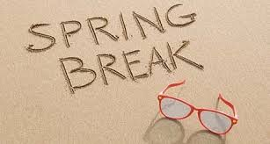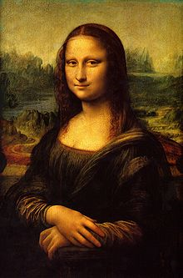**Binder Core: 3/17/2014**

**Spring Break**

Not the best week to have a late start, but the infinite wisdom of the man behind the curtain (ignore the man behind the curtain) trumps all logic. Spring Break interrupts several of our assignments (current events, vocabulary, etc). Please plan accordingly and manage your time well.

******If you are taking off early for vacation, please keep in mind that anything due on Friday (or before you leave) needs to be **completed and submitted prior to departure**. I have been warned several times by the authorities at PDX that my running along the tarmac and hollering at planes taking off is a violation of several laws.

Have a great break. When school resumes it is a long push to the end with only Memorial Day to break up the journey.

***Divergent***

There will be NO food allowed in the theater. Also, the concessions stand will NOT be open.   We will have an extended lunch when we get back and the cafeteria will still be providing lunch service on that day.

For students who don't want to go see divergent, we'll be offering a different book to movie option here at school (we're seeking ideas in this area) that is PG. Last I heard ***Holes*** was the option.

The cost is $7 per person. Parent chaperones DO need to pay for themselves. Sorry.

This is all part of the “Funnest Day Ever II”. It is a sequel to the Funnest Day Ever from several years ago when we watched *Hunger Games*.

♠

**Reading**

**4th Quarter Discussion Groups**

The second semester will focus on reading and discussing novels within small groups. Students need to start gathering ideas for discussion novels for the fourth quarter. The more variety the group has the better the choice they can make. The only rule is that you cannot use a novel for your discussion that you have already read. You can recommend the novel for other groups, but no rereads.

****Start with input from peers. What are they reading and what would they recommend for a good discussion book? There is a critical distinction between good literature and what makes a good discussion novel. Not all literature creates dynamic conversations. Conversations and differing opinions are, however, essential to a good discussion. The book might be a “page turner,” but if it does not prompt conversation then it is a dud as a discussion choice.

Seek input from parents, relatives, librarians, teachers, and members of the canine species—if a dog cannot sink his teeth into the novel then it might not be worth reading. You might want to do an internet search on recommended literature as well. Once you have a list—research.

Many online sites have a synopsis, ratings, and level recommendations for novels. I often use Amazon’s site to gather additional information on novels, but theirs is not the only source. The key is to be prepared…much like the goat in Hoodwinked.

We will gather and go through the recommendations in class on Monday and Tuesday (3/17-18). Unlike third quarter, students will be placed into groups first, and then the groups will list their top choices. Students (and parental units) will have a little time and wiggle room to alter choices and groupings, but by Monday, March 31st students need to have a copy of the novel they will be reading. Students who cannot obtain a copy or reserve a copy for check-out or purchase will be corralled into a group and select a novel from da Vinci’s library.

The choice of a novel is often a contentious and touchy issue. I do not wish to step on any toes or push a student into reading a subject matter they are not ready for or comfortable with. Your help, respect, communication, and diligence are appreciated.

The assignment for the discussion, #5, is due Wednesday (4/9) and the discussion is Thursday (4/10)—it is the end of the third quarter that week and there are no students on Friday, thus, the earlier discussion assignment due date and discussion. The assignment is due a day **before** the discussion so that I have time to evaluate and provide feedback on the assignment. It is something that I have learned over the years and it has generated better discussions. The post-discussion reflection is due **after** the discussion.

contributed well.” entries, but that is what students still submit. The purpose and intent of the post-discussion entries

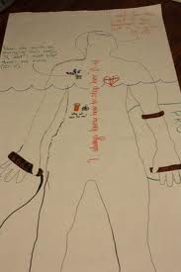**Body Biography**

[mostly repeated]

The culminating activity for the third quarter discussion novel is a body biography for a significant character in the novel. Discussion groups have apportioned themselves into two groups: one group for the protagonist and one group for the antagonist—or whatever seemed to fit for the groups.

For the chosen character, students will be creating a **body biography**—a visual and written portrait illustrating several aspects of the character’s life within the novel. At minimum, each student is responsible

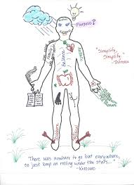Groups are responsible for planning and coordinating at least three additions to the body biography for their character for each student for each discussion. Essentially, students must add 12 items to the body biography, but from the breadth and depth of the novel instead of just the last three chapters. Students will be given class time and asked to pick a unique color to use in order to visually identify which are their comments on the paper. For each discussion, each student is responsible for one written, one visual, and one symbolic addition to the character.

There are many possibilities for filling up the giant sheet of paper. I have listed several, but students are free to come up with their own creations. As always, the choices they make should be based on the text, for they will be verbally explaining (and thus, in a sense, defending) them at a showing of their work. Above all, their choices should be creative, analytical, and accurate.

After completing the portrait, students will participate in a showing in which they will present their masterpiece to the class. This showing should accomplish these objectives:

* review significant events, choices, and changes involving your character
* 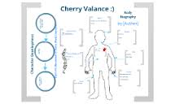communicate to others the full essence of your character by emphasizing the traits that comprise that person
* promote discussion of the character

Although I expect the biography to contain additional dimensions, the portrait **must** contain the following:

* a review of significant happenings in the novel (with regards to the character)
* visual symbols that represent meaningful images, objects, etc. for the character in the novel
* an original text presenting your view/interpretation of the character and his/her/its role in the novel
* the character’s three most important lines/scenes from the novel.

****The project is due on **Thursday, March 20** by the **end** of class. Students will have the week before Spring Break to finish tracing a “body” onto butcher paper and adorn it with words and imagery.

**90” Films**

*courtesy of James Kennedy*

The 90-Second Newbery Film Festival is a video contest in which filmmakers of any age make movies that tell the entire story of a Newbery award-winning book in 90 seconds or less. Not all 3rd quarter novels are Newbery winners, but all discussion groups will complete a 90" film.

Ever since 1922, the Newbery Medal has been recognized as the most prestigious award in children’s literature. But it turns out that any book, no matter how worthy and somber, becomes pleasingly ludicrous when compressed into 90 seconds.

Everyone enters. Everyone wins! There will be awards.

The rules:

1. Your video should be 90 seconds or less. (Okay, okay: if it’s two minutes long but absolute genius, we’ll bend the rules for you. But let’s try to keep them short.)
2. No book trailers! No video book reports! We’re looking for full-on dramatizations, with mostly child actors, that manage to tell the entire story of the book in 90 seconds.
3. Upload your videos to YouTube or Vimeo or whatever and send Binder the the link at pbinder@pps.net and kennedyjames@gmail.com (if your novel is a Newbery novel). For Mr. Kennedy, make the subject line be “90 SECOND NEWBERY” and please tell me your name, age, where you’re from, and whatever other comments you’d like to include, including whether you’d like me to link to your personal site. You can give an alias if you want; I understand privacy concerns.
4. Sending the link to Mr. Kennedy grants him (James Kennedy) the right to post it on his blog and to other websites where he sometimes posts content (like Facebook, Twitter, etc.) and to share at public readings, school visits—and hopefully the “90-Second Newbery” Film Festival screenings!

Intimidated? Don’t know where to start? I recommend checking out this handy guide of tips, tricks, and strategies for making a 90-Second Newbery.

[http://houston.kidsoutandabout.com/sites/default/files/images/Curriculum for Creating a 90-Second Newbery Film.pdf](http://houston.kidsoutandabout.com/sites/default/files/images/Curriculum%20for%20Creating%20a%2090-Second%20Newbery%20Film.pdf)

♠

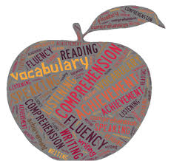

**Writing**

**Vocabulary #12**

Vocabulary #12 is an “end-of-the-quarter” quiz on academic steroids. Quiz #12 will contain a small review of previous lists’ stems and words for both regular vocabulary and Word Within the Word.

With regards to vocabulary assignments, we continue to struggle with the same issues. Many regular vocabulary students are using part, parts, or all of the definition to provide context for the vocabulary words. Many Word Within the Word students are still not rereading the example sentences with the definition they created to see if their definition “fits and makes sense” in the example sentence. I have pontificated on this subject ad nauseum. I will simply hand back the entire assignment for revision from now on. My repeated requests and offers for help have fallen upon deaf ears (what?).

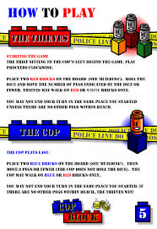

**Create-a-Board-Game**

[mostly repeated]

Students will research, design, and create a game board. The board game can be a card game, but the cards cannot be a standard 52 card (54 with Jokers) deck.

1. Design and make a board game.
   1. Use cardboard, tag board, construction paper, legal sized file folders, augment an older board game, etc.
   2. Decorate the board and box with art that relates to the game.
   3. There should be a START and FINISH box connected by at least a 50-space path.
   4. Create playing pieces that relate to the game (a minimum of 4).
2. Make up and write the rules for the game.
3. Playtest the game in various draft forms.  Adjust (correct) parts of your game as needed.
4. Exchange and play the games of other students.
5. Complete an evaluation form for each game played.

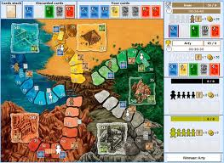

Students have researched board games and submitted a premise of their idea for their board game projects. We will have time this week to finish drafting our rulebooks. However, students should be prepared to work on rulebook rough drafts at home if they don’t use their class time wisely.

Here are a couple of due dates to keep in mind:

* Rough draft of rules due today: Monday, March 10
* First test of draft game board: Monday-Thursday, **March 17-20**
* Second test of draft game board: Monday-Friday, March 31-April 4
* Final project due: Monday, April 14

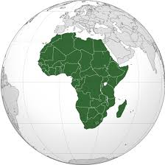

♠

History

**Current Event #12**

Current event #12 focuses on articles and news items from Africa. In addition to the individual news quiz on Wednesday (3/19), students will take an individual quiz on the nations and significant bodies of water of Africa. The quiz has an increasing level of expectation for each grade level for the map.

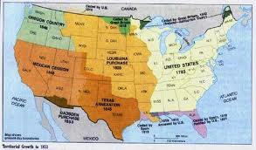The current events for the rest of the semester are by continent/world region. There are specific assignments sheets for each current event region already posted to the [CURRENT EVENT](http://733257565503770808.weebly.com/current-events.html) website.

**Manifest Destiny**

Expansion westward seemed perfectly natural to many Americans in the mid-nineteenth century. Like the Massachusetts Puritans who hoped to build a "city upon a hill, "courageous pioneers believed that America had a divine obligation to stretch the boundaries of their noble republic to the Pacific Ocean. Independence had been won in the Revolution and reaffirmed in the War of 1812. The spirit of nationalism that swept the nation in the next two decades demanded more territory. The "every man is equal" mentality of the Jacksonian Era fueled this optimism. Now, with territory up to the Mississippi River claimed and settled and the Louisiana Purchase explored, Americans headed west in droves. Newspaper editor John O'Sullivan coined the term "manifest destiny" in 1845 to describe the essence of this mindset.

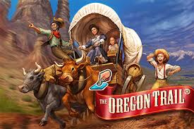The religious fervor spawned by the Second Great Awakening created another incentive for the drive west. Indeed, many settlers believed that God himself blessed the growth of the American nation. The Native Americans were considered heathens. By Christianizing the tribes, American missionaries believed they could save souls and they became among the first to cross the Mississippi River.

Economic motives were paramount for others. The fur trade had been dominated by European trading companies since colonial times. German immigrant John Jacob Astor was one of the first American entrepreneurs to challenge the 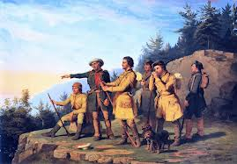Europeans. He became a millionaire in the process. The desire for more land brought aspiring homesteaders to the frontier. When gold was discovered in California in 1848, the number of migrants increased even more.

At the heart of manifest destiny was the pervasive belief in American cultural and racial superiority. Native Americans had long been perceived as inferior, and efforts to "civilize" them had been widespread since the days of John Smith and Miles Standish. The Hispanics who ruled Texas and the lucrative ports of California were also seen as "backward."

In 1840, the entire southwestern corner of the United States was controlled by foreign powers (shown in orange), and the territorial dispute over the Oregon Territory (light green) had not been settled. By 1850 the U.S. had control of lands from the Atlantic to the Pacific, covering almost all of today's continental United States.

Expanding the boundaries of the United States was in many ways a cultural war as well. The desire of southerners to find more lands suitable for cotton cultivation would eventually spread slavery to these regions. North of the Mason-Dixon line, many citizens were deeply concerned about adding any more slave states. Manifest destiny touched on issues of religion, money, race, patriotism, and morality. These clashed in the 1840s as a truly great drama of regional conflict began to unfold. (<http://www.ushistory.org/us/29.asp>)

This week (Wednesday 3/19), students will take an quiz over chapter 14-15. After Spring Break, we will continue our movement through the historical unit.

♠

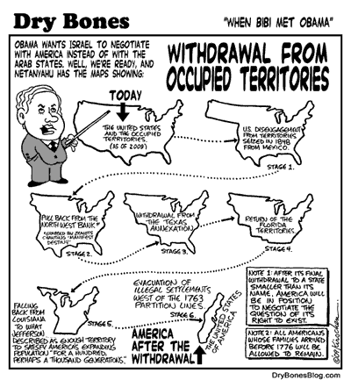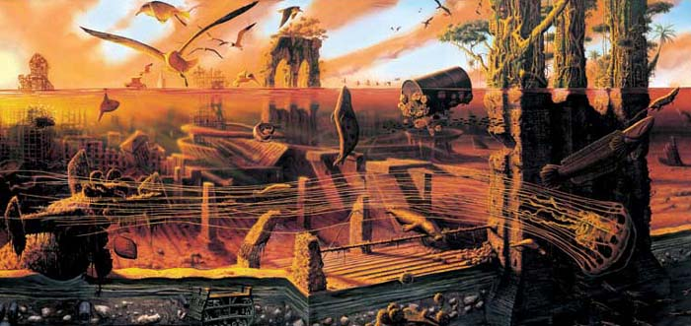



A symbol of Manifest Destiny, the figure "Columbia" moves across the land in advance of settlers, replacing darkness with light and ignorance with civilization.

Planner **March 17 – 30**

|  |  |  |  |  |  |  |
| --- | --- | --- | --- | --- | --- | --- |
|  | **Monday 3/17** | **Tuesday 3/18** | **Wednesday 3/19** | **Thursday 3/20** | **Friday**  **3/21** | **Weekend 3/22-30** |
| **Writing**  (Language Arts) | **Grammar #12**  -run-on sentences & comma splices  -practice  **CABG Playtest I**  *playable draft of game due at **beginning** of class  -playtesting with Myers Core  *peer review form | **Grammar #12**  -conjunctive adverbs (sounds like an eye disease)  -practice  **CABG Playtest I**  -playtesting with Myers Core  *peer review form | **\*grammar #12 assignment**  -due **beginning** of class [3/19]  **CABG Playtest I**  -playtesting with Myers Core  *peer review form  **Vocab #12 Slightly Larger Quiz [3/20]**  -regular = fill-in-the-blank sentences & crossword  -W3 #1-20 = stems, synonyms, cartoons, & mystery questions  -W3 #21+ = words, definitions, stems & flip side | | Funnest Day Ever | **Vocabulary #13**  -words & work 4/7-8  *vocab assignment due 4/10  -grammar #13 guidance & work 4/14-15  *grammar assignment due 4/16  -quiz 4/17  **Create-a-Board Game (CABG)**  -playtesting round II 3/31-4/4  -final product due 4/14 |
| **Reading** | **Body Biography & 90” Film**  -90” film and Body Biography work time  **4th Quarter Discussions**  *novel ideas due  -students into groups  -present novels | **Body Biography & 90” Film**  -90” film and Body Biography work  **4th Quarter Discussions**  -groups discuss novel options | **Body Biography**  -90” film and Body Biography work  *Body Biography due by the **end** of class [3/20]  **4th Quarter Discussions**  -groups decide on a novel  -students must secure a novel by 3/31 | |  | **4th Quarter Discussion**  -novel ideas by 3/31  -groups, pacing, jobs, and more  **OAKS**  -round I 4/1-2  **90” Film**  -work time…due 4/7 |
| **History**  **(Social Studies)** | **Current Event #12: Africa**  -make-up & missing presentations  **Manifest Destiny**  -"Manifest Destiny and the Growing Nation" (chapter 15: pages 196-209)  -lecture & presentation | **Current Event #12: Africa**  -update & review  **Manifest Destiny**  -"Manifest Destiny and the Growing Nation" (chapter 15: pages 196-209)  -lecture & presentation | **Current Event #12 Quiz [3/19]**  -individual current event #12, chapter 14-15, and Africa map quiz | | **Funnest Day Ever II Schedule:**  **8:15** meet with Core & walk to theater  **9:30 *Divergent***  **12:00** movie ends & walk back to school  **12:30-1:15ish** extended lunch  **1:20-1:35**  report to 5th period for attendance & expectations  **1:45-2:45** **Spring Talent Show** | **Current Event #13: Asia**  -presentations 4/7-10# (Friday people present any day)  -make-up & missing presentations 4/14  -group current event & individual Asia map quiz 4/18  **Manifest Destiny**  -"Life in the West" (chapter 16: pages 210-227)  -quiz on chapters 16-17 part of group current event #13 quiz |
| **Other**  Contact Information for Binder  **da Vinci:** 503-916-5356 ext 79140 **Home**: 503-640-5265  voicemail: 503-916-3600 ext 79140  email: [pbinder@pps.net](mailto:pbinder@pps.net)  **WEB PAGE** <http://733257565503770808.weebly.com/> |  | Dough for Dollars at Pizzacato | **late opening @10:30**  **Periods: 2, 4, & 6**  **QSA** 3-4:30 | **Periods 1, 3, 5, & 7**  **Ian Palin**’s birthday |  | 3/22-30 **Spring Break**  4/2 Site Council 4-5:30pm  4/7 **Ivy Foxall**’ birthday |