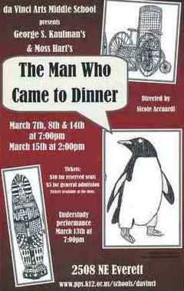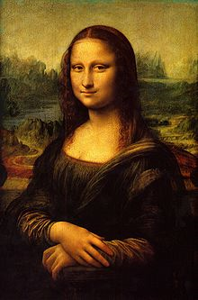**Binder Core: 3/10/2014**

**He’s Here**

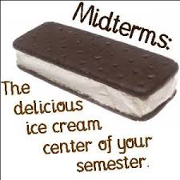The spring production, *The Man Who Came to Dinner*, had its first shows last weekend. The show continues this weekend on Friday and Saturday (3/14 & 3/15) at 7:00pm and one matinee (3/15) at 2:00pm. Much like the demands and frantic schedule of the dance recitals, the drama productions will send those who are involved into a tailspin of bad habits, lack of sleep, and desperation. Well, hopefully it will not be that bad. Looking ahead, please keep yourselves apprised of what is coming and when so that you can plan accordingly.

**Midterms**

[mostly repeated]

Midterms have been sent. Please keep in mind that is a snapshot of the student’s grade. Parents and guardians are often surprised by grades (hopefully more of the pleasant than the other kind of surprise with grades). Use it as a conversation starter, a tool to establish a reward program, the impetus to set up homework routines, etc.

The 3rd quarter ends Thursday, April 10th. Please take steps sooner than later to address missing, absent, late, or low-scoring assignments. I do have cut-off dates. All work from 3rd quarter is due before or by Friday, April 4th. That is the first Friday after Spring Break.

♠

**Reading**

**Discussion #4**

[mostly repeated]

Students have twenty minutes each day to read their discussion novel. Additionally, students should use whatever time **at home** necessary to fulfill the number of pages or chapters required for each discussion. Each student has a bookmark listing the dates of each discussion and the assigned pages. The bookmarks are also available via the “[Reading](http://733257565503770808.weebly.com/reading.html)” page of my web page.

The assignment sheets for the discussions are also available via the “[Reading](http://733257565503770808.weebly.com/reading.html)” page of my web page. You will have to access the bookmarks (or ask the student) to determine what assignment the student must complete. Students are given the new assignment sheet two weeks(ish) ahead of time I recommend using the assignment sheet as a second bookmark and completing the assignment as the novel is read. Directions are on each sheet, but the “post discussion” part is completed and submitted after the discussion.

The assignment for the last discussion, #4, is due next Thursday (3/13) and the discussion is next Friday (3/14). The assignment is due a day **before** the discussion so that I have time to evaluate and provide feedback on the assignment. It is something that I have learned over the years and it has generated better discussions. The post-discussion reflection is due **after** the discussion.

The common thread for post-discussion reflections is that most are too vague and generalized. I usually make fun of the “It was a great discussion. Everyone participated. We all contributed well.” entries, but that is what students still submit. The purpose and intent of the post-discussion entries is to mull over and reflect…how did my assignment promote a good discussion and/or how did it hinder a good discussion?

A good post-discussion will contain relevant specifics from the discussion that allow me (the reader and the evaluator) insight and another perspective on the discussion. I should not be able to read the comments and have no clue whether the discussion took place that day or ten years ago.

Another way to think of it is that the assignment is worth 20 points and the post-discussion is worth 5 points. The time, effort, and word production should reflect the value. Fifteen ineffective and meaningless words will not earn many points.

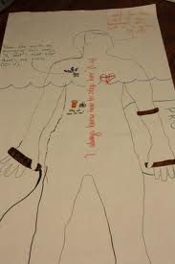

**Body Biography**

[mostly repeated]

The culminating activity for the third quarter discussion novel is a body biography for a significant character in the novel. Discussion groups have apportioned themselves into two groups: one group for the protagonist and one group for the antagonist—or whatever seemed to fit for the groups.

For the chosen character, students will be creating a **body biography**—a visual and written portrait illustrating several aspects of the character’s life within the novel. At minimum, each student is responsible

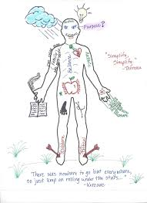Groups are responsible for planning and coordinating at least three additions to the body biography for their character for each student for each discussion. Essentially, students must add 12 items to the body biography, but from the breadth and depth of the novel instead of just the last three chapters. Students will be given class time and asked to pick a unique color to use in order to visually identify which are their comments on the paper. For each discussion, each student is responsible for one written, one visual, and one symbolic addition to the character.

There are many possibilities for filling up the giant sheet of paper. I have listed several, but students are free to come up with their own creations. As always, the choices they make should be based on the text, for they will be verbally explaining (and thus, in a sense, defending) them at a showing of their work. Above all, their choices should be creative, analytical, and accurate.

After completing the portrait, students will participate in a showing in which they will present their masterpiece to the class. This showing should accomplish these objectives:

* review significant events, choices, and changes involving your character
* 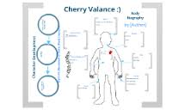communicate to others the full essence of your character by emphasizing the traits that comprise that person
* promote discussion of the character

Although I expect the biography to contain additional dimensions, the portrait **must** contain the following:

* a review of significant happenings in the novel (with regards to the character)
* visual symbols that represent meaningful images, objects, etc. for the character in the novel
* an original text presenting your view/interpretation of the character and his/her/its role in the novel
* the character’s three most important lines/scenes from the novel.

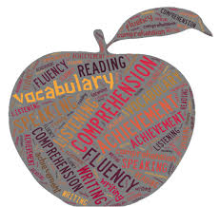The project is due on Thursday, March 20 by the end of class. The fourth, and final, discussion takes place the previous Friday (3/14). Students will have the week before Spring Break to finish tracing a “body” onto butcher paper and adorn it with words and imagery.

♠

**Writing**

**Vocabulary #12**

We begin work on our twelfth list of the year…only three more after this one. It seems like just yesterday that we started. They grow up so fast…

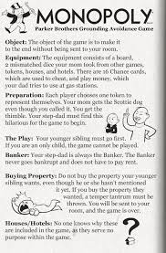Students will get **thirty** minutes Monday and **thirty** minutes Tuesday (3/10-11) to work on list #12. I am repeating a lot of the same comments for students in Synergy. I also write the comments on the student’s work.

**Create-a-Board-Game**

[mostly repeated]

Students will research, design, and create a game board. The board game can be a card game, but the cards cannot be a standard 52 card (54 with Jokers) deck.

1. Design and make a board game.
   1. Use cardboard, tag board, construction paper, legal sized file folders, augment an older board game, etc.
   2. Decorate the board and box with art that relates to the game.
   3. There should be a START and FINISH box connected by at least a 50-space path.
   4. Create playing pieces that relate to the game (a minimum of 4).
2. Make up and write the rules for the game.
3. Playtest the game in various draft forms.  Adjust (correct) parts of your game as needed.
4. Exchange and play the games of other students.
5. 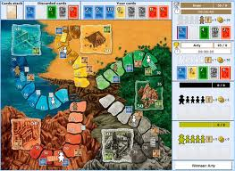Complete an evaluation form for each game played.

Students have researched board games and submitted a premise of their idea for their board game projects. We will have time this week to finish drafting our rulebooks. However, students should be prepared to work on rulebook rough drafts at home if they don’t use their class time wisely.

Here are a couple of due dates to keep in mind:

* Rough draft of rules due today: **Monday, March 10**
* First test of draft game board: Monday-Thursday, March 17-20
* ****Second test of draft game board: Monday-Friday, March 31-April 4
* Final project due: Monday, April 14

**DWA**

Students who need more time to finalize, will be provided time this week. It will most likely come during reading time. Students should be prepared to make up for any lost reading time at home.

♠

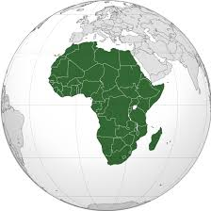

History

**Current Event #12**

[mostly repeated]

Student preparation is similar to first semester. Students need to read a significant news item and summarize it. The “who, when, & where” can/should be copied from the article, but the “what” still needs to be paraphrased. Students still need to be able to locate the current event on the map and I still need a copy of the article. Students can staple the article to their current event summary or email me the article.

On the assigned day, students who have an article prepared will meet and practice in the hallway during reading time. Students need to be comfortable with the information in the news item otherwise the practice time is of little use. I do check the articles to assist and advise them. Students who are not prepared will present the next day.

Current event #12 focuses on articles and news items from Africa. In addition to the individual news quiz on Wednesday (3/19), students will take an individual quiz on the nations and significant bodies of water of Africa. The quiz has an increasing level of expectation for each grade level for the map.

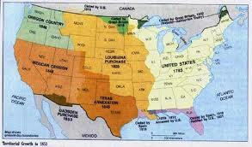The current events for the rest of the semester are by continent/world region. There are specific assignments sheets for each current event region already posted to the [CURRENT EVENT](http://733257565503770808.weebly.com/current-events.html) website.

**Manifest Destiny**

Expansion westward seemed perfectly natural to many Americans in the mid-nineteenth century. Like the Massachusetts Puritans who hoped to build a "city upon a hill, "courageous pioneers believed that America had a divine obligation to stretch the boundaries of their noble republic to the Pacific Ocean. Independence had been won in the Revolution and reaffirmed in the War of 1812. The spirit of nationalism that swept the nation in the next two decades demanded more territory. The "every man is equal" mentality of the Jacksonian Era fueled this optimism. Now, with territory up to the Mississippi River claimed and settled and the Louisiana Purchase explored, Americans headed west in droves. Newspaper editor John O'Sullivan coined the term "manifest destiny" in 1845 to describe the essence of this mindset.

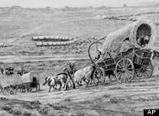The religious fervor spawned by the Second Great Awakening created another incentive for the drive west. Indeed, many settlers believed that God himself blessed the growth of the American nation. The Native Americans were considered heathens. By Christianizing the tribes, American missionaries believed they could save souls and they became among the first to cross the Mississippi River.

Economic motives were paramount for others. The fur trade had been dominated by European trading companies since colonial times. German immigrant John Jacob Astor was one of the first American entrepreneurs to challenge the Europeans. He became a millionaire in the process. The desire for more land brought aspiring homesteaders to the frontier. When gold was discovered in California in 1848, the number of migrants increased even more.

At the heart of manifest destiny was the pervasive belief in American cultural and racial superiority. Native Americans had long been perceived as inferior, and efforts to "civilize" them had been widespread since the days of John Smith and Miles Standish. The Hispanics who ruled Texas and the lucrative ports of California were also seen as "backward."

In 1840, the entire southwestern corner of the United States was controlled by foreign powers (shown in orange), and the territorial dispute over the Oregon Territory (light green) had not been settled. By 1850 the U.S. had control of lands from the Atlantic to the Pacific, covering almost all of today's continental United States.

Expanding the boundaries of the United States was in many ways a cultural war as well. The desire of southerners to find more lands suitable for cotton cultivation would eventually spread slavery to these regions. North of the Mason-Dixon line, many citizens were deeply concerned about adding any more slave states. Manifest destiny touched on issues of religion, money, race, patriotism, and morality. These clashed in the 1840s as a truly great drama of regional conflict began to unfold. (<http://www.ushistory.org/us/29.asp>)

Next week (Wednesday 3/19), students will take an quiz over chapter 14-15.

♠

A symbol of Manifest Destiny, the figure "Columbia" moves across the land in advance of settlers, replacing darkness with light and ignorance with civilization.

Planner **March 10 – 16**

|  |  |  |  |  |  |  |
| --- | --- | --- | --- | --- | --- | --- |
|  | **Monday 3/10** | **Tuesday 3/11** | **Wednesday 3/12** | **Thursday 3/13** | **Friday**  **3/14** | **Weekend 3/15-16** |
| **Writing**  (Language Arts) | **Vocabulary #12**  -regular = words #1-10  -W3 #1-20 = sentences  -W3 #21+ = list  **CABG Rulebook**  *due at the **beginning** of class  -workshop with a partner | **Vocabulary #12**  -regular = words #11-20  -W3 #1-20 = sentences & list  -W3 #21+ = list & ideas  **CABG**  -work time to create a playable draft of the game  -playing pieces, cards, randomizers, board, etc. | **Create-a-Board-Game**  -work time to create a playable draft of the game  -playing pieces, cards, randomizers, board, etc. | | **\*vocab #12 assignment**  -due **beginning** of class  -regular vocabulary = 5 cartoons **or** sentences  -W3 #1-20 = flashcards & sentences  -W3 #21+ = flashcards & ideas  **CABG**  -work time to create a playable draft  -playing pieces, cards, randomizers, board, etc. | **Vocabulary #12**  -grammar #12 guidance & work 3/17-18  *assignment due 3/19  -quiz 3/20  **Create-a-Board Game (CABG)**  -playtesting with Myers Core 3/17-20  -playtesting round II 3/31-4/4  -final product due 4/14 |
| **Reading** | **20’ Reading**  -student book of choice  -student meetings  **Discussion Groups**  -help with individual discussion assignments  -time to work on discussion assignment | **20’ Reading**  -student book of choice  -student meetings | **20’ Reading**  -student book of choice  -student meetings  **Body Biography**  -meet with character group to plan  -what are the 3-4 items each person will put on the outline  **Discussion #4**  *assignment due at the beginning of class [**3/13**] | | **Discussion #4**  -AM = 10:30-11:15  -PM = 1:45-2:30^  *post-discussion reflection due after the meeting  ^M’Kay 1:00-1:45 | **Body Biography & 90” Film**  -90” film and Body Biography work 3/17-20  -project due by the **end** of class 3/20  **Chains**  -novel read aloud |
| **History**  **(Social Studies)** | **Current Event #12: Africa**  -Daily Show groups Team II & Spaceballs  **Manifest Destiny**  -"Andrew Jackson and the Growth of American Democracy" (chapter 14: pages 184-195)  -lecture & presentation | **Current Event #12: Africa**  -Daily Show groups Animal Lovers & Jiffy Lube  **Manifest Destiny**  -"Andrew Jackson and the Growth of American Democracy" (chapter 14: pages 184-195)  -lecture & presentation | **Current Event #12: Africa**  -Daily Show groups Hungry Cows & Mocking Ninnies [3/12]  -Daily Show groups Bulbous Daily Show & Hello Show [3/13]  **Manifest Destiny**  -"Andrew Jackson and the Growth of American Democracy" (chapter 14: pages 184-195)  -lecture & presentation | | **Current Event #12: Africa**  -Daily Show groups Dragons & Santa Baby | **Current Event #12**  -make-up & missing presentations 3/17  -individual current event & Africa map quiz **3/19**  **Manifest Destiny**  -"Manifest Destiny and the Growing Nation" (chapter 15: pages 196-209)  -quiz on chapters 14-15 part of individual current event #12 quiz |
| **Other**  Contact Information for Binder  **da Vinci:** 503-916-5356 ext 79140 **Home**: 503-640-5265  voicemail: 503-916-3600 ext 79140  email: [pbinder@pps.net](mailto:pbinder@pps.net)  **WEB PAGE** <http://733257565503770808.weebly.com/> |  | Leo Leader lunch | **Periods: 2, 4, 6, & FLEX** | **Periods 1, 3, 5, & 7** | ***The Man Who Came to Dinner*** @7:00pm | 3/15 ***The Man Who Came to Dinner*** @2 & 7:00pm  3/18 **Dough for Dollars** at Pizzacato  3/14 **QSA** 3-4:30  3/20 **Ian Palin**’s birthday  3/21 **Funnest Day Ever II**  3/21 Talent Show  3/22-30 **Spring Break** |