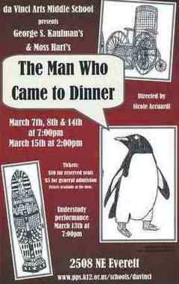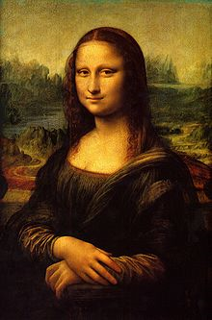**Binder Core: 3/3/2014**

**He’s Here**

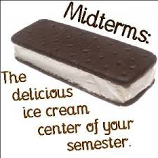The spring production, *The Man Who Came to Dinner*, has its first shows this weekend. The show debuts Friday (3/7) at 7:00pm. Shows continue on Saturday (3/8) at 7:00 and continue next weekend (3/14 & 3/15) at 7:00pm and one matinee (3/15) at 2:00pm. Much like the demands and frantic schedule of the dance recitals, the drama productions will send those who are involved into a tailspin of bad habits, lack of sleep, and desperation. Well, hopefully it will not be that bad. Looking ahead, please keep yourselves apprised of what is coming and when so that you can plan accordingly.

**Midterms**

Midterms are upon us. Please keep in mind that is a snapshot of the student’s grade. Parents and guardians are often surprised by grades (hopefully more of the pleasant than the other kind of surprise with grades). Use it as a conversation starter, a tool to establish a reward program, the impetus to set up homework routines, etc.

The 3rd quarter ends Thursday, April 10th. Please take steps sooner than later to address missing, absent, late, or low-scoring assignments. I do have cut-off dates. All work from 3rd quarter is due before or by Friday, April 4th. That is the first Friday after Spring Break.

♠

**Reading**

**Discussion Groups**

[mostly repeated]

Students should be reading and working on the second discussion’s assignment. The list of chapters or pages to read and each person’s assignment is listed on the bookmarks that were handed to each student in class. The assignments and the bookmarks are available on the “Reading” page of my website.

I provide twenty to thirty minutes each day for students to read. One of the days will be consumed with the “Daily Show” practice, but that still leaves four days of the week to work on the discussion assignment. At minimum, that provides 140 minutes of class (baring an absence) for students to read and work on their assignment. There will be students who will need to read and work on the assignment at home, but it should not be a last minute, panicky, I have thirty minutes to read the entire section and complete my assignment because Binder is a big meanie, huffing and puffing sideshow. If it is, videotape it and keep it to show your grandchildren.

I recommend keeping the bookmark and assignment with the novels the students are reading. Students should work on the assignment as they read, not try and cull meaningful quotes or descriptions after reading the entire section. The only exception might be the summarizer, but even then the student could be summarizing each chapter into a sentence as s/he goes. Yes, reality says that most students will not do that. It would, however, make their lives a lot easier.

♠



**Reading** 

**Discussion #4**

[mostly repeated]

Thank you to the fantastic adults who continue to volunteer their time to help facilitate discussions. It is not an easy task to “teach” students how to have an intelligent and meaningful discussion about a novel. Discussions are going well—especially when the students read the novel. Thank you.

Students have twenty minutes each day to read their discussion novel. Additionally, students should use whatever time **at home** necessary to fulfill the number of pages or chapters required for each discussion. Each student has a bookmark listing the dates of each discussion and the assigned pages. The bookmarks are also available via the “[Reading](http://733257565503770808.weebly.com/reading.html)” page of my web page.

The assignment sheets for the discussions are also available via the “[Reading](http://733257565503770808.weebly.com/reading.html)” page of my web page. You will have to access the bookmarks (or ask the student) to determine what assignment the student must complete. Students are given the new assignment sheet two weeks(ish) ahead of time I recommend using the assignment sheet as a second bookmark and completing the assignment as the novel is read. Directions are on each sheet, but the “post discussion” part is completed and submitted after the discussion.

The assignment for the last discussion, #4, is due next Thursday (3/13) and the discussion is next Friday (3/14). The assignment is due a day **before** the discussion so that I have time to evaluate and provide feedback on the assignment. It is something that I have learned over the years and it has generated better discussions. The post-discussion reflection is due **after** the discussion.

The common thread for post-discussion reflections is that most are too vague and generalized. I usually make fun of the “It was a great discussion. Everyone participated. We all contributed well.” entries, but that is what students still submit. The purpose and intent of the post-discussion entries is to mull over and reflect…how did my assignment promote a good discussion and/or how did it hinder a good discussion?

A good post-discussion will contain relevant specifics from the discussion that allow me (the reader and the evaluator) insight and another perspective on the discussion. I should not be able to read the comments and have no clue whether the discussion took place that day or ten years ago.

Another way to think of it is that the assignment is worth 20 points and the post-discussion is worth 5 points. The time, effort, and word production should reflect the value. Fifteen ineffective and meaningless words will not earn many points.

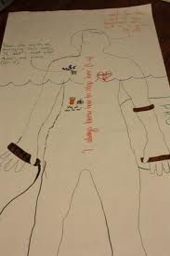

**Body Biography**

[mostly repeated]

The culminating activity for the third quarter discussion novel is a body biography for a significant character in the novel. Discussion groups have apportioned themselves into two groups: one group for the protagonist and one group for the antagonist—or whatever seemed to fit for the groups.

For the chosen character, students will be creating a **body biography**—a visual and written portrait illustrating several aspects of the character’s life within the novel. At minimum, each student is responsible

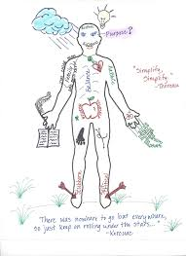Groups are responsible for planning and coordinating at least three additions to the body biography for their character for each student for each discussion. Essentially, students must add 12 items to the body biography, but from the breadth and depth of the novel instead of just the last three chapters. Students will be given class time and asked to pick a unique color to use in order to visually identify which are their comments on the paper. For each discussion, each student is responsible for one written, one visual, and one symbolic addition to the character.

There are many possibilities for filling up the giant sheet of paper. I have listed several, but students are free to come up with their own creations. As always, the choices they make should be based on the text, for they will be verbally explaining (and thus, in a sense, defending) them at a showing of their work. Above all, their choices should be creative, analytical, and accurate.

After completing the portrait, students will participate in a showing in which they will present their masterpiece to the class. This showing should accomplish these objectives:

* review significant events, choices, and changes involving your character
* 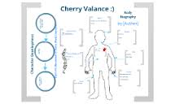communicate to others the full essence of your character by emphasizing the traits that comprise that person
* promote discussion of the character

Although I expect the biography to contain additional dimensions, the portrait **must** contain the following:

* a review of significant happenings in the novel (with regards to the character)
* visual symbols that represent meaningful images, objects, etc. for the character in the novel
* an original text presenting your view/interpretation of the character and his/her/its role in the novel
* the character’s three most important lines/scenes from the novel.

The project is due on Friday, March 21. The fourth, and final, discussion takes place the previous Friday (3/14). Students will have the week before Spring Break to finish tracing a “body” onto butcher paper and adorn it with words and imagery.

♠

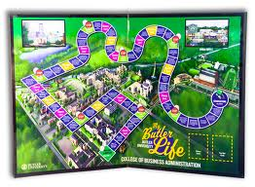

**Writing**

**Grammar #11**

In the interests of time, sanity, and the perplexity of life, we will be forgoing the grammar lesson for this week. We will resume our regularly scheduled grammar in two weeks.

**Create-a-Board-Game**

Students will research, design, and create a game board. The board game can be a card game, but the cards cannot be a standard 52 card (54 with Jokers) deck.

1. Design and make a board game.
   1. Use cardboard, tag board, construction paper, legal sized file folders, augment an older board game, etc.
   2. Decorate the board and box with art that relates to the game.
   3. 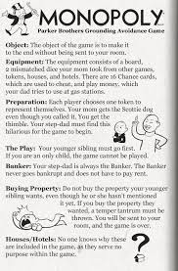There should be a START and FINISH box connected by at least a 50-space path.
   4. Create playing pieces that relate to the game (a minimum of 4).
2. Make up and write the rules for the game.
3. Playtest the game in various draft forms.  Adjust (correct) parts of your game as needed.
4. Exchange and play the games of other students.
5. Complete an evaluation form for each game played.

Students have researched board games and submitted a premise of their idea for their board game projects. We will have time this week to continue drafting our rulebooks. However, students should be prepared to work on rulebook rough drafts at home if they don’t use their class time wisely.

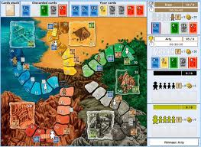 Here are a couple of due dates to keep in mind:

* Rough draft of rules due: Monday, March 10
* First test of draft game board: Monday-Thursday, March 17-20
* Second test of draft game board: Monday-Friday, March 31-April 4
* Final project due: Monday, April 14



**Direct Writing Assessment**

The annual right of passage is nearly upon us…again. This week, students will be taking part in the Direct Writing Assessment (DWA).

Students cannot get help from others (including me), they cannot discuss their writing, and they cannot use resources other than those that are part of the normal classroom routine. The intention and purpose is to determine the writing ability of the student. It is an authentic assessment of the student’s writing skills and the scores that they earn help determine the focus and instruction during the upcoming months.

Each session is thirty to forty-five minutes. Each session is focused. During the first session, I will distribute materials, explain the guidelines, and students will work on a prewriting strategy. During the second session, students will write their first draft. The third session focuses on editing and revising. The fourth and any further sessions will focus on finalizing their writings.

♠

History

**Current Event #11**

[mostly repeated]

Student preparation is similar to first semester. Students need to read a significant news item and summarize it. The “who, when, & where” can/should be copied from the article, but the “what” still needs to be paraphrased. Students still need to be able to locate the current event on the map and I still need a copy of the article. Students can staple the article to their current event summary or email me the article.

On the assigned day, students who have an article prepared will meet and practice in the hallway during reading time. Students need to be comfortable with the information in the news item otherwise the practice time is of little use. I do check the articles to assist and advise them. Students who are not prepared will present the next day.

Current event #11 focuses on articles and news items from South America. In addition to the group news quiz on Friday (3/7), students will take an individual quiz on the nations and significant bodies of water of South America. The quiz has an increasing level of expectation for each grade level for the map.

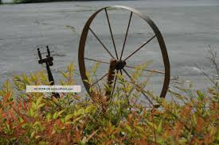The current events for the rest of the semester are by continent/world region. There are specific assignments sheets for each current event region already posted to the [CURRENT EVENT](http://733257565503770808.weebly.com/current-events.html) website.

**Early America**

Students have apportioned themselves into groups of three for our Early America. Each group divided the three chapters (chapter 11-13) amongst themselves. During last week and this week, students are reading the chapter they self-selected or were assigned.

Later this week (midweek), students will meet with others who read the same chapter to “think-pair-share”. The group will help determine the essential elements from the chapter and use the information to help their Early America group on a quiz over the chapters on Friday (3/7).

♠

Planner **March 3 – 9**

|  |  |  |  |  |  |  |
| --- | --- | --- | --- | --- | --- | --- |
|  | **Monday 3/3** | **Tuesday 3/4** | **Wednesday 3/5** | **Thursday 3/6** | **Friday**  **3/7** | **Weekend 3/8-9** |
| **Writing**  (Language Arts) | **Create-a-Board-Game**  -draft of objective & materials  . | **Create-a-Board-Game**  -draft of set-up & how-to-play | **murder mystery party**  -the party  -roles, costumes, food, etc.  **Direct Writing Assessment**  -Prewriting: 45’  -Draft #1, Edit & Revise: 45’  **Vocab #11 Quiz [3/6]**  -regular = fill-in-the-blank sentences  -W3 #1-20 = stems & mystery questions  -W3 #21+ = words, definitions, stems & flip side | | **Direct Writing Assessment**  -2nd draft: 45’  *Finalize: 45’  **murder mystery party**  -the party  -roles, costumes, food, etc. | **Vocabulary #12**  -words & work 3/10-11  *assignment due 3/14  -quiz 3/20  **Create-a-Board Game**  *draft of rule book 3/10  -playtesting with Myers Core 3/17-20  -playtesting round II 3/31-4/4  -final product due 4/14 |
| **Reading** | **20’ Reading**  -student book of choice  -student meetings  **Body Biography**  -meet with character group to plan  -what are the 3-4 items each person will put on the outline | **20’ Reading**  -student book of choice  -student meetings  **Body Biography**  -meet with character group to plan  -what are the 3-4 items each person will put on the outline | **20’ Reading**  -student book of choice  -student meetings | | **20’ Reading**  -student book of choice  -student meetings | **Discussion #4**  -assignment due at the beginning of class 3/13  -discussion 3/14  -90” film and Body Biography work 3/17-20  **Chains**  -novel read aloud |
| **History**  **(Social Studies)** | **Current Event #11: South America**  -make-up & missing  **Early America:**  -"Political Developments in the Early Republic" (11: pages 144-159)  -"Foreign Affairs in the Young Nation" (12: pages 160-173)  -"A Growing Sense of Nationhood" (13: pages 174-183) | **Current Event #11**  -update & review  **Early America:**  -"Political Developments in the Early Republic" (11: pages 144-159)  -"Foreign Affairs in the Young Nation" (12: pages 160-173)  -"A Growing Sense of Nationhood" (13: pages 174-183) | **Early America:**  -"Political Developments in the Early Republic" (11: pages 144-159)  -"Foreign Affairs in the Young Nation" (12: pages 160-173)  -"A Growing Sense of Nationhood" (13: pages 174-183)  *compare, contrast, and determine the essential information within each chapter | | **Current Event #11 Quiz**  -group current events & chapter 11-13 quiz  -South America map individual quiz | **Current Event #12**  -presentations 3/10-14  -make-up & missing presentations 3/17  -individual quiz 3/21  **Manifest Destiny**  -"Andrew Jackson and the Growth of American Democracy" (chapter 14: pages 184-195) |
| **Other**  Contact Information for Binder  **da Vinci:** 503-916-5356 ext 79140 **Home**: 503-640-5265  voicemail: 503-916-3600 ext 79140  email: [pbinder@pps.net](mailto:pbinder@pps.net)  **WEB PAGE** <http://733257565503770808.weebly.com/> | **Period 1-7** | **Period 1-7**  **MIDTERM** | **Period 1-7** | **Period 1-7**  **drama pullout** | **Period 1-7**  ***The Man Who Came to Dinner*** @7:00pm | 3/8 ***The Man Who Came to Dinner*** @7:00pm  3/11 Leo Leader lunch  3/14 ***The Man Who Came to Dinner*** @7:00pm  3/15 ***The Man Who Came to Dinner*** @2 & 7:00pm |