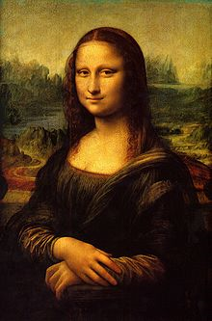**Binder Core: 2/24/2014**

**Problem Solving**

We have missed a few days due to inclement weather, there have been a few holidays, an early dismissal, and a late start thrown in for good measure. Please be mindful of what we are doing, what has been amended, and what we will be doing. Plan your time accordingly, rather than suffer from last-minute panic. That being said, reality happens. Please communicate any issues or concerns in a proactive versus a reactive manner.

This is a repeat from last year, but the same student is back in contact…

A former student, who is still teaching in Costa Rica, recently contacted me again. She said, last year, that during the end-of-the-year conversation (that I hold annually with eighth graders) I had said that I hoped I caused a little distress in their lives. At the time, she had been shocked. I did follow up with a statement about hoping I had provided any needed support, but she had been so flustered by my original statement to pay much notice to what I had explained.

I hope I do cause distress, and I hope I do provide enough support. Without distress, people do not learn to solve problems. Without support, those problems can become unbearable. Students need an environment that is challenging and nurturing, but if we do everything for them then they never learn how to figure out solutions and use their resources. Middle school is the perfect environment for this process. Students learn to advocate for themselves, seek out and use resources, and build self-confidence. The best lessons are learned, rather than taught.

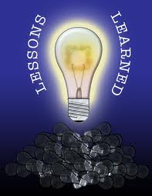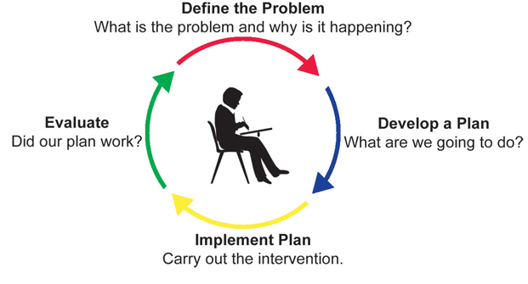My former students related tales of her own struggles and how she had solved them. She told me that her “distress” in middle school had given her the skills and the poise to confront high school and beyond. She finally understood what I was trying to say that day—of course, listening would have helped—but she learned the lesson far better on her own.

♠

**Reading**

**Discussion #3**

[mostly repeated]

I provide twenty to thirty minutes each day for students to read. One of the days will be consumed with the “Daily Show” practice, but that still leaves four days of the week to work on the discussion assignment. At minimum, that provides 140 minutes of class (baring an absence) for students to read and work on their assignment. There will be students who will need to read and work on the assignment at home, but it should not be a last minute, panicky, I have thirty minutes to read the entire section and complete my assignment because Binder is a big meanie, huffing and puffing song-and-dance sideshow. If it is, videotape it and keep it to show your grandchildren.

Students should use whatever time **at home** necessary to fulfill the number of pages or chapters required for each discussion. Each student has a bookmark listing the dates of each discussion and the assigned pages. The bookmarks are also available via the “[READING](http://733257565503770808.weebly.com/reading.html)” page of my web page.

The assignment sheets for the discussions are also available via the “[READING](http://733257565503770808.weebly.com/reading.html)” page of my web page. You will have to access the bookmarks (or ask the student) to determine what assignment the student must complete. Students are given the new assignment sheet two weeks(ish) ahead of time I recommend using the assignment sheet as a second bookmark and completing the assignment as the novel is read. Directions are on each sheet, but the “post discussion” part is completed after the discussion.

I recommend keeping the bookmark and assignment with the novels the students are reading. Students should work on the assignment as they read, not try and cull meaningful quotes or descriptions after reading the entire section. The only exception might be the summarizer, but even then the student could be summarizing each chapter into a sentence as s/he goes. Yes, reality says that most students will not do that. It would, however, make their lives a lot easier.

The assignment for discussion #3 is due Thursday (2/27) and the discussion is on Friday (2/28). The assignment is due a day before the discussion so that I have time to evaluate and provide feedback on the assignment. Students who are absent for a discussion must complete an alternative to earn the points. They will, however, be excused from the reflections.

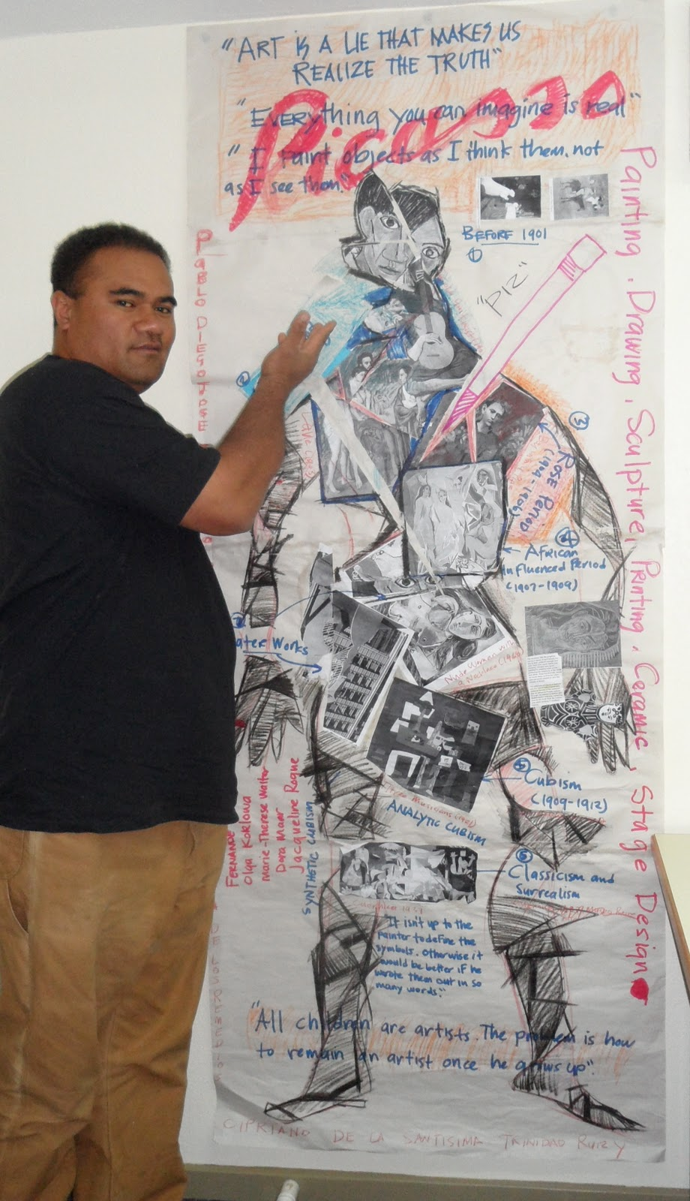**Body Biography**

[mostly repeated]

The culminating activity for the third quarter discussion novel is a body biography for a significant character in the novel. Discussion groups have apportioned themselves into two groups: one group for the protagonist and one group for the antagonist.

For the chosen character, students will be creating a **body biography**—a visual and written portrait illustrating several aspects of the character’s life within the novel.

Groups are responsible for planning and coordinating at least three additions to the body biography for their character for each student for each discussion. Essentially, students must add 12 items to the body biography, but from the breadth and depth of the novel instead of just the last three chapters. Students will be given class time and asked to pick a unique color to use in order to visually identify which are their comments on the paper. For each discussion, each student is responsible for one written, one visual, and one symbolic addition to the character.

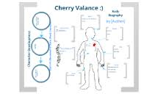There are many possibilities for filling up the giant sheet of paper. I have listed several, but students are free to come up with their own creations. As always, the choices they make should be based on the text, for they will be verbally explaining (and thus, in a sense, defending) them at a showing of their work. Above all, their choices should be creative, analytical, and accurate.

After completing the portrait, students will participate in a showing in which they will present their masterpiece to the class. This showing should accomplish these objectives:

* review significant events, choices, and changes involving your character
* communicate to others the full essence of your character by emphasizing the traits that comprise that person
* promote discussion of the character

Although I expect the biography to contain additional dimensions, the portrait **must** contain the following:

* a review of significant happenings in the novel (with regards to the character)
* visual symbols that represent meaningful images, objects, etc. for the character in the novel
* an original text presenting your view/interpretation of the character and his/her/its role in the novel
* the character’s three most important lines/scenes from the novel.

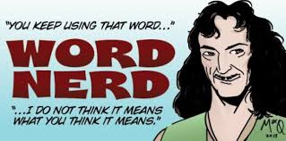The project is due on Friday, March 21. The fourth, and final, discussion takes place the previous Friday (3/14). Students will have the week before Spring Break to finish tracing a “body” onto butcher paper and adorn it with words and imagery.

♠

**Writing**

**Vocabulary #11**

We will be working on vocabulary Regular vocabulary students submit only cartoons or sentences utilizing any five of the current list’s vocabulary words. W3 students on lists #1-20 need only submit the list and sentences, while those on lists #21+ still have to submit the list and ideas. Vocabulary #10 assignment is due at the beginning of class on Friday (2/14).

The second week of vocabulary during the second semester incorporates skill building in conventions. The second week we will continue to concentrate on the sentence. What is a clause? What is the difference between a dependent and independent clause?

The grammar lesson will be presented in the beginning of the second week. Students will complete a short assignment, and elements of the lessons may be used in the vocabulary quizzes. Students might be asked to correct, identify, or create sentences using the studied grammatical lesson.

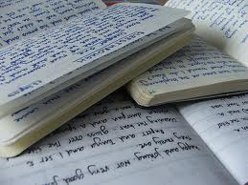

**Direct Writing Assessment**

The annual right of passage is nearly upon us. In February, students will be taking part in the Direct Writing Assessment (DWA).

Students cannot get help from others (including me), they cannot discuss their writing, and they cannot use resources other than those that are part of the normal classroom routine. The intention and purpose is to determine the writing ability of the student. It is an authentic assessment of the student’s writing skills and the scores that they earn help determine the focus and instruction during the upcoming months.

Each session is thirty to forty-five minutes. Each session is focused. During the first session, I will distribute materials, explain the guidelines, and students will work on a prewriting strategy. During the second session, students will write their first draft. The third session focuses on editing and revising. The fourth and any further sessions will focus on finalizing their writings.

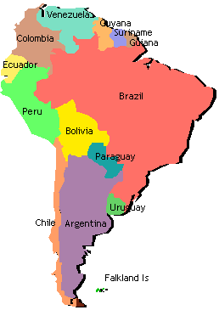This year’s writing assessment will take place Monday through Friday of this week (2/24-2/28). Absent students or those who need more time will have it provided during the following week (3/3-7).

♠

History

**Current Event #11**

Student preparation is similar to first semester. Students need to read a significant news item and summarize it. The “who, when, & where” can/should be copied from the article, but the “what” still needs to be paraphrased. Students still need to be able to locate the current event on the map and I still need a copy of the article. Students can staple the article to their current event summary or email me the article.

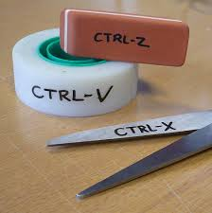Too many students are “cut and pasting” the article’s words in the summary of “what”. They may not physically cut and paste the words, but simply reorganizing, rearranging, or replacing a word here-and-there is not putting the article’s text into one’s own words. We have talked about, shown examples of, and practiced the difference between paraphrasing, plagiarizing, and quoting. Students who run afoul of this will have to redo the article or, in the case of multiple offenses, receive a zero for their summary.

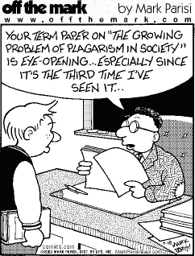On the assigned day, students who have an article prepared will meet and practice in the hallway during reading time. Students need to be comfortable with the information in the news item otherwise the practice time is of little use. I do check the articles to assist and advise them. Students who are not prepared will present the next day.

Current event #11 focuses on articles and news items from South America. In addition to the group news and chapter 11-13 quiz on Friday (3/7), students will take an individual quiz on the nations and significant bodies of water of South America. The quiz has an increasing level of expectation for each grade level for the map (6th grade students must complete any 16 of the items, 7th any 18, and 8th must complete all 20).

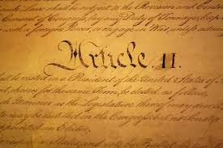The current events for the rest of the semester are by continent/world region. There are specific assignments sheets for each current event region already posted to the [CURRENT EVENT](http://733257565503770808.weebly.com/current-events.html) website.

**Constitution**

The *Constitution of the United States*is the supreme law of the United States of America. The Constitution originally consisted of seven Articles. The first three Articles embody the doctrine of the separation of powers, whereby the federal government is divided into three branches: the legislature, consisting of the bicameral Congress; the executive, consisting of the President; and the judiciary, consisting of the Supreme Court and other federal courts. The fourth and sixth Articles frame the doctrine of federalism, describing the relationship between State and State, and between the several States and the federal government. The fifth Article provides the procedure for amending the Constitution. The seventh Article provides the procedure for ratifying the Constitution.

The Constitution was adopted on September 17, 1787, by the Constitutional Convention in Philadelphia, Pennsylvania, and ratified by conventions in eleven States. It went into effect on March 4, 1789.

Since the Constitution was adopted, it has been amended twenty-seven times. The first ten amendments (along with two others that were not ratified at the time) were proposed by Congress on September 25, 1789, and were ratified by the necessary three-fourths of the States on December 15, 1791. These first ten amendments are known as the Bill of Rights.

(<http://en.wikipedia.org/wiki/United_States_Constitution>)

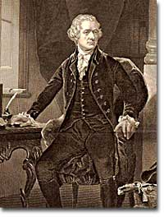

As part of the Constitution unit, students will be reading and discussing chapters 8-10. As a cumulative project, students will create a continent and constitution. Students will get a handout delineating the expectations and due dates as we progress through the chapters. Information is accessible via the Google calendar.

This week students will have time to create the legal basis for their government on their continent. There are several key areas that students must outline and clearly define in their constitution: how laws are created, who creates them, how they are enforced, etc. The project is due February 26 at the beginning of class.

♠

Planner **February 24 – March 2**

|  |  |  |  |  |  |  |
| --- | --- | --- | --- | --- | --- | --- |
|  | **Monday 2/24** | **Tuesday 2/25** | **Wednesday 2/26** | **Thursday 2/27** | **Friday**  **2/28** | **Weekend 3/1-2** |
| **Writing**  (Language Arts) | **Direct Writing Assessment**  -Prewriting: 45’  **Vocabulary #11**  -regular = words #1-10  -W3 #1-20 = sentences  -W3 #21+ = list  **Create-a-Board Game**  *initial proposal due at the beginning of class | **Direct Writing Assessment**  -Draft #1: 45’  **Vocabulary #11**  -regular = words #11-20  -W3 #1-20 = sentences  -W3 #21+ = list & ideas | **Direct Writing Assessment**  -Edit & Revise: 45’ [2/26]  -Draft #2 & “Workshop” [2/27]  **Create-a-Board Game**  -workshop objective, equipment, and winning conditions  -begin draft of board and pieces | | **\*vocab #11 assignment**  -due **beginning** of class  -regular vocabulary = 5 cartoons or sentences  -W3 #1-20 = flashcards & sentences  -W3 #21+ = list & ideas  **Direct Writing Assessment**  *Finalize: 45’ | **Grammar #11**  -guidance & work 2/18-19  *assignment due 2/20  **Murder Mystery**  -mystery event 3/3-7  **Create-a-Board Game**  -playtesting 3/10-14  *board game due 4/14 |
| **Reading** | **20’ Reading**  -student book of choice  -student meetings  **Discussion Groups**  -help with new individual discussion assignments  -time to work on discussion assignment | **20’ Reading**  -student book of choice  -student meetings | **20’ Reading**  -student book of choice  -student meetings  **Body Biography**  -meet with character group to plan  -what are the 3-4 items each person will put on the outline  -each person should have a minimum of 6 items for the Body Biography | | **Discussion #3**  -AM = 10:30-11:15  -PM = 1:45-2:30^  *reflection due after the meeting  ^M’Kay 1-1:45 | **Discussion #4**  -assignment due at the beginning of class 3/13  -discussion 3/14  **Body Biography**  -finalize 3/17-20  *due at the beginning of class 3/21  **Chains**  -novel read aloud |
| **History**  **(Social Studies)** | **Current Event #11**  -Daily Show groups Team II & Spaceballs  **Create-a-Constitution**  -revise ideas  -have you addressed the required “articles”? | **Current Event #11**  -Daily Show groups Animal Lovers & Jiffy Lube  **Create-a-Constitution**  -finalize ideas  -have you addressed the required “articles”? | **Current Event #11**  -Daily Show groups Hungry Cows & Mocking Ninnies [2/26]  -Daily Show groups Bulbous Daily Show & Hello Show [2/27]  **Create-a-constitution**  *due at the beginning of class [**2/26**]  -share in small table groups?  **Early America:**  -"Political Developments in the Early Republic" (11: pages 144-159)  -"Foreign Affairs in the Young Nation" (12: pages 160-173)  -"A Growing Sense of Nationhood" (13: pages 174-183) | | **Current Event #11**  -Daily Show groups Dragons & Santa Baby  **Early America:**  -"Political Developments in the Early Republic" (11: pages 144-159)  -"Foreign Affairs in the Young Nation" (12: pages 160-173)  -"A Growing Sense of Nationhood" (13: pages 174-183) | **Current Event #11**  -make-up & missing presentations 3/3  -group currents events & individual South America map quiz 3/7  **Early America**  -finish reading chapter 11, 12, **or** 13 3/3-4  -teach one-another the chapters 3/5-7  *quiz on chapters 3/7 |
| **Other**  Contact Information for Binder  **da Vinci:** 503-916-5356 ext 79140 **Home**: 503-640-5265  voicemail: 503-916-3600 ext 79140  email: [pbinder@pps.net](mailto:pbinder@pps.net)  **WEB PAGE** <http://733257565503770808.weebly.com/> | drama blackout | drama blackout | drama blackout  **Periods: 2, 4, 6, & FLEX**  **Ashland** trip | drama blackout  **Periods 1, 3, 5, & 7**  **Miles Dustin**’s bday  **Ashland** trip | drama blackout  **Ashland** trip  **Alumni Dance** @5pm | 2/17 no school  2/19 late opening & QSA 3:00-4:30  2/21 **Haydn Bocian**’s birthday |