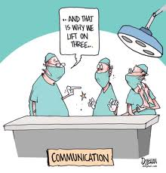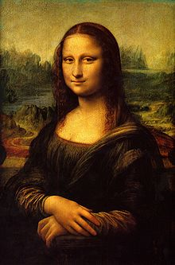**Binder Core: 2/17/2014**

**Information & Communication**

[repeated]

I put a lot out there…perhaps too much for some, and not enough for others. It is always a delicate balance. Please keep in mind that the 2.5 hours I spend with students on the average day cannot be recreated sufficiently in newsletter or email form. Baring illness or absence (dance pullout, random OAKS or EasyCBM testing pullout, etc), I rely on the students to listen to, write down, and communicate any updates or new items.

I realize that the newsletters can seem daunting. Who really wants to read that much each week—for that matter, who wants to write that much each week? The reality is that it helps me be a better teacher. It helps me explore and explain my reasoning and the process. The newsletter can help you. It can help you with time management, expectations, directions, etc. The best advice anyone ever gave me was, print the newsletter and put it in the bathroom. It will get read.

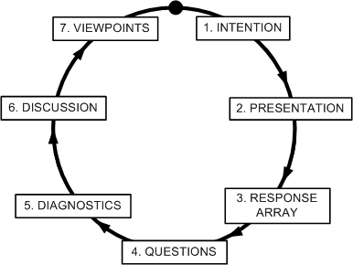You may not agree with my methods or reasoning, and I invite you to open a dialogue with me. Please realize, that this is a dialogue. I will listen. I will reflect on your ideas. I might not, however, agree with you or change what I am doing. There are sixty-three different students in Binder Core, most with more than one set of parents. If you toss me into the mix, it means that there are a myriad of opinions and ideas on how things should be done. Loud and angry does not make one right, but silent simmering will not change things either.

****Please do your best to read, review, and digest the information coming at you. Please work with me to help make things better. I look forward to working with you throughout the second semester and beyond.

♠

**Reading**

**Discussion #2 & 3**

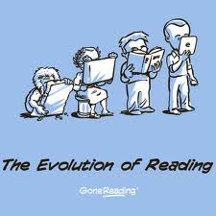Thank you to the fantastic adults who volunteered their time to help facilitate discussion #2. It is not an easy task to “teach” students how to have an intelligent and meaningful discussion about a novel. Discussions seem to be developing and progressing well. Thank you to all who help assist in their success.

Students have twenty minutes each day to read their discussion novel. Additionally, students should use whatever time **at home** necessary to fulfill the number of pages or chapters required for each discussion. Each student has a bookmark listing the dates of each discussion and the assigned pages. The bookmarks are also available via the “[READING](http://733257565503770808.weebly.com/reading.html)” page of my web page.

The assignment sheets for the discussions are also available via the “[READING](http://733257565503770808.weebly.com/reading.html)” page of my web page. You will have to access the bookmarks (or ask the student) to determine what assignment the student must complete. Students are given the new assignment sheet two weeks(ish) ahead of time I recommend using the assignment sheet as a second bookmark and completing the assignment as the novel is read. Directions are on each sheet, but the “post discussion” part is completed after the discussion.

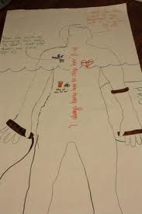The assignment for discussion #3 is due Thursday (2/27) and the discussion is on Friday (2/28). The assignment is due a day before the discussion so that I have time to evaluate and provide feedback on the assignment. Students who are absent for a discussion must complete an alternative to earn the points. They will, however, be excused from the reflections.

**Body Biography**

The culminating activity for the third quarter discussion novel is a body biography for a significant character in the novel. Discussion groups have apportioned themselves into two groups: one group for the protagonist and one group for the antagonist.

For the chosen character, students will be creating a **body biography**—a visual and written portrait illustrating several aspects of the character’s life within the novel.

Groups are responsible for planning and coordinating at least three additions to the body biography for their character for each student for each discussion. Essentially, students must add 12 items to the body biography, but from the breadth and depth of the novel instead of just the last three chapters. Students will be given class time and asked to pick a unique color to use in order to visually identify which are their comments on the paper. For each discussion, each student is responsible for one written, one visual, and one symbolic addition to the character.

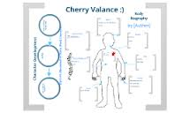There are many possibilities for filling up the giant sheet of paper. I have listed several, but students are free to come up with their own creations. As always, the choices they make should be based on the text, for they will be verbally explaining (and thus, in a sense, defending) them at a showing of their work. Above all, their choices should be creative, analytical, and accurate.

After completing the portrait, students will participate in a showing in which they will present their masterpiece to the class. This showing should accomplish these objectives:

* review significant events, choices, and changes involving your character
* communicate to others the full essence of your character by emphasizing the traits that comprise that person
* promote discussion of the character

Although I expect the biography to contain additional dimensions, the portrait **must** contain the following:

* a review of significant happenings in the novel (with regards to the character)
* visual symbols that represent meaningful images, objects, etc. for the character in the novel
* an original text presenting your view/interpretation of the character and his/her/its role in the novel
* the character’s three most important lines/scenes from the novel.

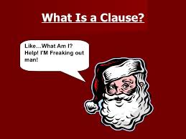The project is due on Friday, March 21. The fourth, and final, discussion takes place the previous Friday (3/14). Students will have the week before Spring Break to finish tracing a “body” onto butcher paper and adorn it with words and imagery.

♠

**Writing**

**Grammar #10**

The second week of vocabulary during the second semester incorporates skill building in conventions. The second week we will continue to concentrate on the sentence. What is a clause? What is the difference between a dependent and independent clause?

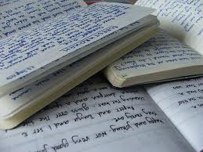The grammar lesson will be presented in the beginning of the week. We will review the three essential components of a sentence: subject, predicate, and complete thought. Students will complete a short assignment that is due by the end of class on Wednesday (2/19). Elements of the lessons may be used in the vocabulary quizzes. Students might be asked to correct, identify, or create sentences using the studied grammatical lesson.

**Direct Writing Assessment**

The annual right of passage is nearly upon us. In February, students will be taking part in the Direct Writing Assessment (DWA).

Students cannot get help from others (including me), they cannot discuss their writing, and they cannot use resources other than those that are part of the normal classroom routine. The intention and purpose is to determine the writing ability of the student. It is an authentic assessment of the student’s writing skills and the scores that they earn help determine the focus and instruction during the upcoming months.

Each session is thirty to forty-five minutes. Each session is focused. During the first session, I will distribute materials, explain the guidelines, and students will work on a prewriting strategy. During the second session, students will write their first draft. The third session focuses on editing and revising. The fourth and any further sessions will focus on finalizing their writings.

This year’s writing assessment will take place 2/24-2/28. Absent student or those who need more time will have it provided during the following week (3/3-7).



♠

History

**Current Event #10**

Current event #10 focuses on articles and news items from North America, but not the United States. In addition to the individual news quiz on Friday (2/21), students will take an individual quiz on the nations and significant bodies of water of North America. The quiz has an increasing level of expectation for each grade level for the map (6th grade students must complete any 20 of the items, 7th any 22, and 8th must complete all).

The current events for the rest of the semester are by continent/world region. There are specific assignments sheets for each current event region already posted to the [CURRENT EVENT](http://733257565503770808.weebly.com/current-events.html) page of the website.

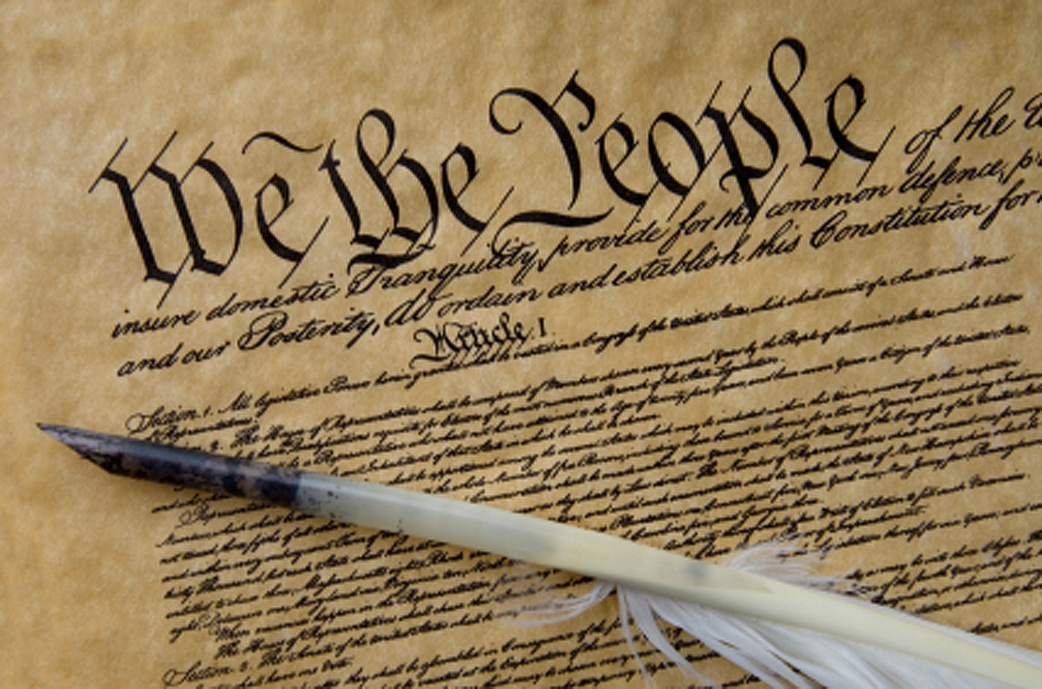**Constitution**

The *Constitution of the United States*is the supreme law of the United States of America. The Constitution originally consisted of seven Articles. The first three Articles embody the doctrine of the separation of powers, whereby the federal government is divided into three branches: the legislature, consisting of the bicameral Congress; 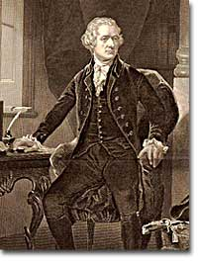the executive, consisting of the President; and the judiciary, consisting of the Supreme Court and other federal courts. The fourth and sixth Articles frame the doctrine of federalism, describing the relationship between State and State, and between the several States and the federal government. The fifth Article provides the procedure for amending the Constitution. The seventh Article provides the procedure for ratifying the Constitution.

The Constitution was adopted on September 17, 1787, by the Constitutional Convention in Philadelphia, Pennsylvania, and ratified by conventions in eleven States. It went into effect on March 4, 1789.

Since the Constitution was adopted, it has been amended twenty-seven times. The first ten amendments (along with two others that were not ratified at the time) were proposed by Congress on September 25, 1789, and were ratified by the necessary three-fourths of the States on December 15, 1791. These first ten amendments are known as the Bill of Rights.

The Constitution is interpreted, supplemented, and implemented by a large body of constitutional law. The Constitution of the United States was the first constitution of its kind, and has influenced the constitutions of other nations.

It was not, however, the first “law of the land.” The Articles of Confederation and Perpetual Union was the first constitution of the United States of America. It was drafted by the Continental Congress in mid-1776 to late 1777, and formal ratification by all 13 states was completed in early 1781. The chief problem with the new government under the Articles of Confederation was, in the words of George Washington, "no money.” (<http://en.wikipedia.org/wiki/United_States_Constitution>)

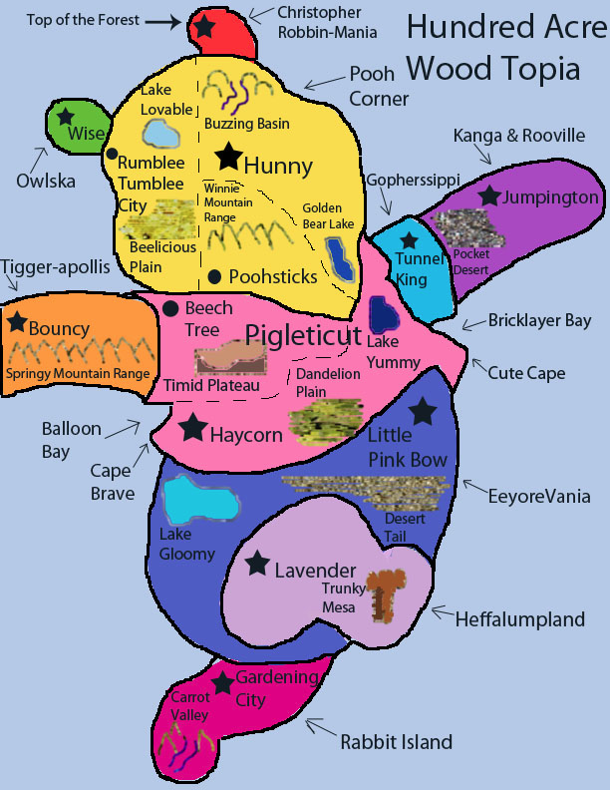

As part of the Constitution unit, students will be reading and discussing chapters 8-10. As a cumulative project, students will create a continent and constitution. Students will get a handout delineating the expectations and due dates as we progress through the chapters. Information is accessible via the Google calendar.

Students will have time this week to focus on, create, revise, and finalize their continent. It must incorporate at least 15 geographic features. The names of the features and the shape of the continent must adhere to a theme. The theme is up to the student—it could be Harry Potter, Katniss, classic rock, Greek mythology, etc. The continent is due at the beginning of class on Friday (2/21).

Next week students will have time to create the legal basis for their government on their continent. There are several key areas that students must outline and clearly define in their constitution: how laws are created, who creates them, how they are enforced, etc. The project is due February 26 at the beginning of class.

♠

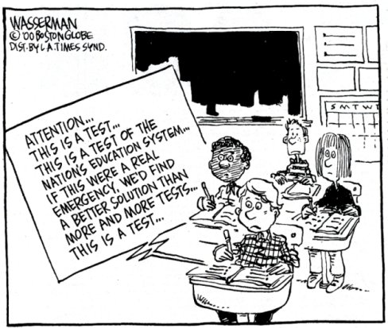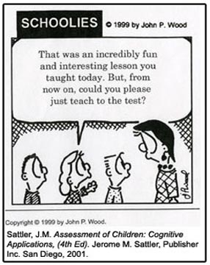

Planner **February 17 – 23**

|  |  |  |  |  |  |  |
| --- | --- | --- | --- | --- | --- | --- |
|  | **Monday 2/17** | **Tuesday 2/18** | **Wednesday 2/19** | **Thursday 2/20** | **Friday**  **2/21** | **Weekend 2/22-23** |
| **Writing**  (Language Arts) | Presidents’ Day | **Create-a-board-game**  -product research in focus groups I  -pieces, rulebook section titles, diagrams, etc.  **Grammar #10**  -review subject, predicate, and clauses | **Create-a-board-game**  -product research in focus groups II [2/19]  -theme, rulebook section titles, time, etc.  -product research in focus groups III [2/20]  -theme, set up, rulebook section titles, etc.  **Grammar #10**  -turning fragments into real sentences  *assignment due by the **end** of class [**2/19**]  **Vocab #10 Quiz [2/20]**  -regular = fill-in-the-blank sentences  -W3 #1-20 = stems & mystery questions  -W3 #21+ = words, definitions, stems & flip side | | **Create-a-board-game**  -product research in focus groups IV: A New Hope  -pieces, rulebook section titles, “voice” in rules, etc.  -work on initial ideas for board game | **Vocabulary #11**  -words & work 2/24-27  *assignment due 2/28  -quiz 3/6  **DWA**  -prewriting, drafting, editing & revising, “workshop”, & finalize 2/24-28  **Create-a-Board Game**  -initial idea 2/24  **Murder Mystery**  -mystery event 3/3-7 |
| **Reading** |  | **20’ Reading**  -student book of choice  -student meetings  **Discussion Groups**  -help with new individual discussion assignments  -time to work on discussion assignment | **20’ Reading**  -student book of choice  -student meetings  **Body Biography**  -meet with character group to plan  -what are the 3-4 items each person will put on the outline | | **20’ Reading**  -student book of choice  -student meetings | **Discussion #3**  -assignment due at the beginning of class 2/27  -discussion 2/28  **Chains**  -novel read aloud |
| **History**  **(Social Studies)** |  | **Current Event #10**  -make up and missing daily show  **Create-a-Continent**  -time to work  -do the 15 features & continent reflect the theme? | **Current Event #10**  -current events update & review  **Create-a-Continent**  *draft of continent due at beginning of class [**2/19**]  -time to finalize | | **Current Event #10 Quiz**  -individual current events & North America map quiz  **Create-a-Continent**  * continent due at beginning of class  **Create-a-Constitution**  -initial ideas and guidance | **Current Event #11**  -presentations 2/24-28  -make-up & missing presentations 3/3  -group currents events & individual South America map quiz 3/7  **Constitution**  -Create-a-Constitution work 2/24-25  -Create-a-Constitution due **2/26** |
| **Other**  Contact Information for Binder  **da Vinci:** 503-916-5356 ext 79140 **Home**: 503-640-5265  voicemail: 503-916-3600 ext 79140  email: [pbinder@pps.net](mailto:pbinder@pps.net)  **WEB PAGE** <http://733257565503770808.weebly.com/> | **no school** |  | **early release** @12:15am  Periods 1- 7 | Periods 1- 7 | **Haydn Bocian’s** birthday | 2/24-28 drama blackout  2/26-28 Ashland Trip  2/27 **Miles Dustin**’s birthday & Leo Leader lunch  2/28 alumni dance @5pm |