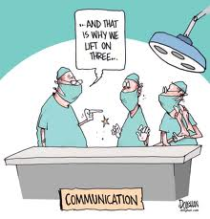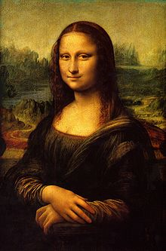**Binder Core: 2/10/2014**

**Information & Communication**

I put a lot out there…perhaps too much for some, and not enough for others. It is always a delicate balance. Please keep in mind that the 2.5 hours I spend with students on the average day cannot be recreated sufficiently in newsletter or email form. Baring illness or absence (dance pullout, random OAKS or EasyCBM testing pullout, etc), I rely on the students to listen to, write down, and communicate any updates or new items.

I realize that the newsletters can seem daunting. Who really wants to read that much each week—for that matter, who wants to write that much each week? The reality is that it helps me be a better teacher. It helps me explore and explain my reasoning and the process. The newsletter can help you. It can help you with time management, expectations, directions, etc. The best advice anyone ever gave me was, print the newsletter and put it in the bathroom. It will get read.

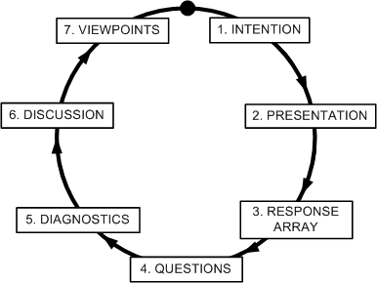You may not agree with my methods or reasoning, and I invite you to open a dialogue with me. Please realize, that this is a dialogue. I will listen. I will reflect on your ideas. I might not, however, agree with you or change what I am doing. There are sixty-three different students in Binder Core, most with more than one set of parents. If you toss me into the mix, it means that there are a myriad of opinions and ideas on how things should be done. Loud and angry does not make one right, but silent simmering will not change things either.

Please do your best to read, review, and digest the information coming at you. Please work with me to help make things better. I look forward to working with you throughout the second semester and beyond.

**Murder Mystery**

As an end of the semester culminating activity, those students who are up-to-date with their work will be participating in a two-day Murder Mystery party. We are still trying to determine which story to use, but all of that should be ironed out soon. We did the same thing last year, and it was a rousing success. We hope to recreate its fun and hijinks.

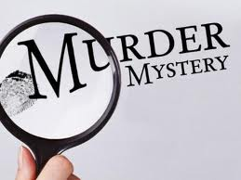Those who would like to participate will receive a role in the Murder Mystery. We might have one mystery or several. If it is one mystery, students will share a role. If we are conducting several mysteries then students will receive a unique role. The task is to become the character…in dress (yes, a simple costume is needed), manner and speech (become the character), and background (“know” the character based on the information provided and interpret how s/he would be or act). Food donations are needed. We worked long and hard first semester and a little active sleuthing will be a refreshing change of pace for a couple of days.

♠



**Reading** 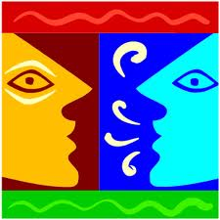

**Discussion #2**

Thank you to the fantastic adults who volunteered their time to help facilitate discussion #1. It is not an easy task to “teach” students how to have an intelligent and meaningful discussion about a novel. Discussions seemed to go well. Thank you.

Students have twenty minutes each day to read their discussion novel. Additionally, students should use whatever time **at home** necessary to fulfill the number of pages or chapters required for each discussion. Each student has a bookmark listing the dates of each discussion and the assigned pages. The bookmarks are also available via the “Reading” page of my web page.

The assignment sheets for the discussions are also available via the “Reading” page of my web page. You will have to access the bookmarks (or ask the student) to determine what assignment the student must complete. Students are given the new assignment sheet two weeks(ish) ahead of time I recommend using the assignment sheet as a second bookmark and completing the assignment as the novel is read. Directions are on each sheet, but the “post discussion” part is completed after the discussion.

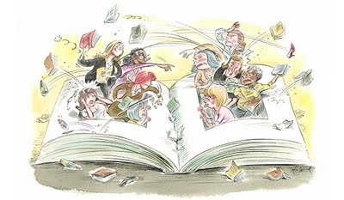The assignment for discussion #2 is due Thursday (2/13) and the discussion is on Friday (2/14). The assignment is due a day before the discussion so that I have time to evaluate and provide feedback on the assignment. It is something that I have learned over the years and it has generated better discussions.

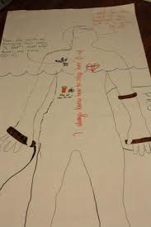**Body Biography**

The culminating activity for the third quarter discussion novel is a body biography for a significant character in the novel. Discussion groups have apportioned themselves into two groups: one group for the protagonist and one group for the antagonist. Students are constantly and continually reminded (which, of course, means that most of them have forgotten) to take notes and document information on their character as they read. It is too difficult to comb through a 200+ page novel after reading to cull information on a character. It can be done, but it is much more difficult.

For the chosen character, students will be creating a **body biography**—a visual and written portrait illustrating several aspects of the character’s life within the novel.

There are many possibilities for filling up the giant sheet of paper. I have listed several, but students are free to come up with their own creations. As always, the choices they make should be based on the text, for they will be verbally explaining (and thus, in a sense, defending) them at a showing of their work. Above all, their choices should be creative, analytical, and accurate.

After completing the portrait, students will participate in a showing in which they will present their masterpiece to the class. This showing should accomplish these objectives:

* review significant events, choices, and changes involving your character
* 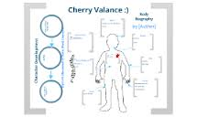communicate to others the full essence of your character by emphasizing the traits that comprise that person
* promote discussion of the character

Although I expect the biography to contain additional dimensions, the portrait **must** contain the following:

* a review of significant happenings in the novel (with regards to the character)
* visual symbols that represent meaningful images, objects, etc. for the character in the novel
* an original text presenting your view/interpretation of the character and his/her/its role in the novel
* the character’s three most important lines/scenes from the novel.

The project is due on Friday, March 21. The fourth, and final, discussion takes place the previous Friday (3/14). Students will have the week before Spring Break to finish tracing a “body” onto butcher paper and adorn it with words and imagery.

♠

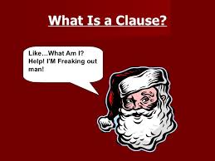**Writing**

**Vocabulary #10**

Regular vocabulary students submit only cartoons or sentences utilizing any five of the current list’s vocabulary words. W3 students on lists #1-20 need only submit the list and sentences, while those on lists #21+ still have to submit the list and ideas. Vocabulary #10 assignment is due at the beginning of class on Friday (2/14).

The second week of vocabulary during the second semester incorporates skill building in conventions. The second week we will continue to concentrate on the sentence. What is a clause? What is the difference between a dependent and independent clause?

The grammar lesson will be presented in the beginning of the second week. Students will complete a short assignment, and elements of the lessons may be used in the vocabulary quizzes. Students might be asked to correct, identify, or create sentences using the studied grammatical lesson.

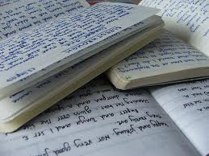

**Direct Writing Assessment**

The annual right of passage is nearly upon us. In February, students will be taking part in the Direct Writing Assessment (DWA). For 6th and 8th grade students, their writings will be assessed locally, at the district level. For 7th grade students, their writings will be assessed at the state level.

Students cannot get help from others (including me), they cannot discuss their writing, and they cannot use resources other than those that are part of the normal classroom routine. The intention and purpose is to determine the writing ability of the student. It is an authentic assessment of the student’s writing skills and the scores that they earn help determine the focus and instruction during the upcoming months.

Each session is thirty to forty-five minutes. Each session is focused. During the first session, I will distribute materials, explain the guidelines, and students will work on a prewriting strategy. During the second session, students will write their first draft. The third session focuses on editing and revising. The fourth and any further sessions will focus on finalizing their writings.

♠

History

**Current Event #10**

Student preparation is similar to first semester. Students need to read a significant news item and summarize it. The “who, when, & where” can/should be copied from the article, but the “what” still needs to be paraphrased. Students still need to be able to locate the current event on the map and I still need a copy of the article. Students can staple the article to their current event summary or email me the article.

On the assigned day, students who have an article prepared will meet and practice in the hallway during reading time. Students need to be comfortable with the information in the news item otherwise the practice time is of little use. I do check the articles to assist and advise them. Students who are not prepared will present the next day.

Current event #10 focuses on articles and news items from North America, but not the United States. In addition to the individual news quiz on Friday (2/21), students will take an individual quiz on the nations and significant bodies of water of North America. The quiz has an increasing level of expectation for each grade level for the map.

The current events for the rest of the semester are by continent/world region. There are specific assignments sheets for each current event region already posted to the CURRENT EVENT website.

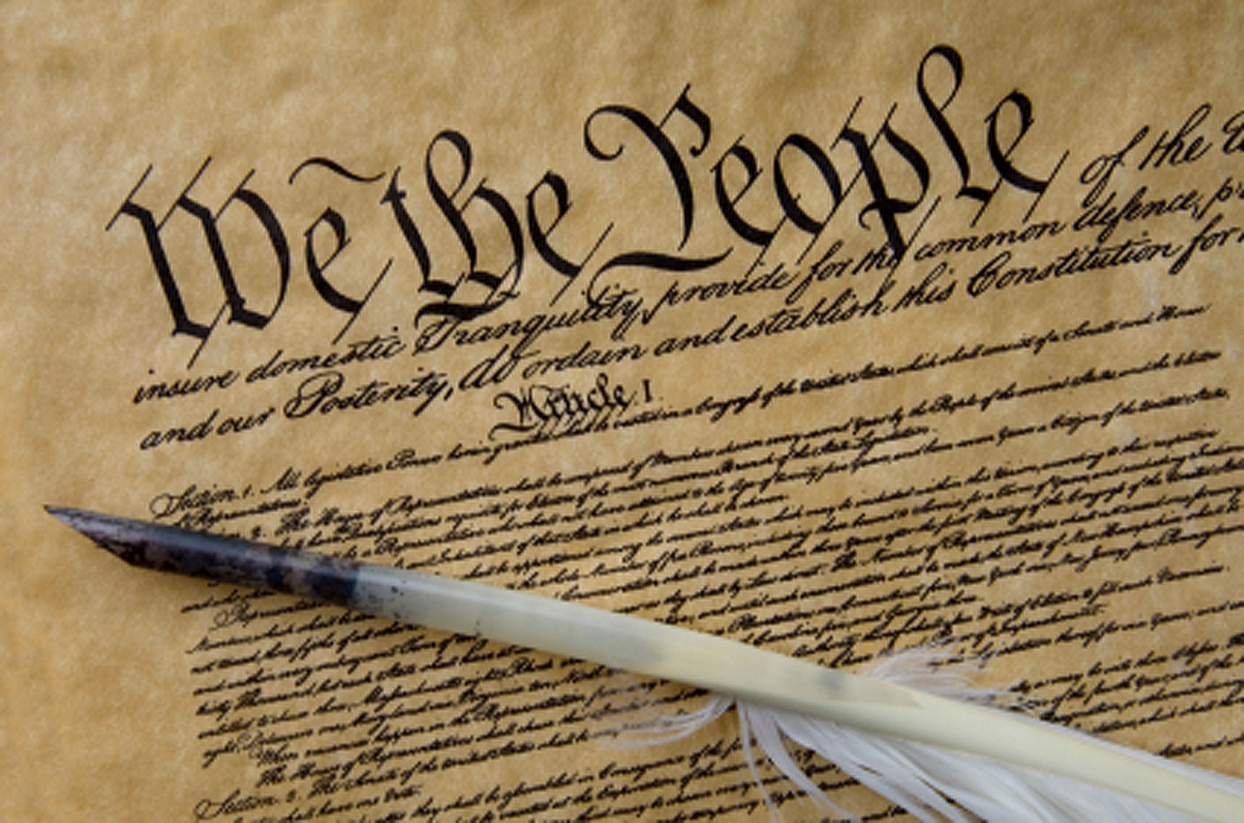**Constitution**

The *Constitution of the United States*is the supreme law of the United States of America. The Constitution originally consisted of seven Articles. The first three Articles embody the doctrine of the separation of powers, whereby the federal government is divided into three branches: the legislature, consisting of the bicameral Congress; the executive, consisting of the President; and the judiciary, consisting of the Supreme Court and other federal courts. The fourth and sixth Articles frame the doctrine of federalism, describing the relationship between State and State, and between the several States and the federal government. The fifth Article provides the procedure for amending the Constitution. The seventh Article provides the procedure for ratifying the Constitution.

The Constitution was adopted on September 17, 1787, by the Constitutional Convention in Philadelphia, Pennsylvania, and ratified by conventions in eleven States. It went into effect on March 4, 1789.

Since the Constitution was adopted, it has been amended twenty-seven times. The first ten amendments (along with two others that were not ratified at the time) were proposed by Congress on September 25, 1789, and were ratified by the necessary three-fourths of the States on December 15, 1791. These first ten amendments are known as the Bill of Rights.

The Constitution is interpreted, supplemented, and implemented by a large body of constitutional law. The Constitution of the United States was the first constitution of its kind, and has influenced the constitutions of other nations.

It was not, however, the first “law of the land.” The Articles of Confederation and Perpetual Union was the first constitution of the United States of America. It was drafted by the Continental Congress in mid-1776 to late 1777, and formal ratification by all 13 states was completed in early 1781. The chief problem with the new government under the Articles of Confederation was, in the words of George Washington, "no money.” (<http://en.wikipedia.org/wiki/United_States_Constitution>)

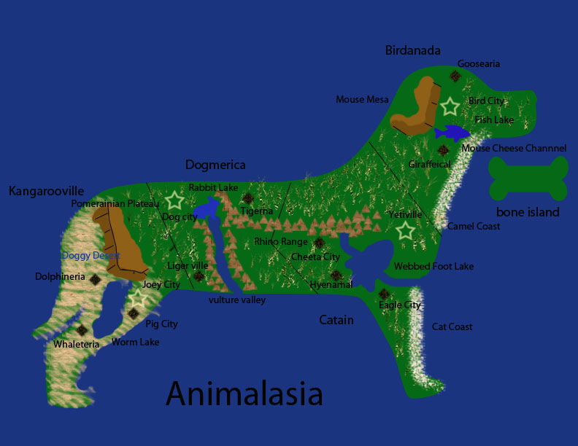

As part of the Constitution unit, students will be reading and discussing chapters 8-10. As a cumulative project, students will create a continent and constitution. Students will get a handout delineating the expectations and due dates as we progress through the chapters. Information is accessible via the Google calendar. The project is due February 26 at the beginning of class.

♠

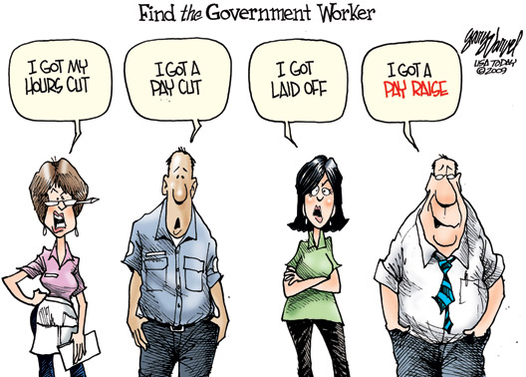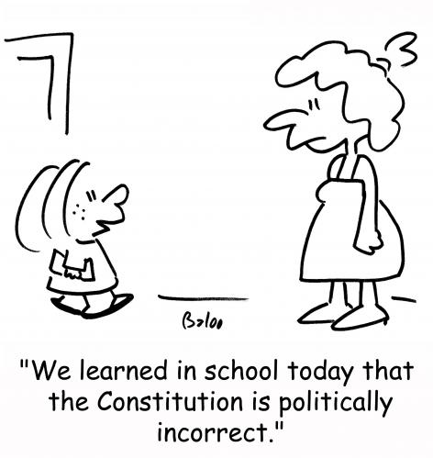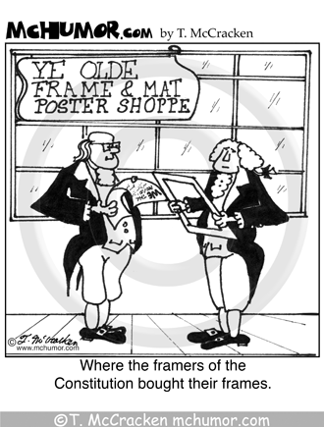

Planner **February 10 – 16**

|  |  |  |  |  |  |  |
| --- | --- | --- | --- | --- | --- | --- |
|  | **Monday 2/10** | **Tuesday 2/11** | **Wednesday 2/12** | **Thursday 2/13** | **Friday**  **2/14** | **Weekend 2/15-16** |
| **Writing**  (Language Arts) | Snow Day | **Vocabulary #10**  -regular = words #1-10  -W3 #1-20 = sentences  -W3 #21+ = list | **Vocabulary #10**  -regular = words #11-20  -W3 #1-20 = sentences  -W3 #21+ = ideas  **murder mystery party**  -planning & preparation  -roles, costumes, food, etc. | | **\*vocab #10 assignment**  -due **beginning** of class  -regular vocabulary = 5 cartoons or sentences  -W3 #1-20 = flashcards & sentences  -W3 #21+ = list & ideas  **murder mystery party**  -planning & preparation  -roles, costumes, food, etc. | **Grammar #10**  -guidance & work 2/18-19  *assignment due 2/20  **Murder Mystery**  -mystery event 2/19-21  **DWA**  -prewriting, drafting, editing & revising, “workshop”, & finalize 2/24-28  **Create-a-Board Game**  -product research 2/18-21  -initial idea 2/24 |
| **Reading** |  | **20’ Reading**  -student book of choice  -student meetings  **Discussion #2**  -questions, comments, concerns on new discussion assignments | **20’ Reading**  -student book of choice  -student meetings  **Body Biography**  -meet with character group to plan  -what are the 3-4 items for each person  **Discussion #2**  *assignment due at the beginning of class [**2/13**] | | **Discussion #2**  -AM = 10:30-11:15  -PM = 1:45-2:30^  *reflection due after the meeting  ^M’Kay 1-1:45 | **Discussion #3**  -assignment due at the beginning of class 2/27  -discussion 2/28  **Chains**  -novel read aloud |
| **History**  **(Social Studies)** |  | **Current Event #9 Quiz**  -group quiz  -individual map quiz on the USA  **Current Event #10**  -Daily Show groups Animal Lovers & Jiffy Lube | **Current Event #10**  -Daily Show groups Hungry Cows, **Team II**, & Mocking Ninnies [2/12]  -Daily Show groups Bulbous Daily Show, **Spaceballs**, & Hello Show [2/13]  **Constitution**  “Constitution: A More Perfect Union” (chapter 9: 118-131)  -read 9:8-9:10  **Constitution**  -"The Bill of Rights" (HA chapter 10: pages 132-143)  -read & discuss 10:1-5 | | **Current Event #10**  -Daily Show groups Dragons & Santa Baby  **Constitution**  -"The Bill of Rights" (HA chapter 10: pages 132-143)  -read & discuss 10:6-7 | **Current Event #10**  -make-up & missing presentations **2/18**  -individual quiz 2/21  **Constitution**  -Create-a-Continent work 2/18-20  *Create-a-Continent due 2/21  -Create-a-Constitution work 2/24-27  -Create-a-Constitution due **2/26** |
| **Other**  Contact Information for Binder  **da Vinci:** 503-916-5356 ext 79140 **Home**: 503-640-5265  voicemail: 503-916-3600 ext 79140  email: [pbinder@pps.net](mailto:pbinder@pps.net)  **WEB PAGE** <http://733257565503770808.weebly.com/> |  | Leo Leader lunch  Master Drama pull-out  Drama Production | **Periods: 2, 4, 6 & FLEX** | **Periods 1, 3, 5, & 7** | **Valentine’s Day** | 2/17 no school  2/19 late opening & QSA 3:00-4:30  2/21 **Haydn Bocian**’s birthday |