**Binder Core: 2/3/2014**

**fresh Start**

The third quarter began last Tuesday (1/28). Everyone has a fresh start and, hopefully, bad habits will atrophy in favor of beneficial and salubrious ones.

Changes…as always, there will be changes. Vocabulary will change slightly, current events have a new twist, reading has morphed, and I am an unintelligible (nothing new there) houseplant with a penchant for dirty laundry. Please keep apprised of information, due dates, and updates in the newsletter.

♠



**Reading** 

**Discussion #2**

Thank you to the fantastic adults who volunteered their time to help facilitate discussion #1. It is not an easy task to “teach” students how to have an intelligent and meaningful discussion about a novel. Discussions seemed to go well. Thank you.

Students have twenty minutes each day to read their discussion novel. Additionally, students should use whatever time **at home** necessary to fulfill the number of pages or chapters required for each discussion. Each student has a bookmark listing the dates of each discussion and the assigned pages. The bookmarks are also available via the “Reading” page of my web page.

The assignment sheets for the discussions are also available via the “Reading” page of my web page. You will have to access the bookmarks (or ask the student) to determine what assignment the student must complete. Students are given the new assignment sheet two weeks(ish) ahead of time I recommend using the assignment sheet as a second bookmark and completing the assignment as the novel is read. Directions are on each sheet, but the “post discussion” part is completed after the discussion.

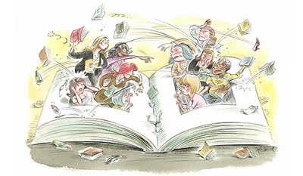The assignment for discussion #2 is due Thursday (2/13) and the discussion is on Friday (2/14). The assignment is due a day before the discussion so that I have time to evaluate and provide feedback on the assignment. It is something that I have learned over the years and it has generated better discussions.

♠

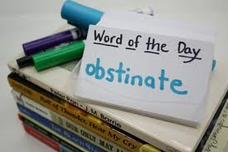**Writing**

**Vocabulary #9**

For the second semester, the first week of vocabulary is the same; words and work at the beginning of the week and the assignment is due at the end of the week. The assignments, however, have been slightly shortened (depending on your vocabulary group) to allow time and mental space for the change to second semester vocabulary—the dreaded grammar.

Regular vocabulary students submit only cartoons or sentences utilizing any five of the current list’s vocabulary words. W3 students on lists #1-20 need only submit the list and sentences, while those on lists #21+ still have to submit the list and ideas. Vocabulary #9 assignment is due at the beginning of class on Friday (1/31).

As part of our second semester vocabulary, we begin to incorporate conventions (grammar)—the abominable leviathan that it is. Most students are inherently aware of the rules and interactions of the words and parts of speech. I strive, however, to make them more cognizant of these guidelines.

The second week of vocabulary during the second semester incorporates skill building in conventions. The first week we will concentrate on the sentence. What is needed for a sentence and what are its basic parts? What is a subject, predicate, and clause?

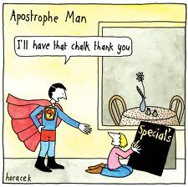A lesson is presented in the beginning of the second week, students complete a short assignment, and elements of the lessons may be used in the vocabulary quizzes. Students might be asked to correct, identify, or create sentences using the studied grammatical lesson.

**Direct Writing Assessment**

The annual right of passage is nearly upon us. In February, students will be taking part in the Direct Writing Assessment (DWA). For 6th and 8th grade students, their writings will be assessed locally, at the district level. For 7th grade students, their writings will be assessed at the state level.

Students cannot get help from others (including me), they cannot discuss their writing, and they cannot use resources other than those that are part of the normal classroom routine. The intention and purpose is to determine the writing ability of the student. It is an authentic 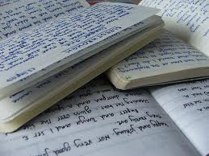assessment of the student’s writing skills and the scores that they earn help determine the focus and instruction during the upcoming months.

Each session is thirty to forty-five minutes. Each session is focused. During the first session, I will distribute materials, explain the guidelines, and students will work on a prewriting strategy. During the second session, students will write their first draft. The third session focuses on editing and revising. The fourth and any further sessions will focus on finalizing their writings.

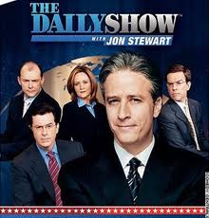

♠

History

**Current Event #9**

[mostly repeated]

The new format for second semester current events is a cross between Jon Stewart’s “Daily Show”, a “Saturday Night Live” news segment, and The Anchorman. Students still need to prepare a current event before they present, but it is a group presentation, not individual.

Student preparation is similar to first semester. Students need to read a significant news item and summarize it. The “who, when, & where” can/should be copied from the article, but the “what” still needs to be paraphrased. Students still need to be able to locate the current event on the map and I still need a copy of the article. Students can staple the article to their current event summary or email me the article.

On the assigned day, students who have an article prepared will meet and practice in the hallway during reading time. Students need to be comfortable with the information in the news item otherwise the practice time is of little use. I do check the articles to assist and advise them. Students who are not prepared will present the next day.

The daily show group members have at least two anchors, a map/weather person, and several in-the-field reporters. Groups are free to assign other roles as well. The main purpose is still to present current events, but the style, format, and “other” elements are up to the daily show group. The daily show group practices the order of the presentations, transitions, and the theme song.

Current event #9 focuses on articles and news items from the United States, but not Oregon. In addition to the group news quiz on Friday (2/7), students will take an individual quiz on the fifty states. This is the only map quiz in which I expect all students to know all items.

The current events for the rest of the semester will be by continent/world region. There are specific assignments sheets for each current event region already posted to the CURRENT EVENT website.

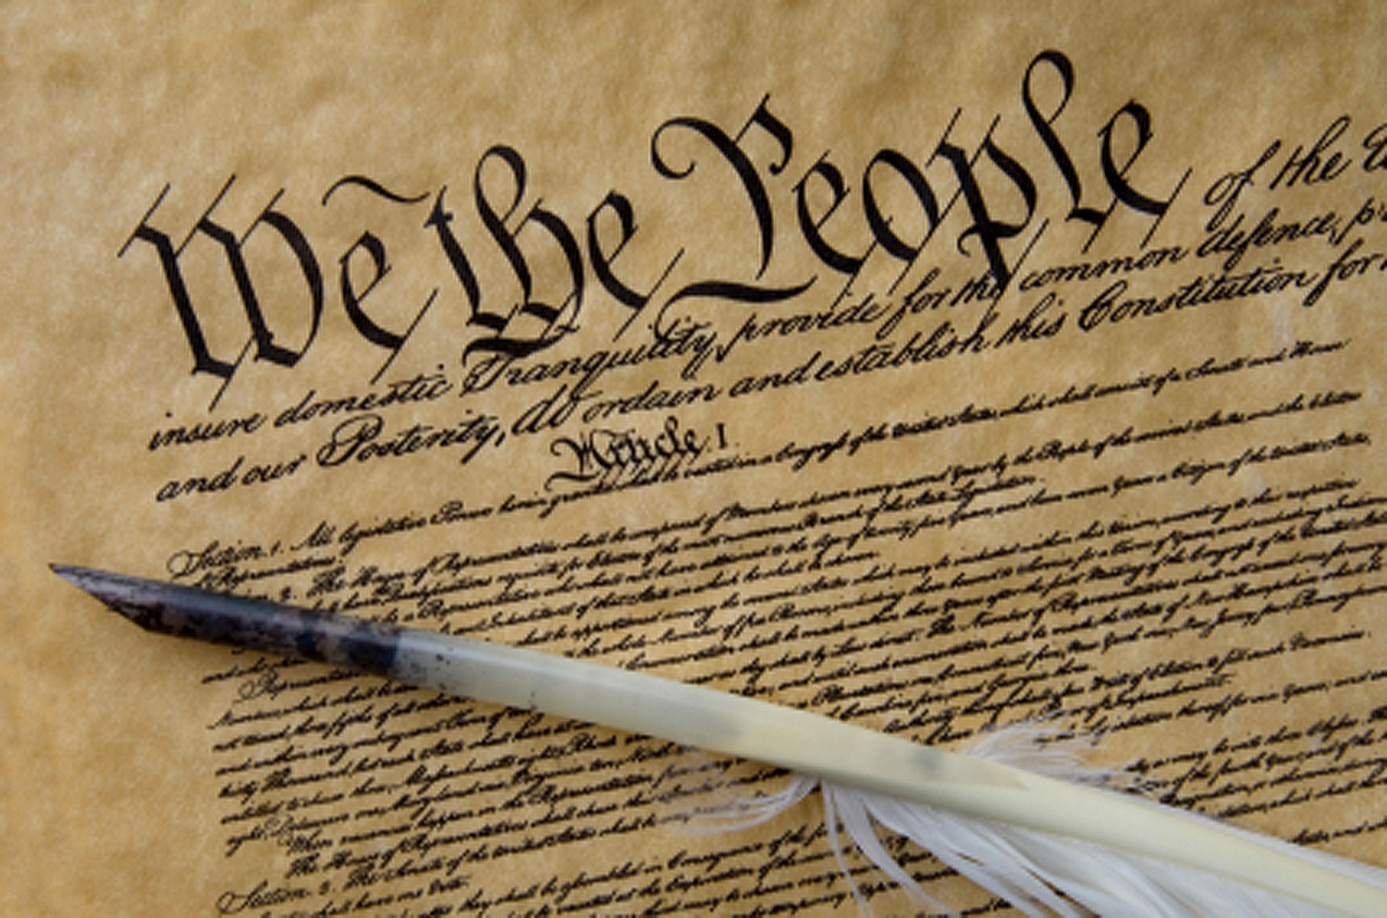**Constitution**

The *Constitution of the United States*is the supreme law of the United States of America. The Constitution originally consisted of seven Articles. The first three Articles embody the doctrine of the separation of powers, whereby the federal government is divided into three branches: the legislature, consisting of the bicameral Congress; the executive, consisting of the President; and the judiciary, consisting of the Supreme Court and other federal courts. The fourth and sixth Articles frame the doctrine of federalism, describing the relationship between State and State, and between the several States and the federal government. The fifth Article provides the procedure for amending the Constitution. The seventh Article provides the procedure for ratifying the Constitution.

The Constitution was adopted on September 17, 1787, by the Constitutional Convention in Philadelphia, Pennsylvania, and ratified by conventions in eleven States. It went into effect on March 4, 1789.

Since the Constitution was adopted, it has been amended twenty-seven times. The first ten amendments (along with two others that were not ratified at the time) were proposed by Congress on September 25, 1789, and were ratified by the necessary three-fourths of the States on December 15, 1791. These first ten amendments are known as the Bill of Rights.

The Constitution is interpreted, supplemented, and implemented by a large body of constitutional law. The Constitution of the United States was the first constitution of its kind, and has influenced the constitutions of other nations.

It was not, however, the first “law of the land.” The Articles of Confederation and Perpetual Union was the first constitution of the United States of America. It was drafted by the Continental Congress in mid-1776 to late 1777, and formal ratification by all 13 states was completed in early 1781. The chief problem with the new government under the Articles of Confederation was, in the words of George Washington, "no money.” (<http://en.wikipedia.org/wiki/United_States_Constitution>)

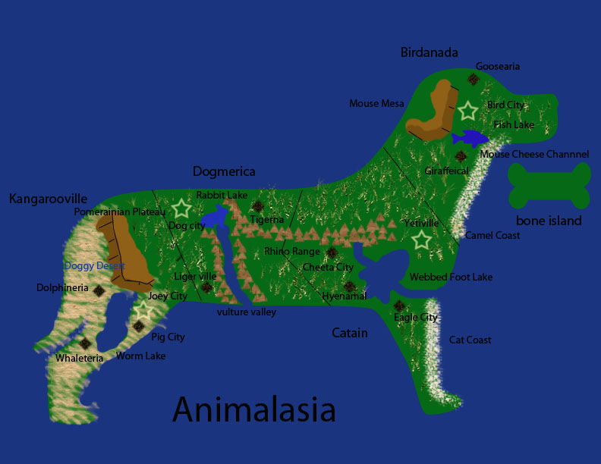

As part of the Constitution unit, students will be reading and discussing chapters 8-10. As a cumulative project, students will create a continent and constitution. Students will get a handout delineating the expectations and due dates as we progress through the chapters. Information is accessible via the Google calendar. The project is due February 26 at the beginning of class.

♠

Planner **January 27 – February 2**

|  |  |  |  |  |  |  |
| --- | --- | --- | --- | --- | --- | --- |
|  | **Monday 2/3** | **Tuesday 2/4** | **Wednesday 2/5** | **Thursday 2/6** | **Friday**  **2/7** | **Weekend 2/8-9** |
| **Writing**  (Language Arts) | **Grammar #9**  -What is a sentence?  -Subject & Predicate | **Grammar #9**  -What is a sentence?  -Clauses | **\*grammar #9 assignment**  -due **beginning** of class [**2/5**]  **murder mystery party**  -planning & preparation  -roles, costumes, food, etc.  **Vocab #9 Quiz [2/6]**  -regular = fill-in-the-blank sentences  -W3 #1-20 = stems & mystery questions  -W3 #21+ = words, definitions, stems & flip side | | **murder mystery party**  -planning & preparation  -roles, costumes, food, etc. | **Vocabulary #10**  -words & work 2/10-11  *assignment due 2/14  -quiz 2/20  **Grammar #10**  -guidance & work 2/18-19  *assignment due 2/20  **DWA**  -some time in February... vague enough for you? |
| **Reading** | **20’ Reading**  -student book of choice  -student meetings  **Discussion #2**  -new assignment  -questions, comments, concerns on new discussion assignments | **20’ Reading**  -student book of choice  -student meetings  **Discussion #2**  -questions, comments, concerns on new discussion assignments | **20’ Reading**  -student book of choice  -student meetings  **Body Biography**  -meet with character group to plan  -what color will each person be using  -what are the 3-4 items each person will put on the outline | | **20’ Reading**  -student book of choice  -student meetings  **Chains**  -novel read aloud | **Discussion #2**  -assignment due at the beginning of class 2/13  -discussion 2/14  **Chains**  -novel read aloud |
| **History**  **(Social Studies)** | **Current Event #9**  -Daily Show groups Team II & Spaceballs  **Constitution**  "Creating the Constitution" (chapter 8: pages 102-117)  -read & discuss 8:11-13 | **Current Event #9**  -Daily Show make-up & missing  **Constitution**  “Constitution: A More Perfect Union” (chapter 9: 118-131)  -read 9:1-3 | **Current Event #9**  -update & review  **Constitution**  “Constitution: A More Perfect Union” (chapter 9: 118-131)  -read 9:4-9:5  -read 9:6-9:7 | | **Current Event #9 Quiz**  -group quiz  -individual map quiz on the USA  **Constitution**  “Constitution: A More Perfect Union” (chapter 9: 118-131)  -read 9:8-9:9 | **Current Event #10**  -presentations 2/10-14  -make-up & missing presentations **2/18**  -individual quiz 2/21  **Constitution**  “Constitution: A More Perfect Union” (chapter 9: 118-131)  -finish reading 9:10  "The Bill of Rights" (HA chapter 10: pages 132-143)  -Create-a-Constitution Project due **2/26** |
| **Other**  Contact Information for Binder  **da Vinci:** 503-916-5356 ext 79140 **Home**: 503-640-5265  voicemail: 503-916-3600 ext 79140  email: [pbinder@pps.net](mailto:pbinder@pps.net)  **WEB PAGE** <http://733257565503770808.weebly.com/> |  |  | **Periods: 2, 4, 6 & FLEX**  **Spelling Bee**  Site Council @ 4:00pm | **Periods 1, 3, 5, & 7** |  | 2/8 VERITAS@ 2:00pm  2/11 Leo Leader lunch  2/17 no school  2/19 late opening & QSA 3:00-4:30  2/21 **Haydn Bocian**’s birthday |