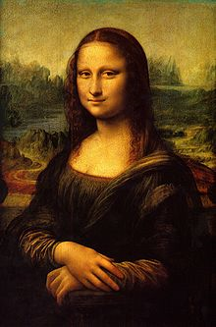**Binder Core: 1/27/2014**

**fresh Start**

The third quarter begins Tuesday (1/28). Everyone gets a fresh start and, hopefully, bad habits will atrophy in favor of beneficial and salubrious ones.

Changes…as always, there will be changes. Vocabulary will change slightly, current events have a new twist, reading has morphed, and I am an unintelligible (nothing new there) houseplant with a penchant for dirty laundry. Please keep apprised of information, due dates, and updates in the newsletter.

♠

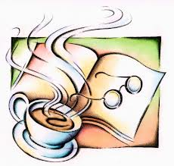

**Reading**

**Discussion Groups**

[mostly repeated]

The second semester will focus on reading and discussing novels within small groups.

There is a critical distinction between good literature and what makes a good discussion novel. Not all literature creates dynamic conversations. Conversations and differing opinions are, however, essential to a good discussion. The book might be a “page turner,” but if it does not prompt conversation then it is a dud as a discussion choice.

The choice of a novel is often a contentious and touchy issue. I do not wish to step on any toes or push a student into reading a subject matter they are not ready for or comfortable with. I emailed the list of novels and groups to families last Thursday (1/16). Please let me know if you have concerns or desires to switch novels as soon as possible. Your help, respect, and diligence are appreciated.

Students prepare for participation in a discussion by completing an assignment. Each discussion focuses on a certain number of pages or chapters as delineated in the "bookmarks" for each discussion group.

Before participating in the discussions, students will complete a job and submit the assignment for the job the day before the discussion. Novel discussions will be held at the end of every other week. The meeting schedule is: 1/31, 2/14, 2/28, and 3/14 for the 3rd quarter. During the 4th quarter the meetings will be 4/10, 4/25, 5/9, and 5/23.

**JOBS:**

* **Riddler**—asks thought provoking questions & leads the discussion
* **Summarizer**—summarizes the assigned section of reading and presents a plot line
* **Story Elements II**—keeps track of 2 major characters and how they change through the assigned reading
* **Illustrator**—provides a cover and teaser for the assigned section of reading
* **Illustrator II**—creates 3 drawings with captions for the assigned section of reading
* **Story Elements**—draws and describes the effects of the setting on the assigned section of reading
* **Literary Luminary**—provides examples of 4 quotes with different literary techniques from the assigned section of reading

Please read and follow directions for the response and reflection sections. If there are any questions, students will have two weeks to clarify assignment expectations. Each assignment and each discussion are worth 25 points.



**Discussion #1**

[mostly repeated]

Students have twenty minutes each day to read their discussion novel. Additionally, students should use whatever time **at home** necessary to fulfill the number of pages or chapters required for each discussion. Each student has a bookmark listing the dates of each discussion and the assigned pages. The bookmarks are also available via the “Reading” page of my web page.

The assignment sheets for the discussions are also available via the “Reading” page of my web page. You will have to access the bookmarks (or ask the student) to determine what assignment the student must complete. Students are given the new assignment sheet two weeks(ish) ahead of time I recommend using the assignment sheet as a second bookmark and completing the assignment as the novel is read. Directions are on each sheet, but the “post discussion” part is completed after the discussion.

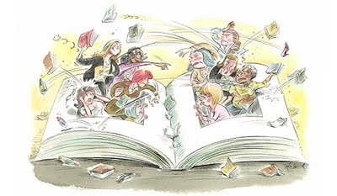The assignment for discussion #1 is due Thursday (1/30) and the discussion is on Friday (1/31). The assignment is due a day before the discussion so that I have time to evaluate and provide feedback on the assignment. It is something that I have learned over the years and it has generated better discussions.

♠

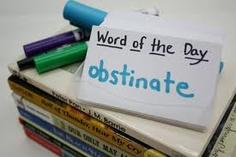**Writing**

**Vocabulary #9**

[mostly repeated]

For the second semester, the first week of vocabulary is the same; words and work at the beginning of the week and the assignment is due at the end of the week. The assignments, however, have been slightly shortened (depending on your vocabulary group) to allow time and mental space for the change to second semester vocabulary—the dreaded grammar.

Regular vocabulary students submit only cartoons or sentences utilizing any five of the current list’s vocabulary words. W3 students on lists #1-20 need only submit the list and sentences, while those on lists #21+ still have to submit the list and ideas. Vocabulary #9 assignment is due at the beginning of class on Friday (1/31).

As part of our second semester vocabulary, we begin to incorporate conventions (grammar)—the abominable leviathan that it is. Most students are inherently aware of the rules and interactions of the words and parts of speech. I strive, however, to make them more cognizant of these guidelines.

The second week of vocabulary during the second semester incorporates skill building in conventions. The first week we will concentrate on the sentence. What is needed for a sentence and what are its basic parts? What is a subject, predicate, and clause?

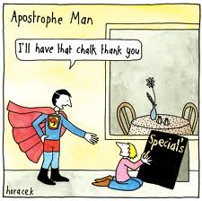A lesson is presented in the beginning of the second week, students complete a short assignment, and elements of the lessons may be used in the vocabulary quizzes. Students might be asked to correct, identify, or create sentences using the studied grammatical lesson.

**Direct Writing Assessment**

The annual right of passage is nearly upon us. In February, students will be taking part in the Direct Writing Assessment (DWA). For 6th and 8th grade students, their writings will be assessed locally, at the district level. For 7th grade students, their writings will be assessed at the state level.

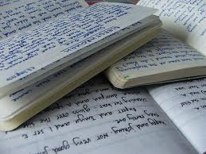Students cannot get help from others (including me), they cannot discuss their writing, and they cannot use resources other than those that are part of the normal classroom routine. The intention and purpose is to determine the writing ability of the student. It is an authentic assessment of the student’s writing skills and the scores that they earn help determine the focus and instruction during the upcoming months.

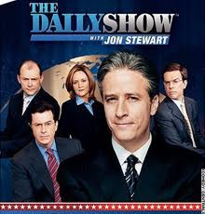Each session is thirty to forty-five minutes. Each session is focused. During the first session, I will distribute materials, explain the guidelines, and students will work on a prewriting strategy. During the second session, students will write their first draft. The third session focuses on editing and revising. The fourth and any further sessions will focus on finalizing their writings.

♠

History

**Current Event #9**

[mostly repeated]

The new format for second semester current events is a cross between Jon Stewart’s “Daily Show”, a “Saturday Night Live” news segment, and The Anchorman. Students still need to prepare a current event before they present, but it is a group presentation, not individual.

Student preparation is similar to first semester. Students need to read a significant news item and summarize it. The “who, when, & where” can/should be copied from the article, but the “what” still needs to be paraphrased. Students still need to be able to locate the current event on the map and I still need a copy of the article. Students can staple the article to their current event summary or email me the article.

On the assigned day, students who have an article prepared will meet and practice in the hallway during reading time. Students need to be comfortable with the information in the news item otherwise the practice time is of little use. I do check the articles to assist and advise them. Students who are not prepared will present the next day.

The daily show group members have at least two anchors, a map/weather person, and several in-the-field reporters. Groups are free to assign other roles as well. The main purpose is still to present current events, but the style, format, and “other” elements are up to the daily show group. The daily show group practices the order of the presentations, transitions, and the theme song.

Students have organized themselves into groups and chosen a day of the week for presentation. Please refer to the CURRENT EVENTS page of my website for a schedule of presentation dates.

Presentations begin this week Tuesday-Friday (1/28-1/31) and continue with the presentations by the Monday groups next week on Monday (2/3). Make-up and missing presentations will happen next Tuesday (2/4). As always, if a student misses, is absent, or forgets the current event assignment on his/her assigned day, it is best to present as soon as possible rather than wait for the make-up day.

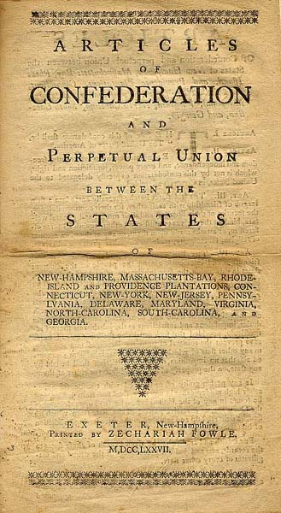

**Constitution**

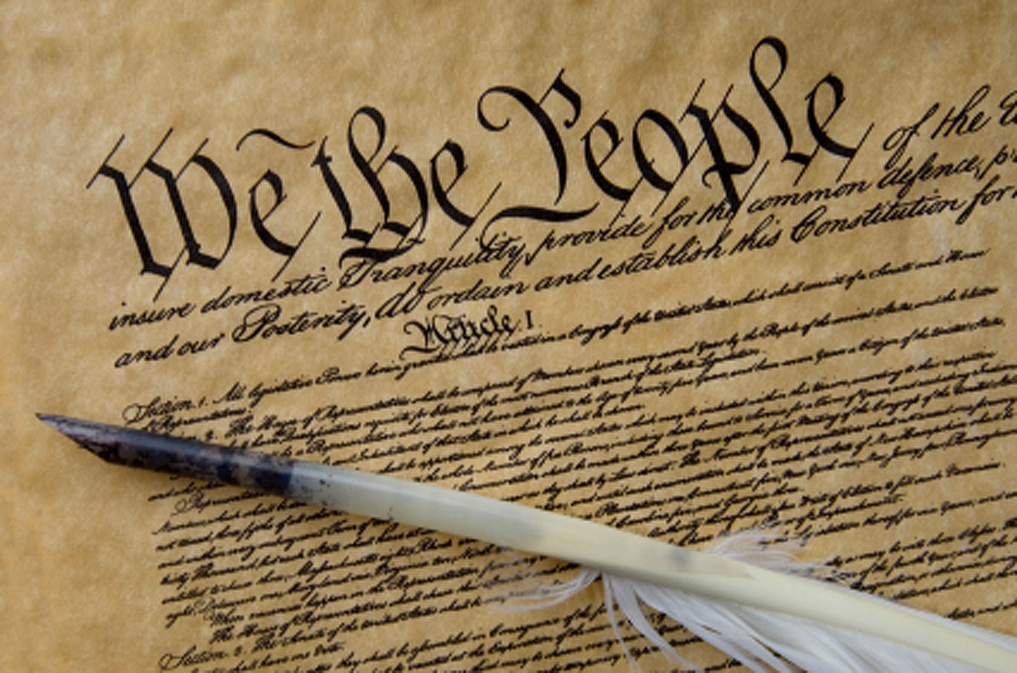The *Constitution of the United States*is the supreme law of the United States of America. The Constitution originally consisted of seven Articles. The first three Articles embody the doctrine of the separation of powers, whereby the federal government is divided into three branches: the legislature, consisting of the bicameral Congress; the executive, consisting of the President; and the judiciary, consisting of the Supreme Court and other federal courts. The fourth and sixth Articles frame the doctrine of federalism, describing the relationship between State and State, and between the several States and the federal government. The fifth Article provides the procedure for amending the Constitution. The seventh Article provides the procedure for ratifying the Constitution.

The Constitution was adopted on September 17, 1787, by the Constitutional Convention in Philadelphia, Pennsylvania, and ratified by conventions in eleven States. It went into effect on March 4, 1789.

Since the Constitution was adopted, it has been amended twenty-seven times. The first ten amendments (along with two others that were not ratified at the time) were proposed by Congress on September 25, 1789, and were ratified by the necessary three-fourths of the States on December 15, 1791. These first ten amendments are known as the Bill of Rights.

The Constitution is interpreted, supplemented, and implemented by a large body of constitutional law. The Constitution of the United States was the first constitution of its kind, and has influenced the constitutions of other nations.

It was not, however, the first “law of the land.” The Articles of Confederation and Perpetual Union was the first constitution of the United States of America. It was drafted by the Continental Congress in mid-1776 to late 1777, and formal ratification by all 13 states was completed in early 1781. The chief problem with the new government under the Articles of Confederation was, in the words of George Washington, "no money.” (<http://en.wikipedia.org/wiki/United_States_Constitution>)

As part of the Constitution unit, students will be reading and discussing chapters 8-10. As a cumulative project, students will create a continent and constitution. Students will get a handout delineating the expectations and due dates as we progress through the chapters. Information is accessible via the Google calendar. The project is due February 26 at the beginning of class.

♠

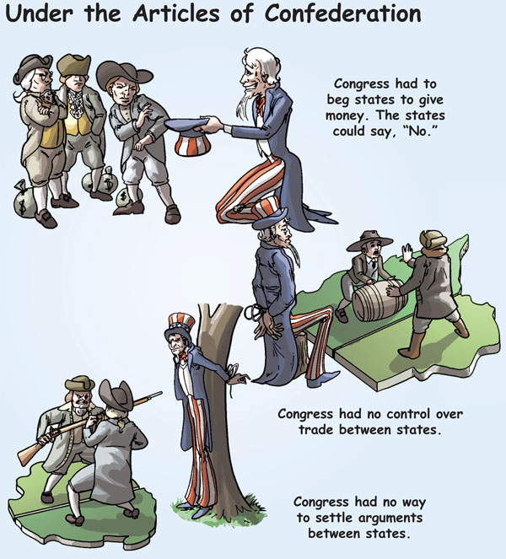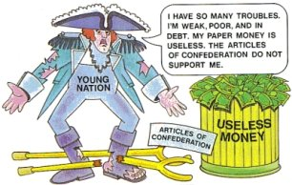

Planner **January 27 – February 2**

|  |  |  |  |  |  |  |
| --- | --- | --- | --- | --- | --- | --- |
|  | **Monday 1/27** | **Tuesday 1/28** | **Wednesday 1/29** | **Thursday 1/30** | **Friday**  **1/31** | **Weekend 2/1-2** |
| **Writing**  (Language Arts) | TEACHER Planning DAY | **Vocabulary #9**  -regular = words #1-10  -W3 #1-20 = sentences  -W3 #21+ = list | **Vocabulary #9**  -regular = words #11-20  -W3 #1-20 = sentences & list  -W3 #21+ = ideas | | **\*vocab #9 assignment**  -due **beginning** of class  -regular vocabulary = 5 cartoons or sentences  -W3 #1-20 = flashcards & sentences  -W3 #21+ = list & ideas | **Vocabulary #9**  -grammar #9: what is a sentence 2/3-4  *grammar #9 assignment due 2/5  -quiz 2/6  **DWA**  -some time in February... vague enough for you? |
| **Reading** |  | **20’ Reading**  -student book of choice  -student meetings  **Discussion Groups**  -help with individual discussion assignments  -time to work on discussion assignment | **20’ Reading**  -student book of choice  -student meetings  **Discussion Groups**  -help with individual discussion assignments [1/29]  -time to work on discussion assignment [1/29]  -review “how to” have a good discussion [1/30]  **Discussion #1**  *assignment  -due at the beginning of class [**1/30**] | | **Discussion #1**  -AM = 10:30-11:15  -PM = 1:45-2:30  *reflection due after the meeting | **Discussion #2**  -assignment due at the beginning of class 2/13  -discussion 2/14  **Chains**  -read aloud |
| **History**  **(Social Studies)** |  | **Current Event #9**  -Daily Show groups Animal Lovers & Jiffy Lube  **Constitution**  "Creating the Constitution" (chapter 8: pages 102-117)  -read & discuss 8:1-3 | **Current Event #9**  -Daily Show groups Hungry Cows & Mocking Ninnies [1/29]  -Daily Show groups Bulbous Daily Show & Hello Show [1/30]  **Constitution**  "Creating the Constitution" (chapter 8: pages 102-117)  -read & discuss 8:4-8:6  -read & discuss 8:7-8 | | **Current Event #9**  -Daily Show groups Dragons & Santa Baby  **Constitution**  "Creating the Constitution" (chapter 8: pages 102-117)  -read & discuss 8:9-10 | **Current Event #9**  -presentations **2/3**  -make-up & missing presentations 2/4  -group quiz 2/7  **Constitution**  "Creating the Constitution" (chapter 8: pages 102-117)  -read & discuss 8:11-13  “Constitution: A More Perfect Union” (chapter 9: 118-131)  -Create-a-Continent & Constitution Project due **2/26** |
| **Other**  Contact Information for Binder  **da Vinci:** 503-916-5356 ext 79140 **Home**: 503-640-5265  voicemail: 503-916-3600 ext 79140  email: [pbinder@pps.net](mailto:pbinder@pps.net)  **WEB PAGE** <http://733257565503770808.weebly.com/> | **teacher planning**—no school | Leo Leader lunch | **Periods: 2, 4, 6 & FLEX**  **Dance 3 & 4** teaser during FLEX | **Periods 1, 3, 5, & 7**  **Dance 3 & 4** rehearsal 3:00-5:00pm | **Visual Arts Show**  **Dance 3 & 4** Showcase 7:00-8:00pm | 2/5 Spelling Bee…then FLEX  2/5 Site Council @ 4:00pm  2/7 da Vinci Alumni Dance 5:00-7:00pm  2/8 VERITAS@ 2:00pm |