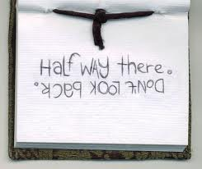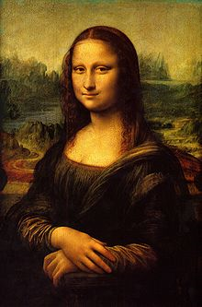**Binder Core: 1/20/2014**

**½ Way Home**

The second quarter, and the first semester, culminates this Friday (1/24). Monday, January 27 is a planning and grading day for teachers.

The third quarter and second semester begin next Tuesday (1/28). Everyone gets a fresh start and, hopefully, bad habits will atrophy in favor of beneficial and salubrious ones.

♠

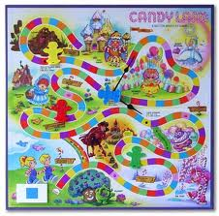

**Reading**

**Reading LOG #6**

[mostly repeated]

The final “reading log” is a project. **All** students need to design a game board for a novel they are currently finishing or have just finished reading. The game board should lead the player of the game through the events of the novel. The spaces should be divided into four parts: exposition, rising action, climax, and falling action/ resolution. The other areas of the board (the non movement spaces) should reflect the setting and significant scenes from the novel. The playing pieces should represent the characters or significant items from the story and by playing the game students should learn what happened throughout the book.

Students **do not** need a rules sheet/directions. The basic rules are to roll a die to get your playing piece to the end in the quickest manner possible. The board, however, should go through several drafts before finalization. The project is due at the beginning of class on Thursday, January 23rd.

**Discussion Groups**

[mostly repeated]

The second semester will focus on reading and discussing novels within small groups.

There is a critical distinction between good literature and what makes a good discussion novel. Not all literature creates dynamic conversations. Conversations and differing opinions are, however, essential to a good discussion. The book might be a “page turner,” but if it does not prompt conversation then it is a dud as a discussion choice.

The choice of a novel is often a contentious and touchy issue. I do not wish to step on any toes or push a student into reading a subject matter they are not ready for or comfortable with. I emailed the list of novels and groups to families last Thursday (1/16). Please let me know if you have concerns or desires to switch novels as soon as possible. Your help, respect, and diligence are appreciated.

Students prepare for participation in a discussion by completing an assignment. Each discussion focuses on a certain number of pages or chapters as delineated in the "bookmarks" for each discussion group.

Before participating in the discussions, students will complete a job and submit the assignment for the job the day before the discussion. Novel discussions will be held at the end of every other week. The meeting schedule is: 1/31, 2/14, 2/28, and 3/14 for the 3rd quarter. During the 4th quarter the meetings will be 4/10, 4/25, 5/9, and 5/23.

**JOBS:**

* **Riddler**—asks thought provoking questions & leads the discussion
* **Summarizer**—summarizes the assigned section of reading and presents a plot line
* **Story Elements II**—keeps track of 2 major characters and how they change through the assigned reading
* **Illustrator**—provides a cover and teaser for the assigned section of reading
* **Illustrator II**—creates 3 drawings with captions for the assigned section of reading
* **Story Elements**—draws and describes the effects of the setting on the assigned section of reading
* **Literary Luminary**—provides examples of 4 quotes with different literary techniques from the assigned section of reading

Please read and follow directions for the response and reflection sections. If there are any questions, students will have two weeks to clarify assignment expectations. Each assignment and each discussion are worth 25 points.

**Discussion #1**

Students have twenty minutes each day to read their discussion novel. Additionally, students should use whatever time at home necessary to fulfill the number of pages or chapters required for each discussion. Each student has a bookmark listing the dates of each discussion and the assigned pages. The bookmarks are also available via the “Reading” page of my web page.

The assignment sheets for the discussions are also available via the “Reading” page of my web page. You will have to access the bookmarks (or ask the student) to determine what assignment the student must complete. Students are given the new assignment sheet two weeks(ish) ahead of time I recommend using the assignment sheet as a second bookmark and completing the assignment as the novel is read. Directions are on each sheet, but the “post discussion” part is completed after the discussion.

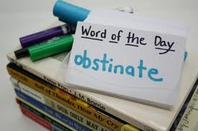The assignment for discussion #1 is due Thursday (1/30) and the discussion is on Friday (1/31). The assignment is due a day before the discussion so that I have time to evaluate and provide feedback on the assignment. It is something that I have learned over the years and it has generated better discussions.

♠

**Writing**

**Vocabulary #9**

For the second semester, the first week of vocabulary is the same; words and work at the beginning of the week and the assignment is due at the end of the week. The assignments, however, have been slightly shortened (depending on your vocabulary group) to allow time and mental space for the change to second semester vocabulary—the dreaded grammar.

Regular vocabulary students submit only cartoons or sentences utilizing any five of the current list’s vocabulary words (examine vocabulary guidelines from first semester to refresh your memory). W3 students on lists #1-20 need only submit the list and sentences, while those on lists #21+ still have to submit the list and ideas.

As part of our second semester vocabulary, we begin to incorporate conventions (grammar)—the abominable leviathan that it is. Most students are inherently aware of the rules and interactions of the words and parts of speech. I strive, however, to make them more cognizant of these guidelines.

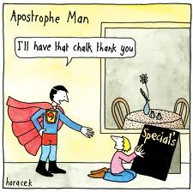The second week of vocabulary during the second semester incorporates skill building in conventions. The first week we will concentrate on the sentence. What is needed for a sentence and what are its basic parts? What is a subject, predicate, and clause?

A lesson is presented in the beginning of the second week, students complete a short assignment, and elements of the lessons may be used in the vocabulary quizzes. Students might be asked to correct, identify, or create sentences using the studied grammatical lesson.

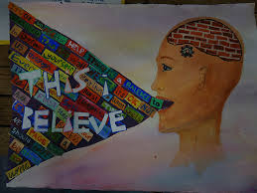**This I Believe**

[mostly repeated]

Students are invited to contribute to this project by writing and submitting their own statement of personal belief. I understand how challenging this is—it requires such intimacy that no one else can do it for them. To guide you through this process, I offer these suggestions:

**Tell a story**: Be specific. Take your belief out of the ether and ground it in the events of your life. Consider moments when belief was formed or tested or changed. Think of your own experience, work, and family, and tell of the things you know that no one else does. Your story need not be heart-warming or gut-wrenching—it can even be funny—but it should be real. Make sure your story ties to the essence of your daily life philosophy and the shaping of your beliefs.

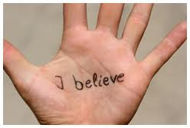**Be brief**: Your statement should be between 350 and 500 words. That’s about three minutes when read aloud at your natural pace.

**Name your belief**: If you can’t name it in a sentence or two, your essay might not be about belief. Also, rather than writing a list, consider focusing on one core belief, because three minutes is a very short time.

**Be positive**: Please avoid preaching or editorializing. Tell us what you do believe, not what you don’t believe. Avoid speaking in the editorial “we.” Make your essay about you; speak in the first person.

**Be personal**: Write in words and phrases that are comfortable for you to speak. We recommend you read your essay aloud to yourself several times, and each time edit it and simplify it until you find the words, tone, and story that truly echo your belief and the way you speak.

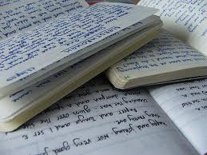Students will work on a proper conclusion and revising and finalizing their introduction and body of the essay during the week. The essay is due at the beginning of class on Wednesday (1/22).

**Direct Writing Assessment**

The annual right of passage is nearly upon us. In February, students will be taking part in the Direct Writing Assessment (DWA). For 6th and 8th grade students, their writings will be assessed locally, at the district level. For 7th grade students, their writings will be assessed at the state level.

Students cannot get help from others (including me), they cannot discuss their writing, and they cannot use resources other than those that are part of the normal classroom routine. The intention and purpose is to determine the writing ability of the student. It is an authentic assessment of the student’s writing skills and the scores that they earn help determine the focus and instruction during the upcoming months.

Each session is thirty to forty-five minutes. Each session is focused. During the first session, I will distribute materials, explain the guidelines, and students will work on a prewriting strategy. During the second session, students will write their first draft. The third session focuses on editing and revising. The fourth and any further sessions will focus on finalizing their writings.

♠

History

**Current Event #9**

The new format for second semester current events is a cross between Jon Stewart’s “Daily Show”, a “Saturday Night Live” news segment, and The Anchorman. Students still need to prepare a current event before they present, but it is a group presentation, not individual.

Student preparation is similar to first semester. Students need to read a significant news item and summarize it. The “who, when, & where” can/should be copied from the article, but the “what” still needs to be paraphrased. Students still need to be able to locate the current event on the map and I still need a copy of the article. Students can staple the article to their current event summary or email me the article.

On the assigned day, students who have an article prepared will meet and practice in the hallway during reading time. Students need to be comfortable with the information in the news item otherwise the practice time is of little use. I do check the articles to assist and advise them. Students who are not prepared will present the next day.

The daily show group members have at least two anchors, a map/weather person, and several in-the-field reporters. Groups are free to assign other roles as well. The main purpose is still to present current events, but the style, format, and “other” elements are up to the daily show group. The daily show group practices the order of the presentations, transitions, and the theme song.

In years past, several groups have really gotten into the presentations. We have had mock commercials, “gossip” corners, grooming advice, counselor moments, costumes, etc. Many students embrace the format while others yearn for the comfort and anonymity of just submitting the article. Regardless, it is a change that is needed to break up the format of current events.

Students will organize themselves into groups and choose a day of the week for presentation. We will also focus on watching examples from the “Daily Show” and “Saturday Night Live” for inspiration and direction. Presentations begin next week.

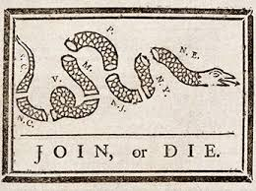**American Revolution**

We conclude our journey in the American Revolution. Students will be finishing and finalizing their mobile with significant people, ideas, events, etc. pertaining to the American Revolution.

Before and during the French and Indian War, from about 1650 to1763, Britain essentially left its American colonies to run themselves in an age of salutary neglect. Given relative freedom to do as they pleased, the North American settlers turned to unique forms of government to match their developing new identity as Americans. They established representative legislatures and democratic town meetings. They also enjoyed such rights as local judiciaries and trials by jury in which defendants were assumed innocent until proven guilty. American shipping, although theoretically regulated by the Navigation Act, functioned apart from the mighty British fleet for more than a hundred years. Finally, the promise of an expansive, untamed continent gave all settlers a sense of freedom and the ability to start fresh in the New World.

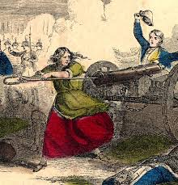After the French and Indian War, the age of salutary neglect was finished. Britain, wanting to replenish its drained treasury, placed a larger tax burden on America and tightened regulations in the colonies. Over the years, Americans were forbidden to circulate local printed currencies, ordered to house British troops, made to comply with restrictive shipping policies, and forced to pay unpopular taxes. Furthermore, many of those failing to comply with the new rules found themselves facing a British judge without jury. Americans were shocked and offended by what they regarded as violations of their liberties. Over time, this shock turned to indignation, which ultimately grew into desire for rebellion. In a mere twelve years—between the end of the French and Indian War in 1763 and the outbreak of the Revolutionary War in 1775—the colonists moved from offering nightly toasts to King George III’s health to demonstrations of outright hostility toward the British Crown.

The American Revolution had profound consequences, not only for the American colonists but for the rest of the world as well. Never before had a body of colonists so boldly declared their monarch and government incapable of governing a free people. The Thomas Jefferson–penned Declaration of Independence was as unique as it was reasonable, presenting a strong, concise case for American rebellion against a tyrannical government. Since then, his declaration has been a model for many groups and peoples fighting their own uphill battles.(<http://www.sparknotes.com/history/american/revolution/context.html>).

Essentially, students need to select, visually represent, and summarize in writing 3 items from each chapter: battles, people (or groups of people), events, and ideas or effects. The project is due Thursday (1/23).

♠

Planner **January 20 –26**

|  |  |  |  |  |  |  |
| --- | --- | --- | --- | --- | --- | --- |
|  | **Monday 1/20** | **Tuesday 1/21** | **Wednesday 1/22** | **Thursday 1/23** | **Friday**  **1/24** | **Weekend 1/25-26** |
| **Writing**  (Language Arts) | **MLK, JR. Day** | **This I Believe**  -edit and revise introduction, body, and conclusion  -finalize essay | **This I Believe**  *finalized copy of essay due **beginning** of class [**1/22**]  -share essays in small table groups, larger table groups, and with class [1/22-23]  **2nd Semester Vocab**  -explanation and review | | **2nd Semester Vocab**  -explanation and review | **Vocabulary #9**  -words & work **1/28-29**  *assignment due 1/31  -quiz 2/6  **DWA**  -some time in February... vague enough for you? |
| **Reading** |  | **20’ Reading**  -student book of choice  -student meetings  -time to revise board game layout for reading project #6  **Discussion Groups**  *copy of the novel by 1/21  -review individual discussion assignments | **20’ Reading**  -student book of choice  -student meetings  -time to revise board game layout [1/22]  **Discussion Groups**  -review “how to” have a good discussion  **Reading Project #6: Board Game**  -due at **beginning** of class [**1/23**]  -representing 250+ pages of reading (1500+ pages total) | | **Reading Project #6: Board Game**  -share and play | **Discussion #1**  -assignment due at the beginning of class 1/30  -discussion 1/31  **Chains**  -read aloud novel |
| **History**  **(Social Studies)** |  | **American Revolution**  -putting together the mobile  -finalize visual & written notes as part of a Revolution Mobile Project | **American Revolution Mobile**  -putting together the mobile, finalize visual & written notes as part of a Revolution Mobile Project[1/22]  *mobile due **beginning** of class [**1/23**] | | **American Revolution Mobile**  -sharing projects | **Current Event #9**  -presentations **1/28-2/3**  -make-up & missing presentations 2/4  -group quiz 2/7  **Constitution**  "Creating the Constitution" (chapter 8: pages 102-117)  -Create-a-Constitution Project due **2/26** |
| **Other**  Contact Information for Binder  **da Vinci:** 503-916-5356 ext 79140 **Home**: 503-640-5265  voicemail: 503-916-3600 ext 79140  email: [pbinder@pps.net](mailto:pbinder@pps.net)  **WEB PAGE** <http://733257565503770808.weebly.com/> | **Rami Holmes**’s birthday  no school |  | **late opening** @10:15am  **Periods: 2, 4, & 6** | **Periods 1, 3, 5, & 7** | **end of 2nd Quarter & 1st Semester** | 1/27 **teacher planning**—no school for students  1/28 Leo Leader lunch  1/29 FLEX with Dance 3 & 4 teaser  1/30 Dance 3 & 4 Tech Rehearsal 3:00-5:00pm  1/31 Visual Arts Show & Dance 3 & 4 Showcase 7:00-8:30pm  2/5 Spelling Bee…then FLEX |