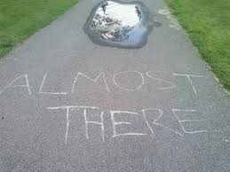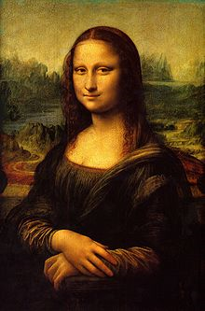**Binder Core: 1/13/2014**

**Almost There**

The second quarter, and the first semester, culminates near the ending of January (1/23). Friday, January 24 is a grading day for teachers. As we march through the next several weeks, please keep up-to-date with things and communicate sooner than later. We do not have a lot of time for procrastination.

All missing, make-up, alternative, etc. assignments and projects are due this Friday (1/17).

♠

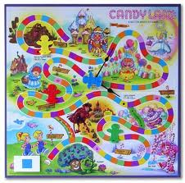

**Reading**

**Reading LOG #6**

The next “reading log” is actually a project. **All** students need to design a game board for a novel they are currently finishing or have just finished reading. The game board should lead the player of the game through the events of the novel. The spaces should be divided into four parts: exposition, rising action, climax, and falling action/ resolution. The other areas of the board (the non movement spaces) should reflect the setting and significant scenes from the novel. The playing pieces should represent the characters or significant items from the story and by playing the game students should learn what happened throughout the book.

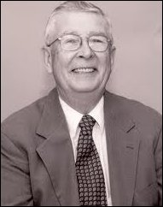Students do not need a rules sheet/directions. The basic rules are to roll a die to get your playing piece to the end in the quickest manner possible. The board, however, should go through several drafts before finalization. The project is due at the beginning of class on Thursday, January 23rd. We will go through an initial draft phase this week and a second draft next week before finalizing.

**Short Stories**

William Brittain, a novelist and school teacher, scattered the pages of *The Ellery Queen Mystery Magazine* and *Alfred Hitchcock's Mystery Magazine* with an abundance of short stories – including "The Man Who Read" series. It's a series of stand-alone mysteries centering on readers of detective fiction that are put in a position where they have to apply the knowledge culled from the stories of their favorite mystery writer to solve a problem of their own... or to create one.

"The Man Who Read John Dickson Carr" is a young orphan, named Edgar Gault, who discovered the undisputed master of the locked room mystery at the impressionable age of fourteen, imbuing him with the conviction that, one day, he will bring his stories to life – preferably with his unpleasant uncle as the victim.

The trick of the locked door is almost as good as the final sentence of the story, which is a real kicker, and it's just overall an amusing and a very rich story. It places the inverted mystery in the convinces of the locked room and even gives you, somewhat, of a character study of the protagonist, but, above all, it's just fun story to read. I wish the entire series, all ten of them, were gathered in one easily accessible volume.

This is our last short story of the semester. We will be transitioning to novels in the second semester.

**Discussion Groups**

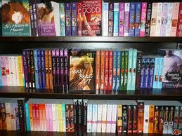The second semester will focus on reading and discussing novels within small groups. Students need to start gathering ideas for discussion novels. Ask peers, parents, librarians, use web site recommendations, etc. The more variety the group has the better the choice they can make. The only rule is that you cannot use a novel for your discussion that you have already read. You can recommend the novel for other groups, but no rereads.

Start with input from peers. What are they reading and what would they recommend for a good discussion book? There is a critical distinction between good literature and what makes a good discussion novel. Not all literature creates dynamic conversations. Conversations and differing opinions are, however, essential to a good discussion. The book might be a “page turner,” but if it does not prompt conversation then it is a dud as a discussion choice.

Seek input from parents, relatives, librarians, teachers, and members of the canine species—if a dog cannot sink his teeth into the novel then it might not be worth reading. You might want to do an internet search on recommended literature as well. Once you have a list—research.

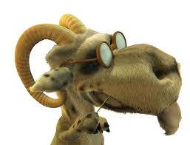Many online sites have a synopsis, ratings, and level recommendations for novels. I often use Amazon’s site to gather additional information on novels, but theirs is not the only source. The key is to be prepared…much like the goat in Hoodwinked.

We will gather and go through the recommendations in class on Monday through Wednesday (1/13-15). Students will list their top choices and I will organize groups based on choices. Students (and parental units) will have a little time and wiggle room to alter choices and groupings, but by Tuesday, January 21st students need to have a copy of the novel they will be reading. Students who cannot obtain a copy or reserve a copy for check-out or purchase will be corralled into a group and select a novel from da Vinci’s library.

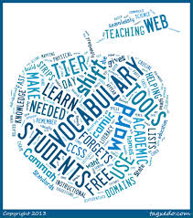The choice of a novel is often a contentious and touchy issue. I do not wish to step on any toes or push a student into reading a subject matter they are not ready for or comfortable with. Your help, respect, communication, and diligence are appreciated.

♠

**Writing**

**Semester Final**

[mostly repeated]

The vocabulary #8 quiz is being rolled into the vocabulary final and is Wednesday and Thursday (1/15-16). Please help make sure that students have been reviewing ten minutes a day and are well-rested and nourished.

The regular vocabulary students have a list with ten words from each of the vocabulary lists we have studied this year.  I culled the easiest and the most difficult words from the previous lists; thus, eliminating ten words from each list.  There will be eighty words total for them to study (eight lists x ten words per list = eighty...unless my math is off).  The review list is posted to my website.

On Wednesday (1/15), regular vocabulary students will complete half of the required fill-in-the-blanks (a review of lists #1-4).  On Thursday (1/16), regular vocabulary students will complete the other half (a review of lists #5-8).  6th graders need to complete fifty blanks total--25 blanks each day.  7th graders need to complete sixty blanks--30 blanks each day.  Regular vocabulary students can complete any of the blanks.

W3 students will complete stem, or whole word (for those past list #20), definitions on Wednesday (1/15).  Students on list #8 and #18 will have the normal 100 stems to identify.  Students on list #23 will have 100 whole words or stems to identify.

****On Thursday (1/16), W3 students will take the "other" portions of their test. The other portions may include mystery questions, antonyms, synonyms, cartoon labeling, etc. The variety and complexity will depend on which list the student is on.

**This I Believe**

[mostly repeated]

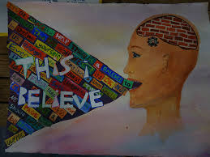Students are invited to contribute to this project by writing and submitting their own statement of personal belief. I understand how challenging this is—it requires such intimacy that no one else can do it for them. To guide you through this process, I offer these suggestions:

**Tell a story**: Be specific. Take your belief out of the ether and ground it in the events of your life. Consider moments when belief was formed or tested or changed. Think of your own experience, work, and family, and tell of the things you know that no one else does. Your story need not be heart-warming or gut-wrenching—it can even be funny—but it should be real. Make sure your story ties to the essence of your daily life philosophy and the shaping of your beliefs.

**Be brief**: Your statement should be between 350 and 500 words. That’s about three minutes when read aloud at your natural pace.

**Name your belief**: If you can’t name it in a sentence or two, your essay might not be about belief. Also, rather than writing a list, consider focusing on one core belief, because three minutes is a very short time.

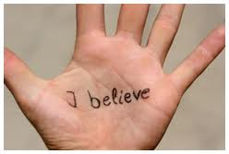**Be positive**: Please avoid preaching or editorializing. Tell us what you do believe, not what you don’t believe. Avoid speaking in the editorial “we.” Make your essay about you; speak in the first person.

**Be personal**: Write in words and phrases that are comfortable for you to speak. We recommend you read your essay aloud to yourself several times, and each time edit it and simplify it until you find the words, tone, and story that truly echo your belief and the way you speak.

Students will work on revising their introduction and crafting the body of the essay during the week. We will be listening to several examples in class to help guide and direct the students. Please ask them about their topic.

This is a much shorter, sweeter, and simpler written piece than the detective story. It is, however, no less of a demand on the students. I am asking them to talk about something they believe it—a topic most adults would consider cringe-worthy. It is essential, however, to examine what it is that we do believe and why. I am excited to see what they write.

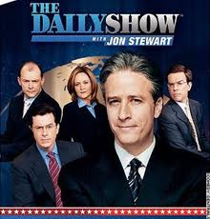

♠

History

**Current Event #8**

Missing or make-up presentations for current event #8 occur Monday (1/13). The individual current event quiz is Friday(1/17) and it will contain questions about our short stories—which will be scored as part of the reading grade.

Next week, if time allows, students will participate in a Jeopardy-style news review of current events #1-8. It is mostly for fun, but glory and prizes will be won. It will also include other items from Core (short stories, quotes, da Vinci happenings, etc.).

**2nd Semester News**

The new format for second semester current events is a cross between Jon Stewart’s “Daily Show”, a “Saturday Night Live” news segment, and The Anchorman. Students still need to prepare a current event the day before they present, but the presentation style is group instead of individual.

As far as student preparation goes…it is similar to first semester. Students need to read a significant news item and summarize it. The “who, when, & where” can/should be copied from the article, but the “what” still needs to be paraphrased. Students still need to be able to locate the current event on the map and I still need a copy of the article. Students can staple the article to their current event summary or email me the article.

On the assigned day, students who have an article prepared will meet and practice in the hallway during reading time. Students need to be comfortable with the information in the news item otherwise the practice time is of little use. I do check the articles to assist and advise them. Students who are not prepared will present the next day.

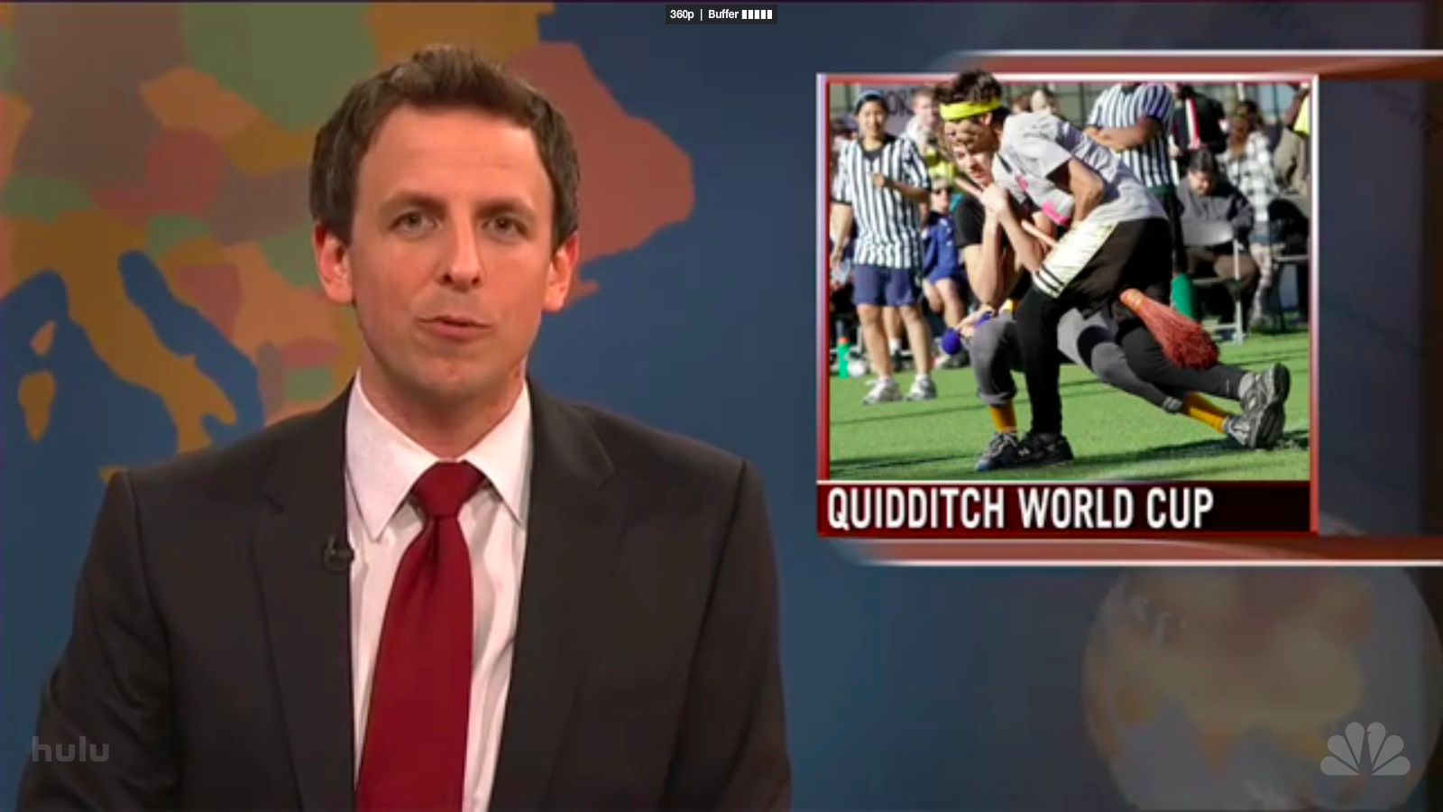The daily show group members have at least two anchors, a map/weather person, and several in-the-field reporters. Groups are free to assign other roles as well. The main purpose is still to present current events, but the style, format, and “other” elements are up to the daily show group. The daily show group practices the order of the presentations, transitions, and the theme song.

In years past, several groups have really gotten into the presentations. We have had mock commercials, “gossip” corners, grooming advice, counselor moments, costumes, etc. Many students embrace the format while others yearn for the comfort and anonymity of just submitting the article. Regardless, it is a change that is needed to break up the format of current events.

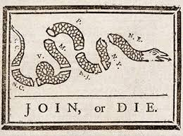Students will organize themselves into groups and choose a day of the week for presentation. We will also focus on watching examples from the “Daily Show” and “Saturday Night Live” for inspiration and direction. Presentations begin next week.

**American Revolution**

We conclude our journey in the American Revolution. This week we will be reading "The American Revolution" (chapter 7: pages 86-101). As we progress through the final chapter students will be creating a mobile with significant people, ideas, events, etc. pertaining to the American Revolution.

Before and during the French and Indian War, from about 1650 to1763, Britain essentially left its American colonies to run themselves in an age of salutary neglect. Given relative freedom to do as they pleased, the North American settlers turned to unique forms of government to match their developing new identity as Americans. They established representative legislatures and democratic town meetings. They also enjoyed such rights as local judiciaries and trials by jury in which defendants were assumed innocent until proven guilty. American shipping, although theoretically regulated by the Navigation Act, functioned apart from the mighty British fleet for more than a hundred years. Finally, the promise of an expansive, untamed continent gave all settlers a sense of freedom and the ability to start fresh in the New World.

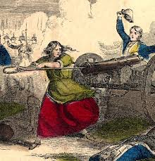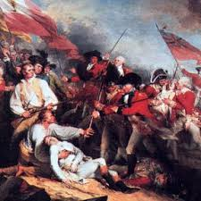After the French and Indian War, the age of salutary neglect was finished. Britain, wanting to replenish its drained treasury, placed a larger tax burden on America and tightened regulations in the colonies. Over the years, Americans were forbidden to circulate local printed currencies, ordered to house British troops, made to comply with restrictive shipping policies, and forced to pay unpopular taxes. Furthermore, many of those failing to comply with the new rules found themselves facing a British judge without jury. Americans were shocked and offended by what they regarded as violations of their liberties. Over time, this shock turned to indignation, which ultimately grew into desire for rebellion. In a mere twelve years—between the end of the French and Indian War in 1763 and the outbreak of the Revolutionary War in 1775—the colonists moved from offering nightly toasts to King George III’s health to demonstrations of outright hostility toward the British Crown.

The American Revolution had profound consequences, not only for the American colonists but for the rest of the world as well. Never before had a body of colonists so boldly declared their monarch and government incapable of governing a free people. The Thomas Jefferson–penned Declaration of Independence was as unique as it was reasonable, presenting a strong, concise case for American rebellion against a tyrannical government. Since then, his declaration has been a model for many groups and peoples fighting their own uphill battles.(<http://www.sparknotes.com/history/american/revolution/context.html>).

Essentially, students need to select, visually represent, and summarize in writing 3 key battles, 3 essential people (or groups of people), 3 important events, and 3 vital ideas or effects. The project is due next Thursday (1/23).

♠

Planner **January 13 –19**

|  |  |  |  |  |  |  |
| --- | --- | --- | --- | --- | --- | --- |
|  | **Monday 1/13** | **Tuesday 1/14** | **Wednesday 1/15** | **Thursday 1/16** | **Friday**  **1/17** | **Weekend 1/18-19** |
| **Writing**  (Language Arts) | **This I Believe**  -review example essays & work on draft of body  **Vocabulary Final**  -review…have flashcards, lists, and other necessary items to help you study | **This I Believe**  -review example essays & work on draft of body  **Vocabulary Final**  -review…have flashcards, lists, and other necessary items to help you study | **Vocab Final [1/15 & 16]**  -regular = complete ½ of the fill-in-the-blank sentences required each day (6th = 25 blanks each day & 7th = 30 blanks each day)  -W3 = stem & whole word definition [1/15]  -W3 = “other portions” [1/16]...mystery questions, flip side, antonyms, synonyms, analogies, math, cartoon labeling, word history mystery, decoding a paragraph, and/or crying | | **This I Believe**  -workshop introduction, body, and focus of essay  *submit draft of introduction & body with feedback, editing, & revising marks by **end**  of class  **Last Day for Late & Missing Work** | **Vocabulary #9**  -words & work **1/28-29**  *assignment due 1/31  -quiz 2/6  **This I Believe**  -draft of conclusion due **beginning** of class 1/21  -workshop entire essay  *finalized/published essay due by **1/22** |
| **Reading** | **20’ Reading**  -student book of choice  -student meetings  *discussion group nominations | **Reading Project #6**  -explain and delineate the project  -show examples of student work  *discussion group nominations | **20’ Reading**  -student book of choice  -student meetings  *discussion group nominations [by **1/15**]  **Discussion Groups**  -initial discussion groups & novel choice…time to negotiate and find copies of the novel  -find a **copy** of the novel by 1/21—if you need help, please ask | | **20’ Reading**  -student book of choice  -student meetings  *initial board game draft | **Discussion Groups**  -copy of the novel by 1/21  -review individual discussion assignments  -review “how to” have a good discussion  **Reading Log/Project #6**  *”finalized” board game layout due 1/23 representing 250+ pages of reading (for a total of 1500+ pages) |
| **History**  **(Social Studies)** | **Current Event #8**  -make-up & missing  **American Revolution**  "American Revolution" (chapter 7: pages 86-101)  -read and take visual & written notes as part of a Revolution Mobile Project | **Current Event #8**  -update & review  **American Revolution**  "American Revolution" (chapter 7: pages 86-101)  -read and take visual & written notes as part of a Revolution Mobile Project | **American Revolution**  "American Revolution" (chapter 7: pages 86-101)  -read and take visual & written notes as part of a Revolution Mobile Project | | **Current Event #8 Quiz**  -individual quiz  -short story quiz aspects (reading grade)  **American Revolution**  "American Revolution" (chapter 7: pages 86-101)  -read and take visual & written notes as part of a Revolution Mobile Project | **Current Event #9**  -presentations **1/28-2/3**  -make-up & missing presentations 2/4  -group quiz 2/7  **American Revolution**  -time to work  -Revolution Mobile Project assignment due **1/23** |
| **Other**  Contact Information for Binder  **da Vinci:** 503-916-5356 ext 79140 **Home**: 503-640-5265  voicemail: 503-916-3600 ext 79140  email: [pbinder@pps.net](mailto:pbinder@pps.net)  **WEB PAGE** <http://733257565503770808.weebly.com/> |  | Leo Leader lunch | **Periods: 2, 4, 6 & FLEX** | **Periods 1, 3, 5, & 7** | **Ariana Sardo Masi**’s birthday | 1/20 MLK, Jr.’s Day, **Rami Holmes**’s birthday, & no school  1/22 **late opening**  1/24 **end of 2nd Quarter**  1/27 **teacher planning**—no school for students |